Name __________________ period _____
6th Grade Do Now
SCI.6.12A Understand that all organisms are composed of one or more cells.
SCI.6.12B Recognize the presence of a nucleus determines whether a cell is prokaryotic or eukaryotic.

Monday Date _______________

What are all living things made of?

A. Rocks
B. Dirt
C. Cells
D. Skin

Tuesday Date _________________

What is the major difference between a prokaryotic cell and a eukaryotic cell?

A. A prokaryotic cell has a chloroplast.
B. A eukaryotic cell has a chloroplast.
C. A prokaryotic cell has a nucleus.
D. A eukaryotic cell has a nucleus.

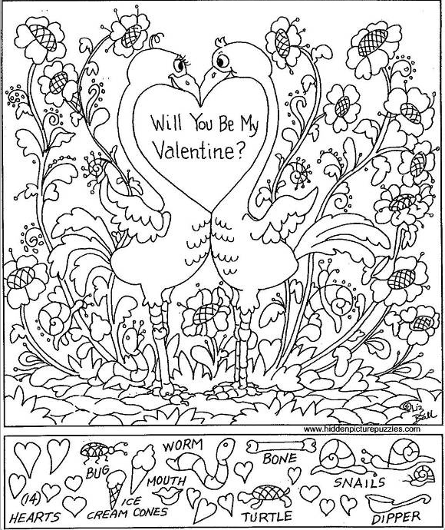

Wednesday Date _________

What scientific tool is used to view things too small to see with the naked eye?

A. A telescope
B. A microscope
C. A laser scope
D. A newton scope

Thursday Date ___________

What is the scientific tool used to place the specimen on when using a microscope?

A. Cover slip
B. Lens
C. Slide
D. Eyepiece

Friday Date _____________

An eyepiece on a microscope magnifies 5X. The lens magnifies 200X. What is the total magnification?

