Name __________________ period _____
6th Grade Do Now
SCI.6.12C Recognize the broadest taxonomic classification of living organisms is divided into currently recognized Domains.
SCI.6.12D Identify the basic characteristics of organisms, including prokaryotic or eukaryotic, unicellular or multicellular, autotrophic or heterotrophic, and mode of reproduction, that further classify them in the currently recognized Kingdoms.

Monday Date _______________

Name 3 different types of living things.

Tuesday Date _________________

Name 3 ways you could classify people in your school.

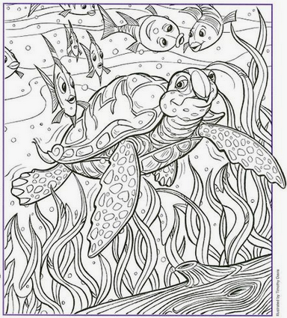
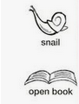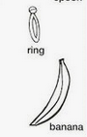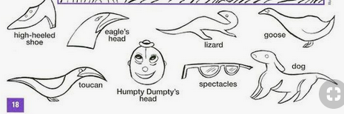
Wednesday Date _____________
Which kingdom below is made entirely of microscopic organisms?

A. Plants
B. Fungi
C. Bacteria
D. Animals

Thursday Date _________
Which kingdom below has organisms that can walk around on legs?

A. Protist
B. Plant
C. Fungi
D. Animals

Friday Date _______

In which kingdom will you find extremophiles?

A. Bacteria
B. Archaebacteria
C. Plants
D. Animals

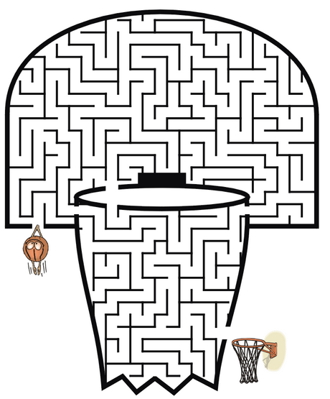


Are the 2 bars straight or curved?

