Name __________________ period _____
6th Grade Do Now
SCI.6.12D Identify the basic characteristics of organisms, including prokaryotic or eukaryotic, unicellular or multicellular, autotrophic or heterotrophic, and mode of reproduction, that further classify them in the currently recognized Kingdoms.

Monday Date _______________

Which list of characteristics describes organisms classified as animals?

A. Unicellular, prokaryotic, autotrophic
B. Multicellular, eukaryotic, heterotrophic
C. Unicellular, eukaryotic, heterotrophic
D. Multicellular, eukaryotic, autotrophic

Tuesday Date _________________

Which list of characteristics describes organisms classified as plants?

A. Unicellular, prokaryotic, autotrophic
B. Multicellular, eukaryotic, heterotrophic
C. Unicellular, eukaryotic, heterotrophic
D. Multicellular, eukaryotic, autotrophic

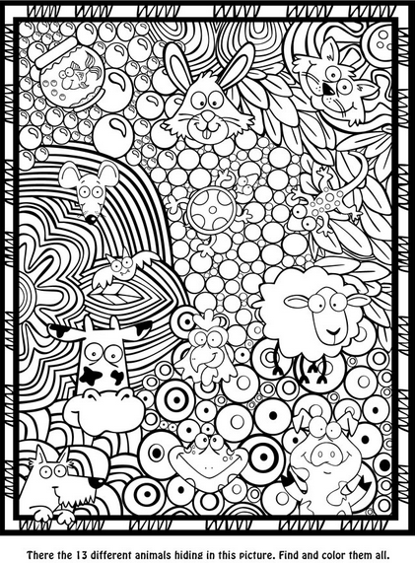

Wednesday Date ________
The characteristics of a particular organism are listed below.

- Is multicellular
- Is autotrophic
- Has cell walls
- Has cell nuclei
- Can reproduce sexually or asexually
In which kingdom should this organism be classified?

A. Fungi
B. Protist
C. Plant
D. Animal

Thursday Date __________
In which kingdom would you find both autotrophs and heterotrophs?

A. Animal
B. Plant
C. Fungi
D. Protist

Friday Date ________
Which of the following is not an animal with a backbone?
A. Snake
B. Frog
C. Fish
D. Butterfly
