Name __________________ period _____
6th Grade Do Now
SCI.6.12F Diagram the levels of organization within an ecosystem including organism, population, community, and ecosystem.

Monday Date _______________

Which of the following would be considered an organism?

A. Rock
B. Water
C. Air
D. Rose bush

Tuesday Date _________________

A group of organisms of the same kind is known as a -

A. Individual
B. Population
C. Community
D. Ecosystem

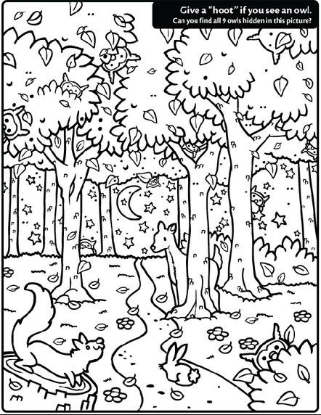

Wednesday Date ________

What part of a habitat includes all the living things in a given area?

A. Individual
B. Population
C. Community
D. Ecosystem

Thursday Date ________
All the living things plus all the non living things in an area is known as an -

A. Individual
B. Population
C. Community
D. Ecosystem

Friday Date _______

What is a major predator of the Snowshoe Hare?

A. Cheetah
B. Lynx
C. Lion
D. Tiger

