Name __________________ period _____
6th Grade Do Now
SCI.6.3D Relate the impact of research on scientific thought and society including the history of science and contributions of scientists as related to the content.
SCI.6.11A Describe the physical properties, locations, and movements of the Sun, planets, Galilean moons, meteors, asteroids, and comets.

Monday Date _______________

What object is in the center of our Solar System?

A. The Earth
B. The Moon
C. The Sun
D. The planet Jupiter

Tuesday Date _________________

Which scientist was instrumental in disproving the geocentric idea of the Solar System?

A. Ptolemy
B. Copernicus
C. Galileo
D. Newton

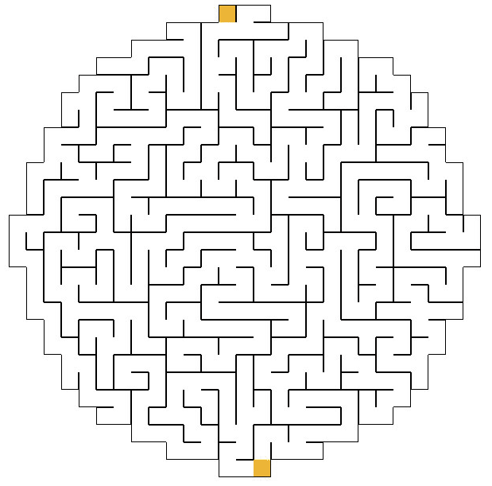

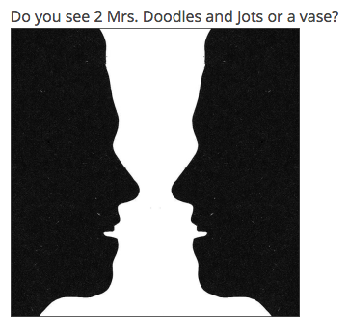

Wednesday Date _________

Name two layers of the Sun.

Thursday Date __________

Why is Pluto no longer considered a planet?

A. It is not in orbit around the Sun.
B. It is not round.
C. It has not cleared the neighborhood around its orbit.
D. It is too large.

Friday Date _________

Which two planets are closest to the Earth?

A. Jupiter and Saturn
B. Uranus and Saturn
C. Mercury and Mars
D. Venus and Mars

