Name __________________ period _____
6th Grade Do Now
SCI.6.11B Understand that gravity is the force that governs the motion of our solar system.
SCI.6.11C Describe the history and future of space exploration including the types of equipment and transportation needed for space travel.
Monday Date _______________

A student stands up with a book in her hand. Another student accidently bumps into her. The first student releases the book. The book falls to the floor. What scientific law explains why the book fell to the floor?

A. The Law of Conservation of Matter
B. The Law of Gravitation
C. The Law of Motion
D. Boyles’ Law

Tuesday Date _________________

In July of 1994 the comet Shoemaker-Levy 9 collided with the planet Jupiter, as scientists had predicted. To be able to accurately predict when a comet will collide with a plant, it is essential to understand -

A. The composition of a planet’s atmosphere
B. The gravitational attraction that exists between all bodies.
C. The attraction of opposite poles of a magnet to each other.
D. The formation of comets.

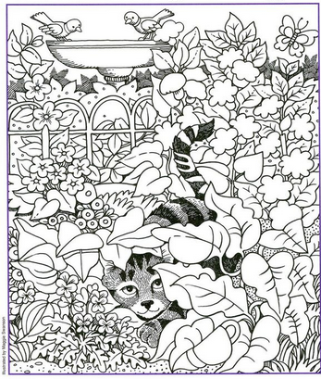

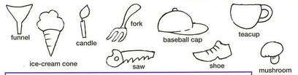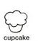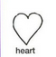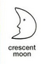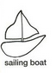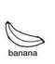

Wednesday Date ________

The diagram below models Mercury and Venus orbiting the sun.
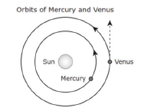
What force causes Venus to travel along a curved path instead of moving in a straight line as indicated by the dashed line in the diagram?

A. Electromagnetic attraction between the sun and Venus
B. Gravitational attraction between the sun and Venus
C. Electromagnetic attraction between Mercury and Venus
D. Gravitational attraction between Mercury and Venus
Thursday Date ___________
When did humans start identifying planets in the night sky?

A. Back in the 1960s
B. Back in the 1700s
C. Back in the 1600s
D. Back in ancient times.

Friday Date ______________
When did the first human walk on the moon?

A. We never have walked on the moon.
B. In 1969
C. In 1940
D. In 1550

