Name ___________________ period _____
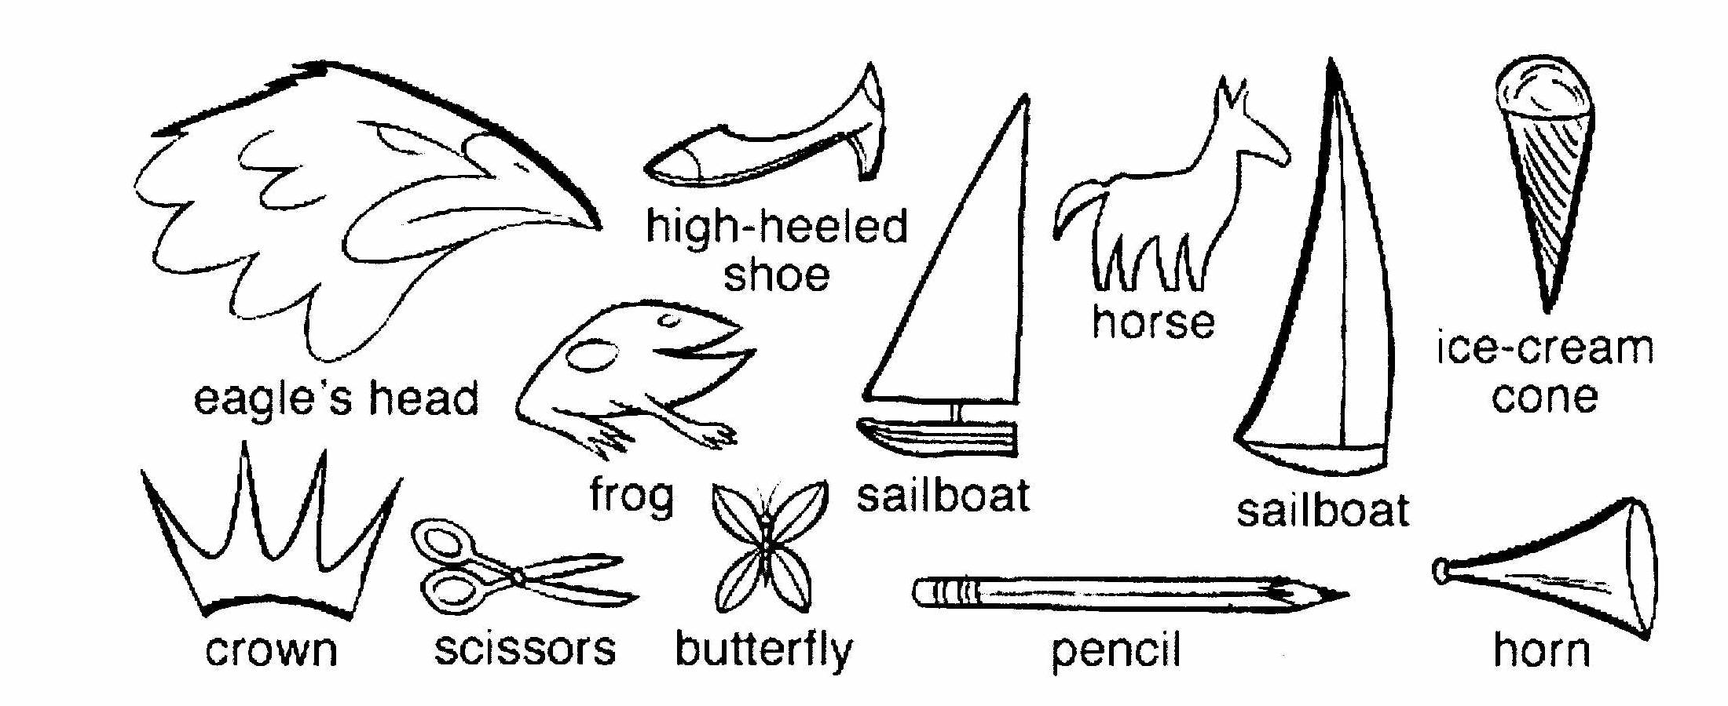
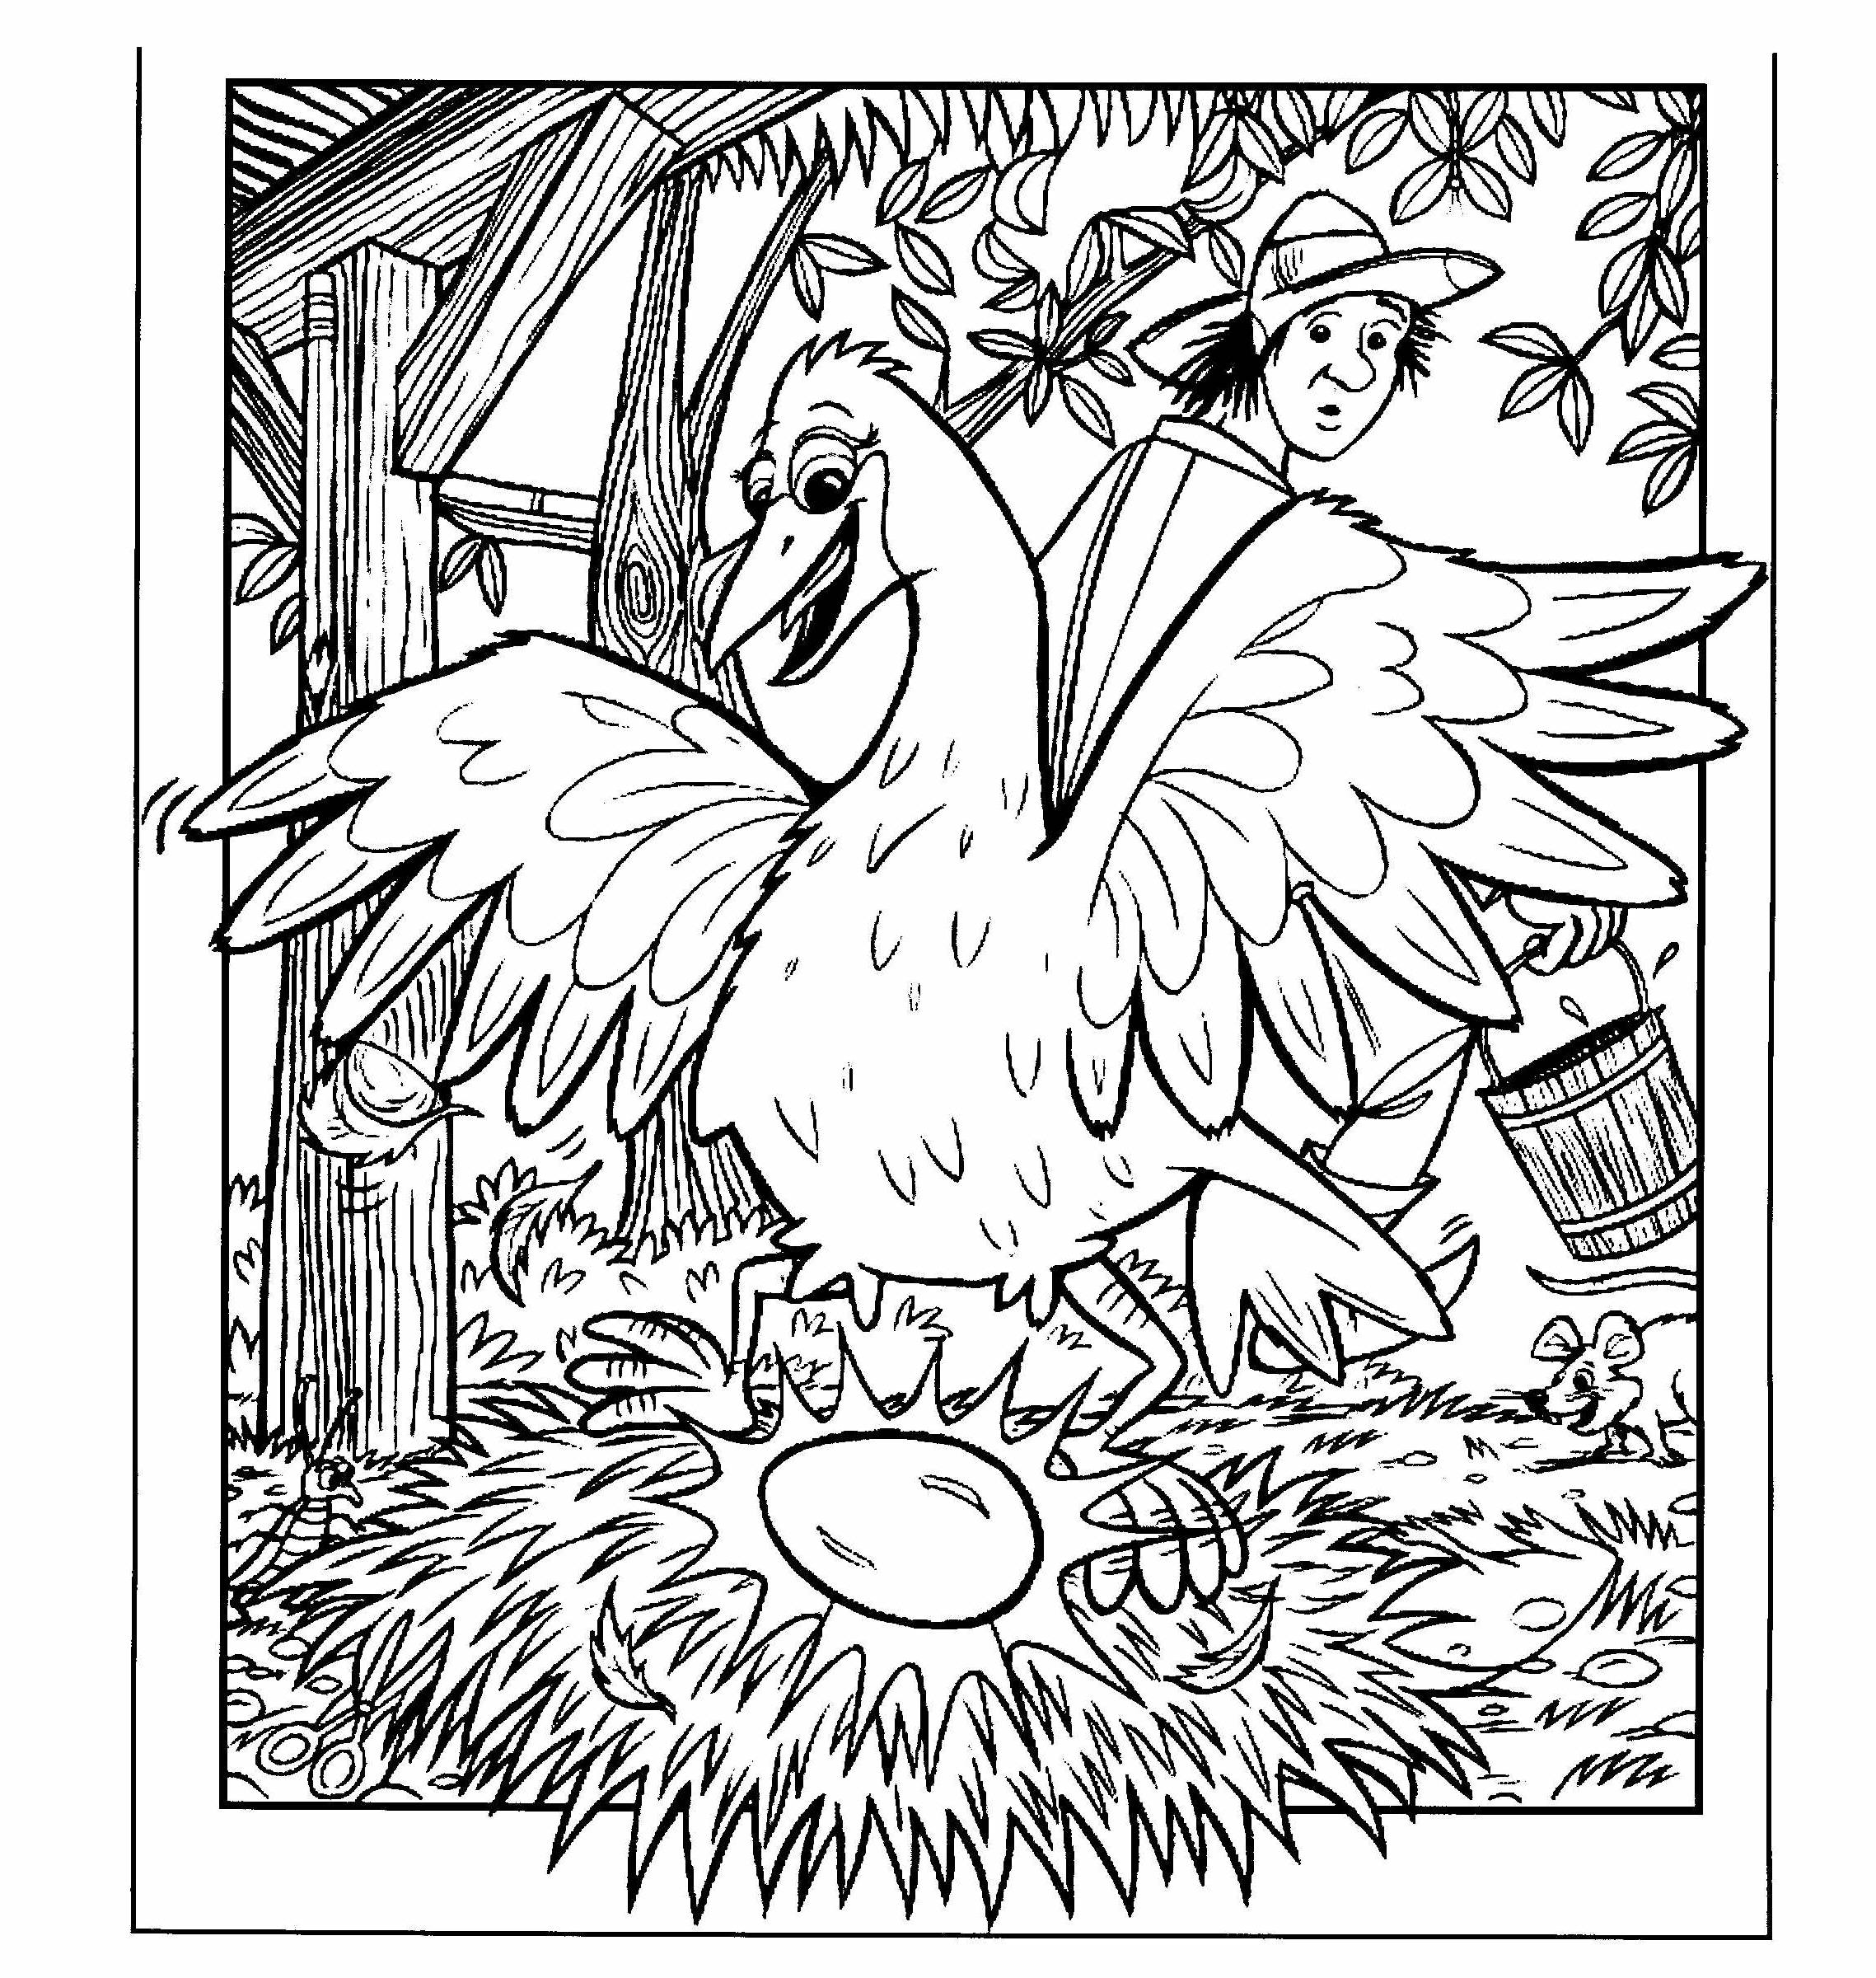
6th Grade DO NOW
6.12E Describe biotic and abiotic parts of an ecosystem in which organisms interact
Monday Date _____________
Match the word with its definition.

_____1. Ecosystem A. The living things that
are part of an ecosystem.

_____2. Biotic Factors B. The job of an organism
in an ecosystem

_____3. Abiotic Factors C. The home of an
organism in an ecosystem

_____4. Niche D. All the living and
non livings things in an
ecosystem

_____5. Habitat E. The non living that
are part of an ecosystem

Tuesday Date ___________

Word | Example
Ecosystem
Biotic Factor
Abiotic Factor
Niche
Habitat

Wednesday Date ______________
Word | NON- Example
Ecosystem
Biotic Factor
Abiotic Factor
Niche
Habitat

Thursday Date _______________
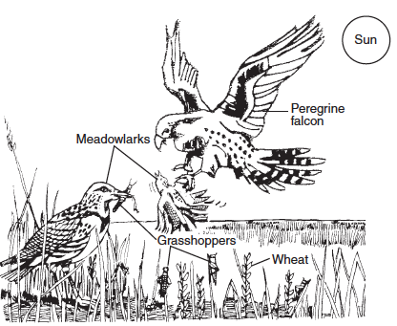
1. Name 3 biotic factors in this ecosystem.
_____________________________________________
2. Name 3 abiotic factors in this ecosystem.
____________________________________________
3. What is the habitat of the grasshoppers? __________
4. What is the niche of the Meadowlarks? __________

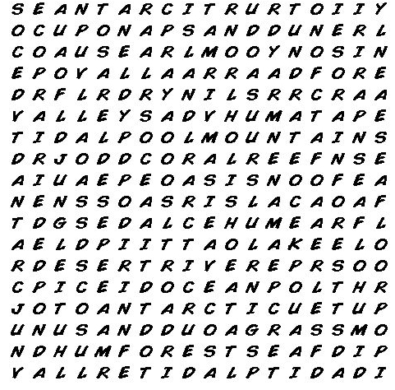

Friday Date _____________

Vocabulary | Draw It!
Niche

Biotic Factor

Abiotic Factor

Habitat

