SCI 6.1A Demonstrate safe practices during classroom and field investigations.
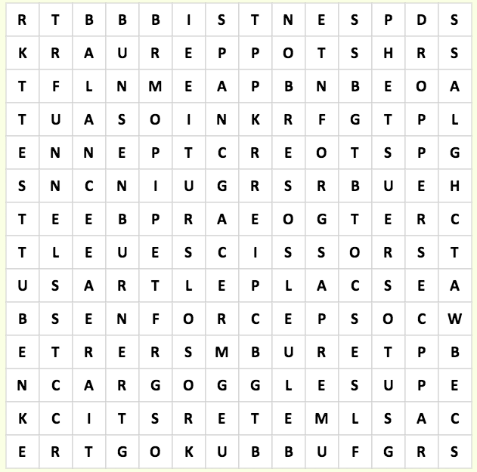
Name __________________ period _____
6th Grade Do Now
SCI 6.4 A Observe, collect, analyze and record information using tools.
SCI 6.4B Use preventative safety equipment
Monday Date _______________
Make three observations about the picture below.

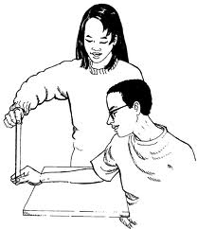

Tuesday Date _____________
Which of the following skills in NOT used in Teamwork?

A. Listening
B. Helping
C. Yelling
D. Sharing
Tongs Balance
Bunsen Burner Funnel
Microscope Stopper
Watch Glass Scalpel
Meter Stick Dropper
Goggles Probe
Test Tube Scissors
Forceps Beaker

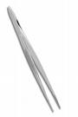
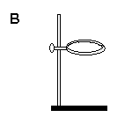
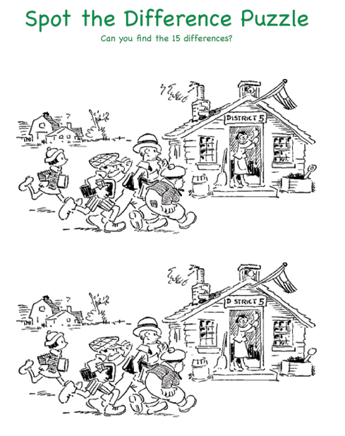
Wednesday Date __________

Which of the science equipment is shown?

A. Tongs
B. Ring Stand
C. Forceps
D. Test tube rack
Thursday Date __________

Which of the science equipment is shown?

A. Tongs
B. Ring Stand
C. Forceps
D. Test tube rack
Friday Date __________

David didn’t eat breakfast at home or in the school cafeteria. During science lab he became hungry. He ate a back of chips while the teacher wasn’t looking. What science safety rule did David break?

