Name __________________ period _____
6th Grade Do Now
SCI.6.5B Recognize that a limited number of the many known elements comprise the largest portion of solid Earth, living matter, oceans, and the atmosphere.
℗ SCI.6.6C Test the physical properties of minerals including hardness, color, luster, and streak

Monday Date _______________

What do you think the Earth is made of?

Tuesday Date _________________

What are rocks made of?

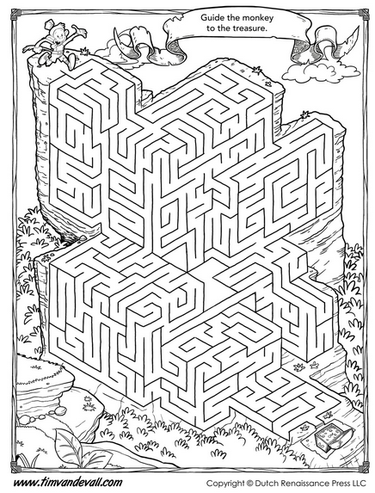

Wednesday Date ___________

Explain how do conduct a streak test.

Thursday Date ________

Name three physical properties of minerals.

Friday Date _________

What elements can be found in the Earth’s crust?

