Read each statement below. Mark whether you
agree (A) or disagree (D) with each statement. After completing the lesson, mark whether you agree or disagree with each statement. Under each statement, explain how the lesson gave evidence to support or change your ideas.

Before | After
 |  | 1. People have walked on the Moon
 |  | 2. People have walked on other planets.
 |  | 3. None of the planets are visible to the naked eye.
 |  | 4. All spacecraft can and will return to Earth.
 |  | 5. The Soviet Union sent the first person into space.
 |  | 6. No spacecraft has left the Solar System.

The History and Future of Space Exploration
Humans have always looked up into the night sky and dreamed about space.
In the latter half of the 20th century, rockets were developed that were powerful enough to overcome the force of gravity to reach orbital velocities, paving the way for space exploration to become a reality.
On Oct. 4, 1957, the Soviets launched the first artificial satellite, Sputnik 1, into space. Four years later on April 12, 1961, Russian Lt. Yuri Gagarin became the first human to orbit Earth in Vostok 1. His flight lasted 108 minutes, and Gagarin reached an altitude of 327 kilometers (about 202 miles).
The first U.S. satellite, Explorer 1, went into orbit on Jan. 31, 1958. In 1961, Alan Shepard became the first American to fly into space. On Feb. 20, 1962, John Glenn’s historic flight made him the first American to orbit Earth.
Modern space exploration is reaching areas once only dreamed about. Mars is focal point of modern space exploration, and manned Mars exploration is a long-term goal of the United States. NASA is on a journey to Mars, with a goal of sending humans to the Red Planet in the 2030s.
NASA and its partners have sent orbiters, landers, and rovers, increasing our knowledge about the planet. The Curiosity Rover has gathered radiation data to protect astronauts, and the MARS 2020 Rover will study the availability of oxygen and other Martian resources.

Materials: Space Events Cards

Questions:
1. In what decade did most events occur? _____________

2. What spacecraft left the Solar System? _____________

3. What country sent the first person into space?
___________________________________________

4. What planet did the rovers land on and explore? ______

5. What was the last planet to be discovered? __________
Why was it last? ____________________________

6. Go look at your agree and disagree statements. Follow the directions.
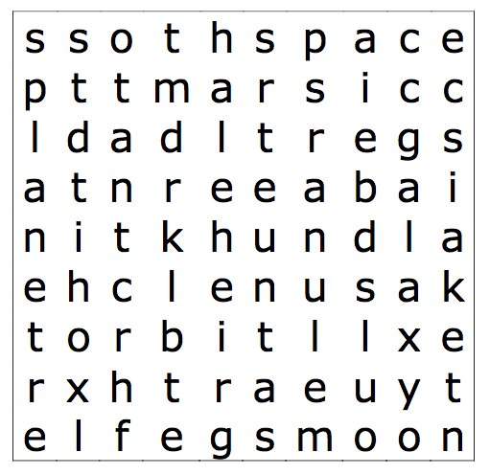

galaxy lunar rocket moon
mars orbit earth star
space planet

What To Do:
1. Spread out the Space Events Cards your teacher gives you.
2. Put them in chronological order.
3. Write the main idea of the event on the lines below.
Date | Space Event
Ancient times
1610
1781
1930
1957
1961
1963
1965
1967
1969
1970
1990
2003
2003
2003

Name __________________ period _____
Exit Ticket
History and Future of Space Exploration

1. Who was the first person in space?

A. Yuri Gagarin
B. John Glenn
C. Alan Shepard
D. Galileo

2. Which planet has been explored by rovers?

A. Uranus
B. Mars
C. Venus
D. Pluto

3. On what other planetary body has a human walked?

A. The sun
B. Mars
C. Venus
D. The moon

4. Which country sent the first woman into space?

A. France
B. United States
C. Soviet Union
D. China

Name __________________ period _____
Exit Ticket
History and Future of Space Exploration

1. Who was the first person in space?

A. Yuri Gagarin
B. John Glenn
C. Alan Shepard
D. Galileo

2. Which country sent the first woman into space?

A. France
B. United States
C. Soviet Union
D. China

3. On what other planetary body has a human walked?

A. The sun
B. Mars
C. Venus
D. The moon

4. Which planet has been explored by rovers?

A. Uranus
B. Mars
C. Venus
D. Pluto

