Space Events Cards

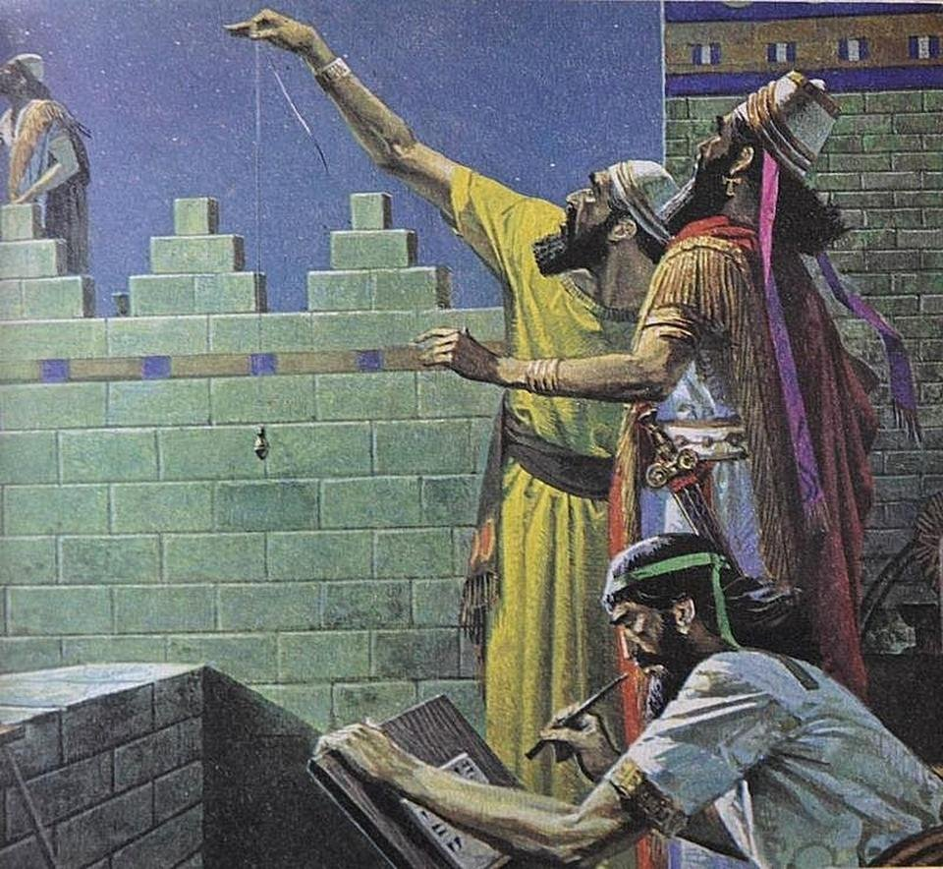  Ancient Babylonian astronomers identified the inner planets, Mercury and Venus during the 2nd millennium BCE. | 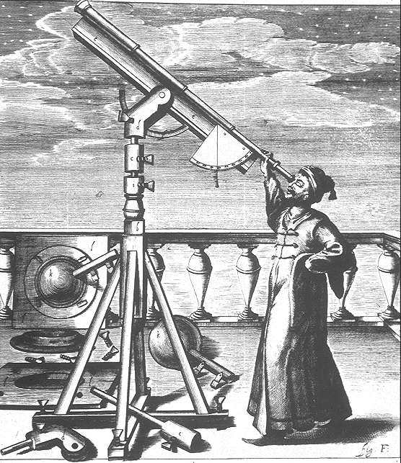  In 1610 Galileo used a telescope he built to identify the moons of Jupiter. | 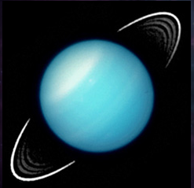  William Herschel discovered Uranus in 1781. It was the first planet to be discovered in more than 2000 years. It was the first planet to be discovered by a telescope.
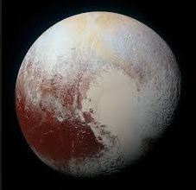  Pluto is a dwarf planet in the Kuiper belt. It was discovered by Clyde Tombaugh in 1930. | 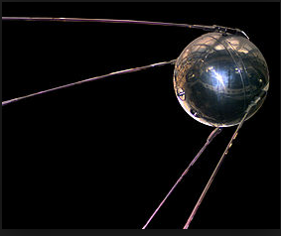  In 1957 the Soviet Union launched the world’s first artificial satellite, Sputnik 1. | 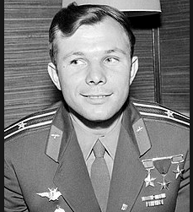  In 1961, aboard the spacecraft Vostok 1, Soviet cosmonaut Yuri Gagarin becomes the first human being to travel into space.

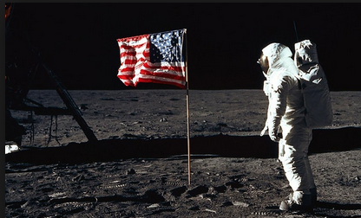  On July 20, 1969, Neil Armstrong became the first human to step on the moon. He and Buzz Aldrin walked around for three hours. | 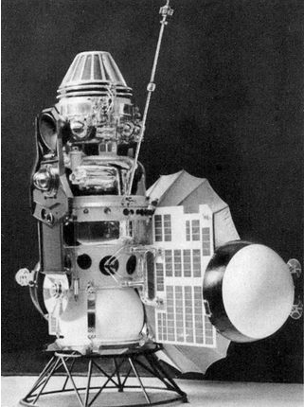  In 1970 the Soviet probe Venera 7 landed on Venus and became the first probe to transmit data back to Earth from another planet. | 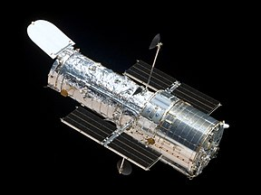  In 1990 the Hubble Space Telescope was launched into space aboard the Space Shuttle Discovery.
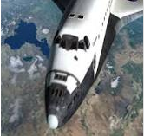  Seven astronauts were lost when the Space Shuttle Columbia broke up during reentry to the atmosphere. | 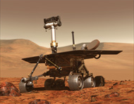  The Mars Rovers launched in 2003 and landed on Mars in 2004. Spirit lasted until 2010 and Opportunity lasted until 2018. | 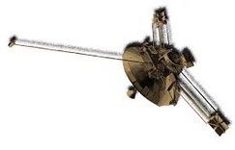  Pioneer 10 Spacecraft was launched on a mission to travel to the Asteroid belt. Its last signal was heard in 2003. It was the first spacecraft to leave the solar system.
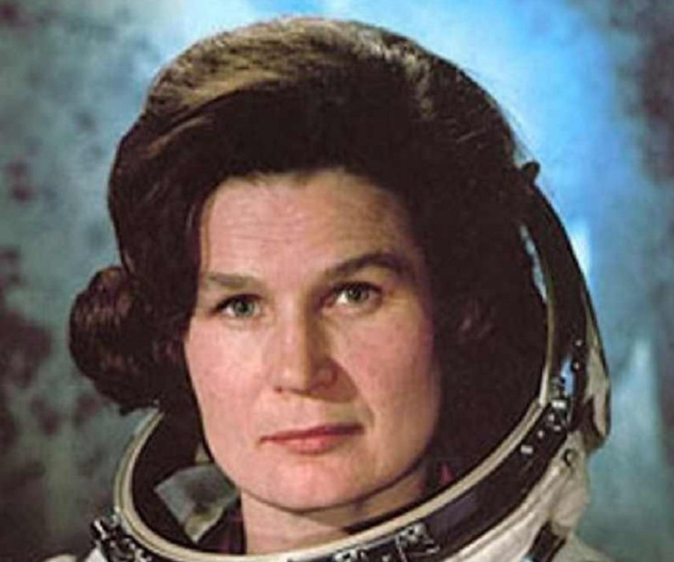  Soviet cosmonaut Valentina Tereshkova became the first woman to fly to space in 1963. | 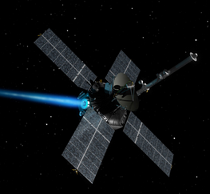  In 1965 Mariner 4 took the first close-up photos of Mars. | 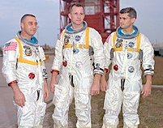  Three American astronauts were killed in 1967 when a cabin fire during a launch rehearsal test destroyed their Command Module.

