Reviewing Rulers

As we have learned length is a physical property of matter. To determine length we must use a ruler, yardstick or meter stick. When measuring with a ruler in science it is important to use the metric side of the ruler. Typically a ruler will have both standard (inches) and metric (centimeters) measurements. Millimeters are the smallest lines on the metric side. The unit is mm. Centimeters are the numbered lines on the metric side. This unit is cm. When using a ruler you must always start at the zero line so that your measurements will be accurate.
When measuring in the metric system we do not use fractions - we use decimals. So, one and a half centimeters becomes 1.5 cm.

Materials: metric rulers, meter sticks, colored pencils
What To Do:
1. Look at the drawing of a metric ruler below. The
centimeter lines are long and have a number below them.
2. Trace each of the centimeter lines with an orange
colored pencil.
3. The millimeter lines are the small ones between the
centimeter lines. The small space between the lines is
the millimeter.
4. Color one millimeter space in each centimeter with a
blue colored pencil. You will have 6 spaces colored
when you are finished.
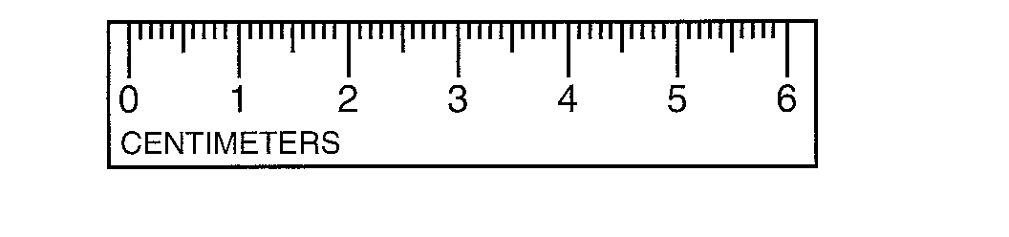

5. Measure each of the line segments below in millimeters and centimeters. Don’t forget to write the unit!

A.

________mm _______cm

B. ________ _______

C. ________ _______

6. Use the meter stick to measure the following items.
Don’t forget the units.

D. The length (long side) of your table top in cm._____

E. The width (short side) of your table top in cm.______

F. The height of your table in cm.___________

Questions:
1. How many centimeters are on your ruler? _______
2. How many millimeters are on your ruler? _______
3. How many centimeters are on the meter stick? ____
4. How many millimeters are on the meter stick? ___

Your teacher will show you a video titled Length called Elementary Video Adventures – Measurement and Scale from www.missdoctorbailer.com.

Match the terms from the video with their definitions.

1. Mile |  | Distance from nose to fingertip
2. Cubit |  | Developed the metric system
3. Foot |  | Derived from the distance from pole to equator
4. Yard |  | 1000 paces
5. French |  | Both a unit of length and weight
6. Meter |  | Now based on the speed of light
7. Length |  | Distance between elbow to finger tip

1. Read the values on the metric ruler below.

2. Write the measurement on the lines below.
3. Don’t forget to use decimals and write your units.
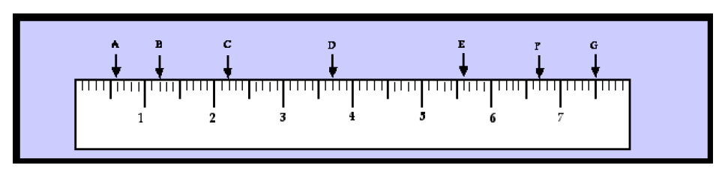

A.
B.
C.
D.
E.
F.
G.

4. What is the length of the screw pictured below in cm and in mm? _________ cm ________mm

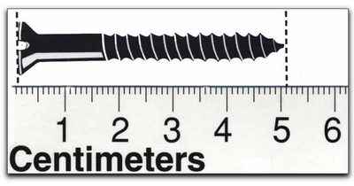

Name _____________ period _____
Exit Ticket
Reviewing Rulers

1. What is wrong with this measurement? 5 ½ cm
_________________________________________

2. What is wrong with this measurement? 10
________________________________________

Conclusion: (unit, decimals, standard, centimeter, large, fractions, metric, small, millimeter

Rulers have both _________ and __________ units on them. The units we use in the metric system for length are ___________ and __________. The centimeter is the ______ unit while the millimeter is the ________ unit. In the metric system __________ are not used but ___________ are used to write the measurement. After measuring it is important to write the correct __________ beside the number.
28

Name _____________ period _____

Exit Ticket
Reviewing Rulers

1. What is wrong with this measurement? 5 ½ cm
_________________________________________

2. What is wrong with this measurement? 10
________________________________________

Conclusion: (unit, decimals, standard, centimeter, large, fractions, metric, small, millimeter

Rulers have both _________ and __________ units on them. The units we use in the metric system for length are ___________ and __________. The centimeter is the ______ unit while the millimeter is the ________ unit. In the metric system __________ are not used but ___________ are used to write the measurement. After measuring it is important to write the correct __________ beside the number.
28

