Learning About Pulleys

When you raise or lower a flag on a flagpole or open and close window blinds you are using a simple machine known as a pulley. A pulley is a grooved wheel with a rope or chain wrapped around it. You use a pulley by pulling on the rope. Typically, a fixed pulley is attached to the ceiling above the objects to be moved. Fixed pulleys help us by changing the direction of the applied force.

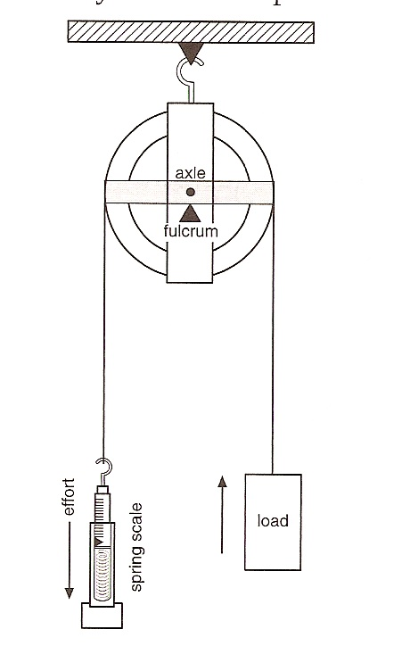
Using a Pulley

Materials: ring stand with ring, pulley tied to the ring ,spring scale, hooked mass, block of wood, ring from ring stand, string, paperclip hook

What To Do:
1. Use the spring scale to determine the weight of the mass in Newtons. Record in the chart below.
2. Place the string over the fixed pulley.
3. Attach the spring scale to one end of the string.
4. Attach the hooked mass to the other end of the string.
5. Be careful to pull the spring scale straight down – not to the side.
6. Measure the force needed to lift the hooked mass.
7. Record it in the chart below.
8. Do the same with the block of wood and the ring.

Object | Force needed to lift the object by itself (N) | Force needed to lift the object with the pulley (N)
Hooked Mass
Block of Wood
Ring from ring stand

Questions:
1. What is the difference between the force needed to lift
the object by itself and the force need to lift with the pulley?

- 10 Newtons
- 5 Newtons
- There was some but not a lot of difference.

2. How did the pulley help to move the object? (circle one)

- It reduced the effort.
- It changed the direction of the effort.
- It doubled the effort

3. The rule of pulleys says that a fixed pulley only changes the direction of the effort. It does not reduce the effort. Why do you think there was some difference in your measurements?

_____________________________________________

Watch the BrainPop video Pulleys.

Name 4 items Moby picked up with a pulley.
________________ ____________
________________ ____________
Watch the Pulley video from www.missdoctorbailer.com

1. Label the names of the following pulleys:

Block and Tackle Fixed Pulley Moveable Pulley

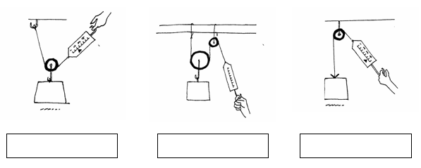

2. Label the load and effort in each picture above.

3. How does a moveable pulley help you? (circle one)

- It only changes the direction of the effort.
- It reduces the effort by ½.
- It doubles the effort.

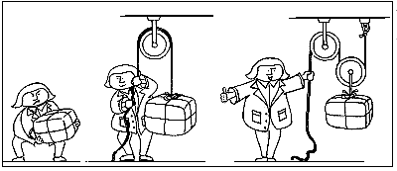

Use your knowledge of how pulleys help you to write a paragraph explaining what is happening in the picture above.

Name ____________________ period _____

EXIT TICKET
Learning About Pulleys

1. Circle the pulley.
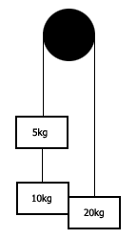
2. Draw an arrow that shows which direction the boxes will move if they are not held in place.

Conclusion: (grooved, direction, effort, string)

A pulley is a simple machine with a __________ wheel and a _________ wrapped around it. Pulleys by themselves help us by changing the ____________ of the __________.

Name __________________ period _____

EXIT TICKET
Learning About Pulleys

1. Circle the pulley.

2. Draw an arrow that shows which direction the boxes will move if they are not held in place.

Conclusion: (grooved, direction, effort, string)

A pulley is a simple machine with a __________ wheel and a _________ wrapped around it. Pulleys by themselves help us by changing the ____________ of the __________.

