More Physical Properties of Minerals
We have learned about the physical property of hardness to identify minerals. There are several other properties that can help to identify minerals. Color describes the dominant color of a mineral. Texture is the way a mineral feels. Descriptive words to use would be smooth or rough. Luster is the way a mineral reflects light from its surface. A metallic luster is shiny like aluminum foil. A non-metallic luster is not shiny and most are considered dull. If the mineral does not have a metallic luster then it should be considered to have a non-metallic luster.
Streak is the color of the mineral’s powder. When you scratch the mineral across a porcelain streak plate it leaves a powder. Many times the powder is the same color as the mineral but there are several minerals, like pyrite, that have a very different color.

Materials: Mineral set, streak plate
What To Do:

1. For each of the minerals in the mineral set you should determine the color, texture and luster.
2. Place the information in the data table on the next page.
3. Use the streak plate to find out the color of the mineral’s powder by following the instructions below.

a. Place the streak plate flat on the table.
b. Find a sharp corner of the mineral and firmly run it
across the streak plate one time.
c. Observe the color of the powder and record it in the
data table.

Mineral | Color | Texture | Luster | Streak
1. Fluorite
2. Feldspar
3. Hematite
4. Pyrite
5. Milky Quartz
6. Calcite
7. Muscovite Mica
8. Magnetite
9. Magnetite
10. Talc
11. Pyrolusite
12. Biotite Mica
13. Graphite
14. Gypsum: Satin Spar
15. Gypsum Selenite

Questions:
1. Which minerals had a metallic luster? ________
__________________________________________
2. Which minerals had a smooth texture? ________
_________________________________________
3. Which minerals had a different color streak that the color of the mineral? _____________________

4. Which mineral did you like the best? ________
Why? ____________________________________

Watch the BrainPop video Mineral Identification and summarize your learning by completing the 3-2-1 summary questions below. If you don’t have access to BrainPop use the Mineral Identification video from www.missdoctorbailer.com

Write 3 things you already knew from the video.

_________________________________________
_________________________________________
_________________________________________
_________________________________________

Write 2 things you learned from the video.

_________________________________________
_________________________________________
_________________________________________

Write one question you still have about minerals.

_________________________________________
_________________________________________

Physical Properties of Minerals 2

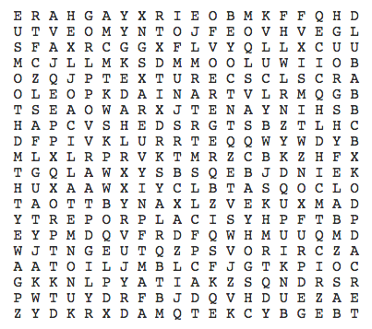

Color Dull
Luster Nonmetallic
Metallic Rough
Smooth Streak
Streak Plate Texture
Physical Property Shiny

Name ________________________ period _____

EXIT TICKET
More Physical Properties of Minerals

Match the physical property with its description below.

 | 1. Luster |  | a. the powder color of the mineral.
 | 2. Texture |  | b. tested with a nail or penny
 | 3. Hardness |  | c. how shiny or dull a mineral is
 | 4. Streak |  | d. how a mineral feels

5. How are gold and pyrite similar?
A. Both have the same streak color
B. Both are very soft
C. Both are gold in color
D. Both have a dull luster

Name ___________________ period _____

EXIT TICKET
More Physical Properties of Minerals

Match the physical property with its description below.

 | 1. Luster |  | a. the powder color of the mineral.
 | 2. Texture |  | b. tested with a nail or penny
 | 3. Hardness |  | c. how shiny or dull a mineral is
 | 4. Streak |  | d. how a mineral feels

5. How are gold and pyrite similar?
A. Both have the same streak color
B. Both are very soft
C. Both are gold in color
D. Both have a dull luster

