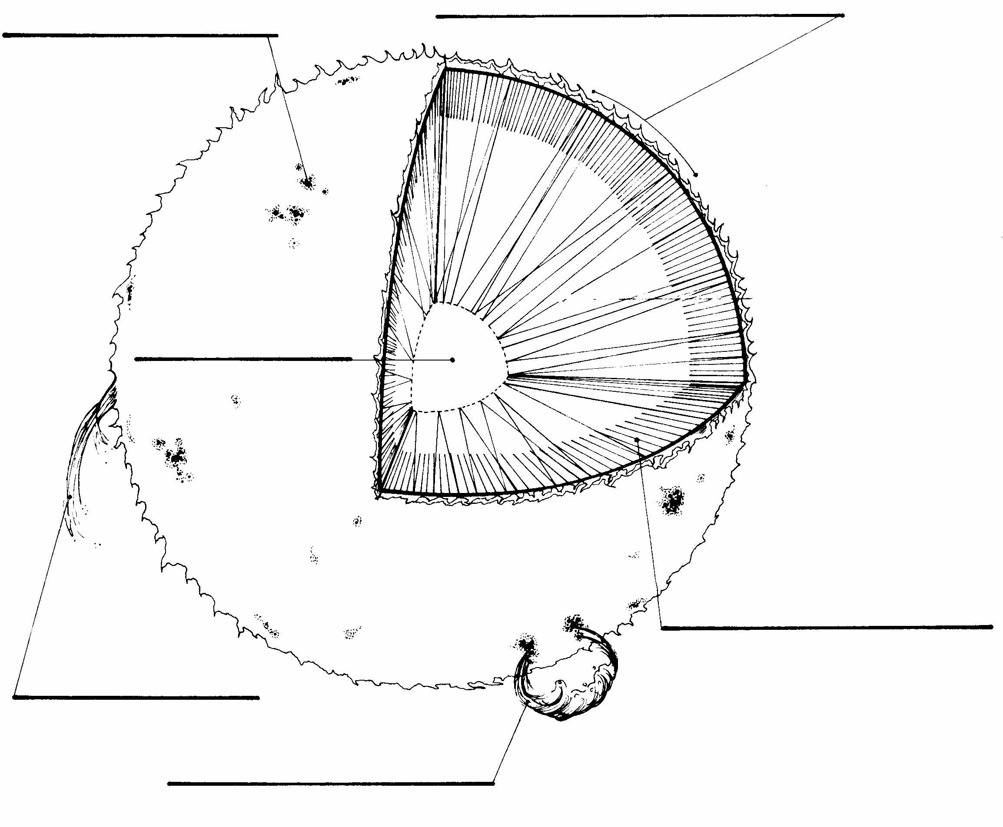
Our Closest Star – The Sun

The sun’s gravity is the most powerful force in the solar system. It is strong enough to hold all the planets, comets and asteroids in orbit. The sun has an interior that is like a giant furnace. The sun’s energy comes from nuclear fusion.

1. The temperature inside the Sun’s core, or center, reaches 15 million ºC. Color the core red.

2. The inner layer of the of the sun’s atmosphere is called the photosphere. Color the photosphere orange.

3. The chromosphere is the outer layer of the sun’s atmosphere. Color it yellow.

4. Sunspots look like small dark areas on the sun. They can be as large as the earth. Sunspots are cooler than the rest of the sun’s atmosphere. Circle the sunspots in purple.

5. Sunspots usually occur in the pairs or groups. Reddish loops of gas called prominences link different parts of sunspot regions. Color the prominence red.

6. Sometimes the area around the sunspot releases a large amount of energy. These explosions are known as solar flares. Color the solar flare orange.

7. Label each line with the correct name.

Watch the video “What Are Solar Flares” from www.missdoctorbailer.com

Circle the science words found in the diagram during the video.

What will happen to our Sun?

Stars go through stages in their lives, just like people. We say that stars are born, go through life and die. When our Sun was born 5.2 billion years ago it was just a cloud of gas and dust called a stellar nebula. It was very cold. After about 5 billion years it became hot enough and dense enough for nuclear reactions to take place and became a medium size yellow star. Our Sun will continue to burn for about 5 billion more years. Then the Sun will gradually get bigger and become a Red Giant. After about 6 billion more years the Sun will change again. It will explode into a planetary nebula. (Planetary Nebulas do not have anything to do with planets!) After about another 7 billion years all the material in the planetary nebula will collapse on itself and form a white dwarf.

Materials: Colored Pencils
What To Do:
1. Label and color the diagram below.
2. Watch the power point to double-check your work.

Life Cycle of Our Star

What About Black Holes?

American physicist J.A. Wheeler first coined the term “black hole” in 1967. Stellar black holes are the result of massive stars dying. A massive star is at least 8-10 times our Sun’s mass. Inside a star, gravity tries to pull matter closer together. While a star is glowing, it is consuming its fuel through a nuclear process known as fusion. It radiates not only light, but heat as well. The pressure of the heated gases pushing outward balances the force of gravity pulling inward. Once the star’s nuclear fuel has been used up, the star becomes unstable and the core implodes causing the outer shell to explode in a supernova. No matter what the size of a black hole, they all share a common characteristic; not even light can escape their gravitational pull.

Cut out the five pieces your teacher gives you. Paste the pieces together in the space below in order to see the completed picture. Color your picture from the power point slide your teacher shows you.

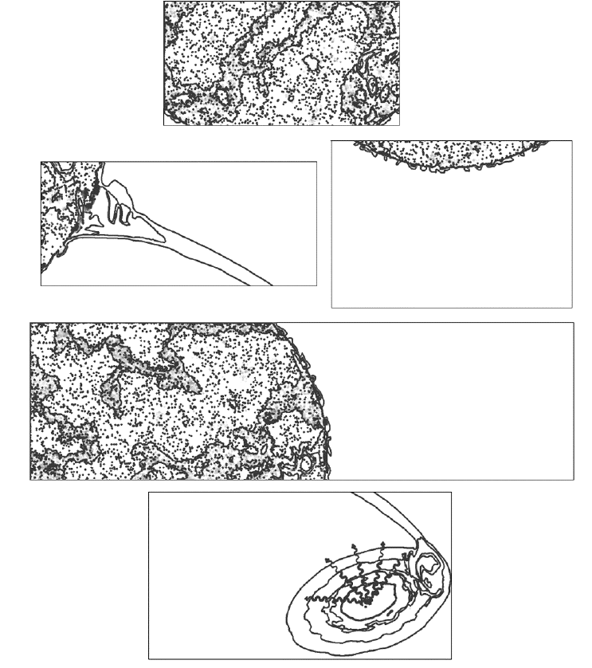
Top Piece

Top Piece

Name _________________ period _____
EXIT TICKET
Our Closest Star - The Sun

1. Which of the following words does not belong in the system of the sun?

Sunspot Chomosphere
Prominence Yellow Dwarf
Photosphere Solar Flare

2. Which of the following words does not belong in the life cycle of our sun?

Stellar Nebula White Dwarf
Medium Yellow Star Red Giant
Neutron Star Planetary Nebula

Conclusion: (Sun, white dwarf, black holes, nuclear fusion, medium yellow)
The _________ is the center of the solar system.
The sun’s power comes from __________ ________.
Our Sun is considered a _______ _______ star. It will eventually become a ________ ________ star. Massive stars will eventually become _______ _______.

Name _________________ period _____
EXIT TICKET
Our Closest Star - The Sun

1. Which of the following words does not belong in the system of the sun?

Sunspot Chomosphere
Prominence Yellow Dwarf
Photosphere Solar Flare

2. Which of the following words does not belong in the life cycle of our sun?

Stellar Nebula White Dwarf
Medium Yellow Star Red Giant
Neutron Star Planetary Nebula

Conclusion: (Sun, white dwarf, black holes, nuclear fusion, medium yellow)
The _________ is the center of the solar system.
The sun’s power comes from __________ ________.
Our Sun is considered a _______ _______ star. It will eventually become a ________ ________ star. Massive stars will eventually become _______ _______.

