Exploring Six Kingdoms

Scientists have identified at least 1.7 million kinds of organisms on Earth. This number includes all forms of life, from bacteria to plants and animals. You should remember that all living things contain at least one cell. There are so many organisms that it is important for biologists to have the living things organized into groups so they can keep track of them. Classification is the process of grouping things based on their shared traits. Biologists use classification to organize living things into groups so that the organisms are easier to study. The highest rank of classification is called a Domain. There are three Domains – Archaea, Bacteria and Eukaryotes. Both the Archaea and the Bacteria are prokaryotes and do not have nuclei while all the rest of the kingdoms are Eukaryotes and have a nucleus.
The next highest rank of classification is the Kingdom. Scientists classify all organisms into six kingdoms. The six kingdoms of organisms are archaebacteria, eubacteria, protists, fungi, plants and animals. An organism is classified into a particular kingdom based on specific characteristics. They include the type of cells found in the organism, whether the organism is unicellular (one cell) or multicellular (many cells) and how the organism gets its food. While the organisms within a kingdom vary greatly, members of a kingdom share those characteristics.

Archaea, Bacteria and Protist Kingdoms
Materials:
3 Kingdoms presentation from missdoctorbailer.com

What To Do:

1. Draw and color the slides from the presentation.
2. Be sure to write the name of each organism and magnification used below the drawing.

Archaebacteria | Archaebacteria
Slide #1  ______________ | Slide #2  ______________

Eubacteria | Eubacteria
Slide #1  ______________ | Slide #2  ______________

Protist | Protist
Slide #1  ______________ | Slide #2  ______________

Questions:
1. How are cells of these three kingdoms alike? _____________________________________
2. How are the cells of these three kingdoms different? _________________________________________
Fungi Kingdom

Materials: mushrooms
What To Do:
1. Observe the mushroom your teacher provides.
2. Use the picture below to identify all its structures.
3. Draw your own mushroom in the box provided.
Fungi | Fungi
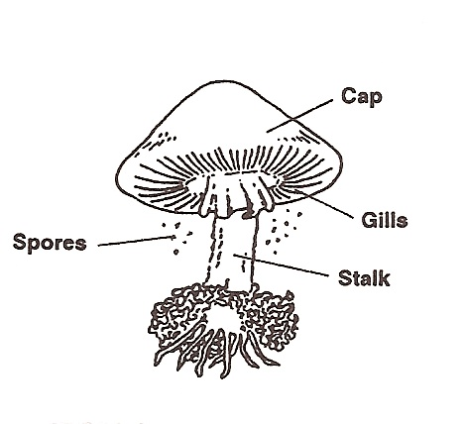

Plant and Animal Kingdoms
What To Do:
1. Your teacher will take you outside to walk around the campus.
2. Count how many of each type of plant or animal you observe on your walk.

Plants | How many? |  | Animals | How many?
Trees (one trunk) |  |  | Birds
Bushes (many trunks) |  |  | Dogs
Flowers |  |  | Ants
Grasses |  |  | Butterflies

What To Do:
1. Classify the list of animals below by their skin covering.
Fish Crocodile Salamander Newt
Ostrich Penguin Flamingo Snake
Elephant Whale Lizard Duck
Alligator Humans Panda Frog

Skin | Scales | Fur | Feathers

Questions:
1. What other characteristics could you use to classify these animals? ________________________________
2. Are the members of the Fungi, Plant and Animal Kingdoms one celled or multicellular? _____________________________________________

Name _______________ period _____
EXIT TICKET
Exploring Six Kingdoms

1. The highest rank in classification is the –

A. Kingdom
B. Order
C. Domain
D. Genus

2. Biologists classify all living things into ___ Kingdoms.

A. Five
B. Six
C. Three
D. Seven

3. What is NOT found in the cells of bacteria?

A. cytoplasm
B. cell membrane
C. nucleus
D. nuclear material

4. Plants are different from Protists because –

A. Plants have only one cell
B. Protists have a nucleus
C. Protists are multicellular
D. Plants are multicellular

Name _______________ period _____
EXIT TICKET
Exploring Six Kingdoms
1. What is NOT found in the cells of bacteria?

A. cytoplasm
B. cell membrane
C. nucleus
D. nuclear material

2. Plants are different from Protists because –

A. Most plants have only one cell
B. Protists have a nucleus
C. Most protists are multicellular
D. Plants are multicellular

3. The highest rank in classification is the –

A. Kingdom
B. Order
C. Domain
D. Genus

4. Biologists classify all living things into ___
Kingdoms.

A. Five
B. Six
C. Three
D. Seven

