Exploring Our Solar System

You probably learned we had nine planets in our Solar System. Now we have only eight! What happened? Astronomers from all over the world had a meeting to decide on the definition of a planet. When they were finished Pluto was no longer considered to be a planet. It is now called a dwarf planet. Watch the Space School - Pluto video from www.missdoctorbailer.com to find out more about Pluto and its reclassification from planet to dwarf planet.
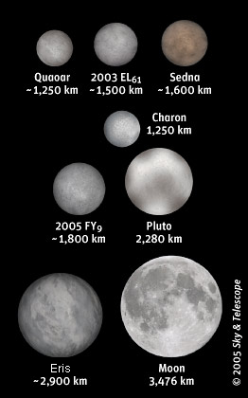
Questions:
1. Circle the rule or rules that
Pluto broke.

- Is in orbit around the Sun
- Has sufficient mass to assume a nearly round shape
- Has cleared the neighborhood around its orbit.

2. Look at the picture above. These are dwarf planets
compared to our moon. How does Pluto’s size compare to
our moon? ______________________________________

3. Which of these dwarf planets is larger than Pluto? _____

4. Do you think Pluto should be reclassified as a planet? __

5. If so, what would you do with Eris? ________________

Remembering the order of the planets

How do you remember the order of the planets from the Sun to the outer planets? You may have learned the sentence:
My Very Educated Mother Just Served Us Nachos where the first letter of each word is the first letter of the name of each planet as you leave the Solar System. What if astronomers decide to include Pluto and Eris as planets?

Make up a new sentence to help you remember the order.

Mercury
Venus
Earth
Mars
Jupiter
Saturn
Uranus
Neptune
Pluto
Eris

Materials: Solar system booklet, scissors, construction paper, glue, colored pencils, Planetary Facts Sheet

What To Do:
1. Make the Solar System Booklet as your teacher directs.
2. Make corrections about Pluto and color the pictures from the reading.
3. Use this booklet and the Planetary Facts Sheet to fill out the information on the next two pages.

Mercury

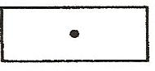
Distance from the Sun _____________
Density ___________________
Time to Orbit the Sun _______________
Fascinating Fact ______________________________
_____________________________________________

Venus

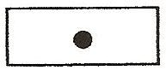
Distance from the Sun _____________
Density ___________________
Time to Orbit the Sun _______________
Fascinating Fact ______________________________
_____________________________________________

Earth

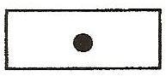
Distance from the Sun _____________
Density ___________________
Time to Orbit the Sun _______________
Fascinating Fact ______________________________
_____________________________________________
_____________________________________________

Mars

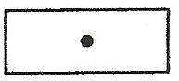
Distance from the Sun _______________
Density ___________________
Time to Orbit the Sun _______________
Fascinating Fact ______________________________
_____________________________________________

Jupiter
Distance from the Sun
______________________
Density ___________
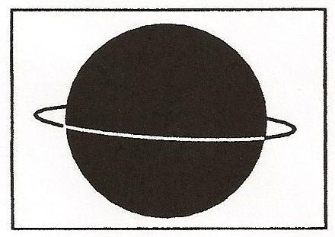
Time to Orbit the Sun _______________

Fascinating Fact_______________________________
_____________________________________________

Saturn
Distance from the Sun
____________________
Density ______
Time to Orbit the Sun
_______________
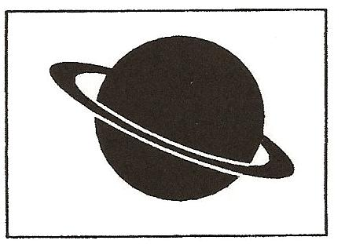
Fascinating Fact_______________________________
_____________________________________________

Uranus
Distance from the Sun
____________________
Density ________
Time to Orbit the Sun
_______________
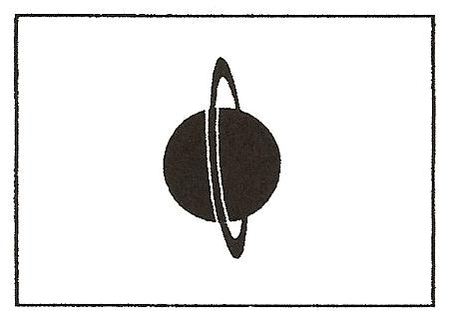
Fascinating Fact ______________________________
_____________________________________________

Neptune
Distance from the Sun
____________________
Density _________
Time to Orbit the Sun ________
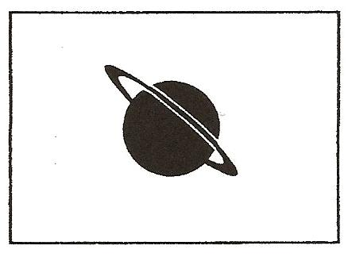
Fascinating Fact ______________________________
_____________________________________________

Name _______________ period _____
EXIT TICKET
Exploring Our Solar System
1. Which two planets are similar in size?

A. Earth and Venus
B. Earth and Uranus
C. Jupiter and Saturn
D. Mercury and Saturn

2. Which two planets are the most different in size?

A. Earth and Venus
B. Mercury and Mars
C. Jupiter and Saturn
D. Jupiter and Mercury

3. Which planet has rings?

A. Mercury
B. Earth
C. Saturn
D. Mars

4. Which planet takes the shortest time to orbit the Sun?

A. Mercury
B. Venus
C. Earth
D. Mars

5. What is Pluto called now?

A. Planet
B. Moon
C. Dwarf Planet
D. Dwarf Moon
Name _______________ period _____

EXIT TICKET
Exploring Our Solar System
1. Which two planets are similar in size?

A. Earth and Venus
B. Earth and Uranus
C. Jupiter and Saturn
D. Mercury and Saturn

2. Which two planets are the most different in size?

A. Earth and Venus
B. Mercury and Mars
C. Jupiter and Saturn
D. Jupiter and Mercury

3. Which planet has rings?

A. Mercury
B. Earth
C. Saturn
D. Mars

4. Which planet takes the shortest time to orbit the Sun?

A. Mercury
B. Venus
C. Earth
D. Mars

5. What is Pluto called now?

A. Planet
B. Moon
C. Dwarf Planet
D. Dwarf Moon

