Facts about the Earth

There are many interesting facts about the Earth. One is that it is the third planet from the Sun in our Solar System. Other facts about our planet are: it has an abundance of liquid water, it is the only planet in our Solar System to have life and it has a rocky composition. You may remember that the earth has a number of layers and the top layer is called the crust. There are many elements that make up the Earth’s crust but there are eight that are the most abundant.
Of course all of the elements that make up the Earth’s crust are found on the Periodic Table of Elements. The earth’s crust is made mostly of Oxygen – 46% and Silicon – 28%. It also has 8% Aluminum, 6% Iron and 4% Magnesium. There is a little Calcium – 2.5% and Potassium – 2.3%. About 3.2% of the Earth’s crust is made up of small amounts of all the other elements.

Materials: Colored pencils
What To Do:
1. Find each of the following elements on the Periodic Table on the next page and color them the listed color.

Oxygen – yellow
Silicon – orange
Aluminum – purple
Iron – red
Magnesium- blue
Calcium – green
Potassium - pink

Questions:
1. How many of these elements are metals? _____
2. How many of these elements are metalloids? _____
3. How many of these elements are nonmetals? _____
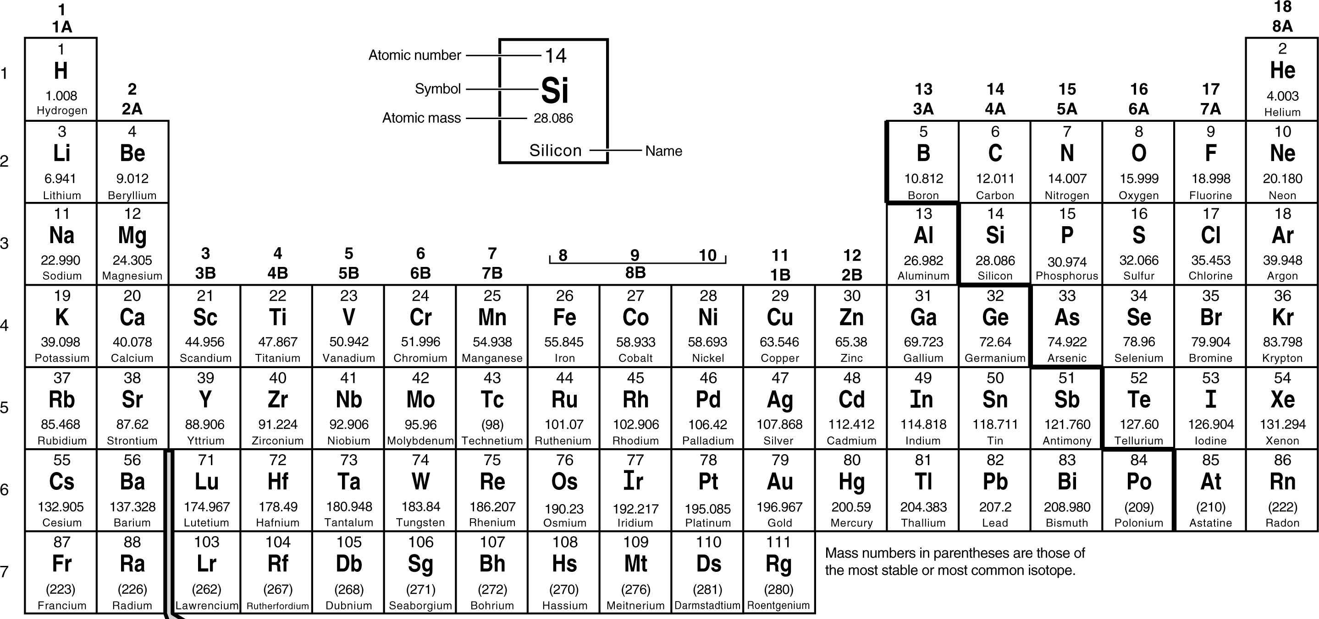
Periodic Table of Elements

Materials: Periodic Table, colored pencils
What To Do:
1. Fill in the data table below with the elements and their percentages that were given in the paragraph on the first page.
2. Use the Periodic Table to find each element’s symbol.
3. Make a bar graph of the elements found in the Earth’s Crust.

Element | Symbol | Percent

Questions:
1. Which three elements are the most abundant in the earth’s crust? _______________________
2. Which element is the least abundant in the earth’s crust? __________________________
3. What are the rules for writing the symbols for elements? _____________________________________________________________________________________________

Name ______________ period _____

EXIT TICKET
Facts about the Earth

1. What does the word abundant mean?

A. not having enough of something
B. having a great deal of something
C. having too much of something

2. Which of the following is NOT an abundant element
found in the Earth’s crust?

A. Silicon
B. Oxygen
C. Helium

3. Which of the following symbols for Oxygen is written
correctly?

A. o
B. O
C. OX

4. Which of the following symbols for Silicon is written
correctly?

A. si
B. sI
C. Si

Name ______________ period _____

EXIT TICKET
Facts about the Earth
1. What does the word abundant mean?

A. not having enough of something
B. having a great deal of something
C. having too much of something

2. Which of the following is NOT an abundant
element found in the Earth’s crust?

A. Silicon
B. Oxygen
C. Helium

3. Which of the following symbols for Oxygen is
written correctly?

A. o
B. O
C. OX

4. Which of the following symbols for Silicon is
written correctly?

A. si
B. sI
C. Si

