Using the Microscope

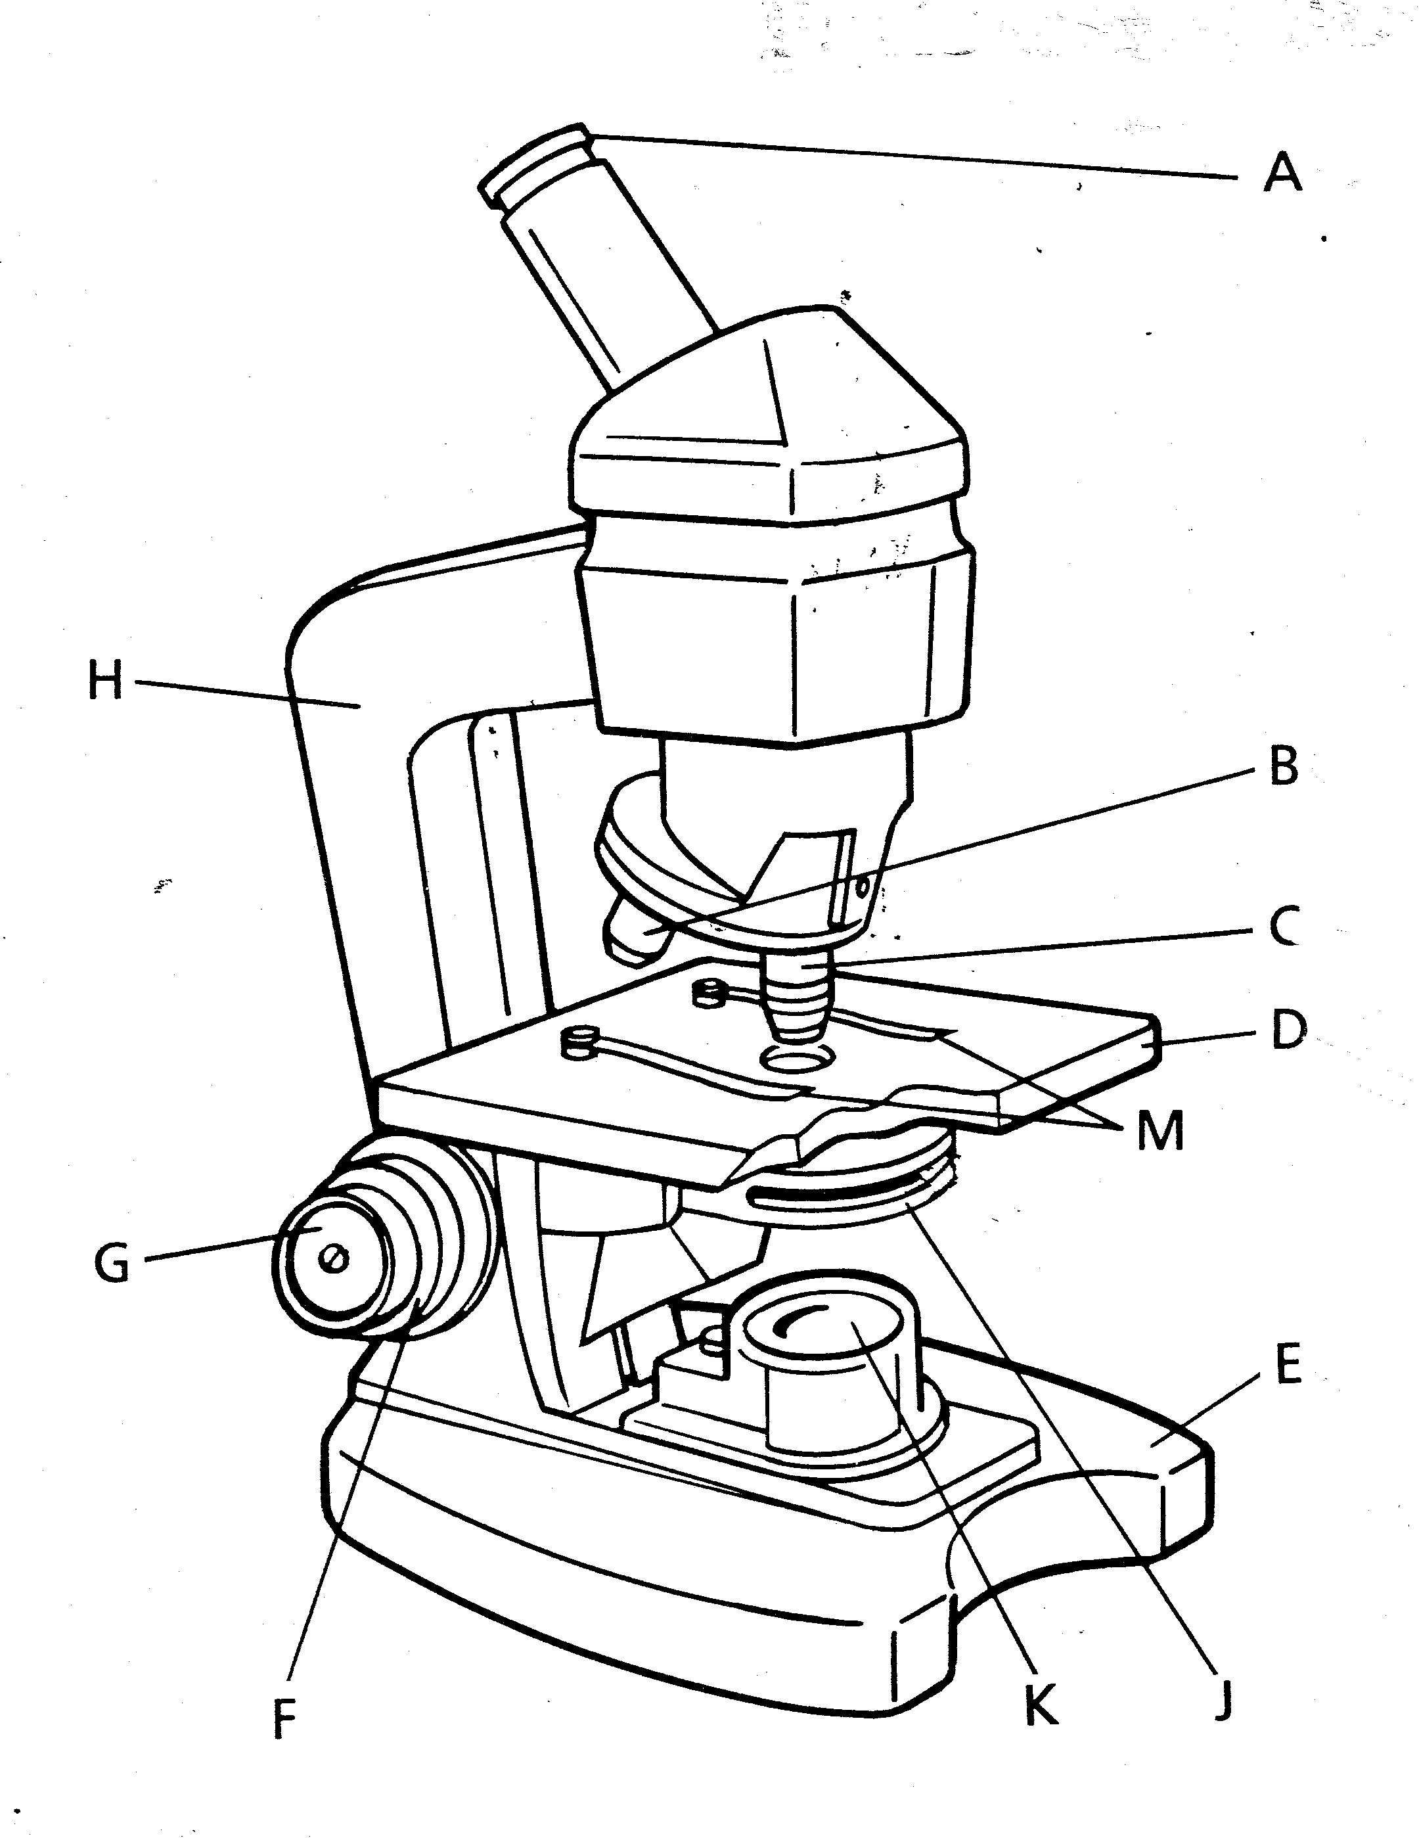
The microscope is an essential tool in the study of life science. It allows you to see things that are too small to be seen with the unaided eye. The compound microscope has more than one lens that magnifies the objects you view. Typically, the compound microscope has one lens in the eyepiece, the part you look through and it also has at least one other objective lens.

In a compound microscope the eyepiece lens usually magnifies 10 times. This is written 10X. Any object you view through this lens would appear 10 times larger than
it is. The other objective lenses are called low power and high-power.

The low-power lens magnifies 10X and the high-power lens magnifies 43X. To calculate the total magnification with which you are viewing an object,
multiply the magnification of the eyepiece lens by the magnification of the objective lens you are using.

Magnification Problems
1. The eyepiece magnifies 10X and the low power
magnifies 4X. What is the total magnification? _____________
2. The eyepiece magnifies 10X and the high power
magnifies 10X. What is the total magnification? ____________

What To Do:

1. Label the parts of the compound microscope as your teacher demonstrates them to you. Use the word bank to spell them correctly.

WORD BANK
eyepiece clips stage
arm high power objective
base low power objective
diaphragm coarse adjustment
light fine adjustment

What To Do:

1. Your teacher will go over the procedures for using
the low-power objective.
2. Highlight or underline important ideas.

Focusing the Microscope
Materials: microscope for each side of the table, extension cords, lens paper, miscellaneous slides, colored pencils
What To Do:
1. Set up your microscope as directed.
2. Place a slide on the stage and focus on low power.
3. Draw and color what you observe in the circles.
4. Label each image on the line and write the total
magnification below it.
5. Put the microscope away following procedures.

Questions:
1. At what magnification did you observe each slide? _______________________
2. Which adjustment makes the lens move up and down?
_______________________
3. Which adjustment brings the image into clear focus?
___________________________________________
Parts of the Microscope

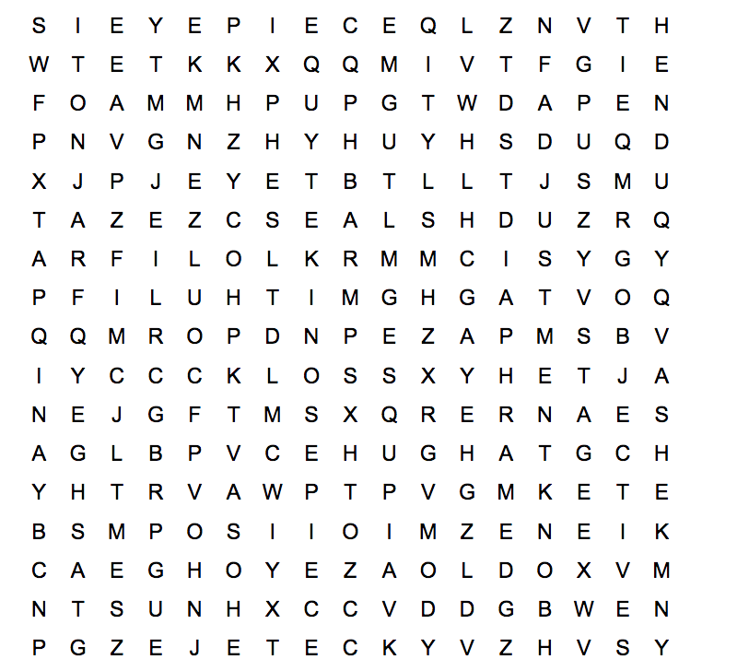

Objectives Diaphram Eyepiece
Stage Adjustment knob Base
Nosepiece Tube Arm
Stage clips Light source

Name _______________ period _____

EXIT TICKET
Using the Microscope
1. Look at the pictures and tell what is right or what is
wrong in each.

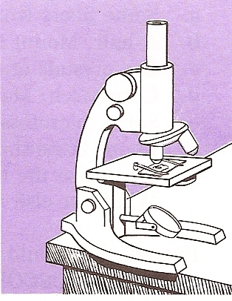
_________________________________________________________________________________

_____________________________________________________________________________
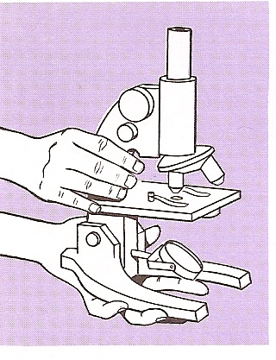

Conclusion: (objective, eyepiece, compound, multiply)
The ____________ microscope has two lenses. The lens you look through is called the __________. The low power and high power lenses are called ___________ lenses. To calculate the total magnification you must __________ the eyepiece by the objective.
Name _______________ period _____

EXIT TICKET
Using the Microscope
1. Look at the pictures and tell what is right or what is
wrong in each.

_________________________________________________________________________________

_____________________________________________________________________________

Conclusion: (objective, eyepiece, compound, multiply)
The ____________ microscope has two lenses. The lens you look through is called the __________. The low power and high power lenses are called ___________ lenses. To calculate the total magnification you must __________ the eyepiece by the objective.

Procedures for the Compound Microscope

When carrying the microscope be sure to place one hand under the base and the other on the arm.

1. Make sure your microscope is placed about 2 inches away from the edge of the table.
2. Unwrap the cord and plug it into the socket. Make sure the microscope cord is not hanging off the table. It could be accidentally pulled off the table and broken.
3. Turn on the lamp by pushing the on/off switch.
4. Check to make sure the low power objective has been clicked into place. If it is not clicked into place, you won’t be able to see much.
5. Clean the objective and eyepiece with a small piece of lens paper - never use a paper towel.
6. Place the slide on the stage over the hole and gently place the clips on the slide.
7. Rotate the coarse adjustment knob away from you until it stops.
8. Adjust the diaphragm to a comfortable light level. Not too bright and not too dim.
9. While looking through the eyepiece, slowly rotate the coarse adjustment knob toward you. This will raise the stage and bring the slide into focus. Stop when you begin to see some shadows.
10. Use the fine adjustment knob to bring the slide into better focus.

Do not keep turning the adjustment knobs past their stopping point. This causes the microscope lenses and mirrors to get permanently out of focus.

USING THE HIGH POWER OBJECTIVE.

11. After finding the object with low power you can then find it with high power.
12. Make sure what you want to see is focused on low power.
13. Watch from the side while you rotate the high power objective into place. The high power objective is longer than the low power objective and it can break the slide if you don’t watch carefully.
14. Click the high power objective into place.
15. Use the fine adjustment knob to try to bring the slide into focus. Use the coarse adjustment knob only if needed and only a little bit.

When finished with the microscope:

A. Return the objective to low power.
B. Take the slide off the stage.
C. Turn off the light.
D. Wrap the cord neatly around the microscope under the stage.
E. Carry it correctly where your teacher tells you.

