Balanced and Unbalanced Forces

We have learned that arrows can represent forces. Did you notice that the bigger the arrow, the larger the force? If the arrows are the same size, then the forces are equal.
A force has both size and direction. Usually more than one force acts on an object at the same time. Forces may work together or they may be opposite forces. Two or more opposite forces are balanced if their effects cancel each other and do not cause a change in the object’s motion. If one force is stronger than the other the forces are unbalanced forces. Unbalance forces can cause a change in motion, speed and/or direction. The net force is the combination of all forces acting on an object.

Look at the picture below and answer the questions.

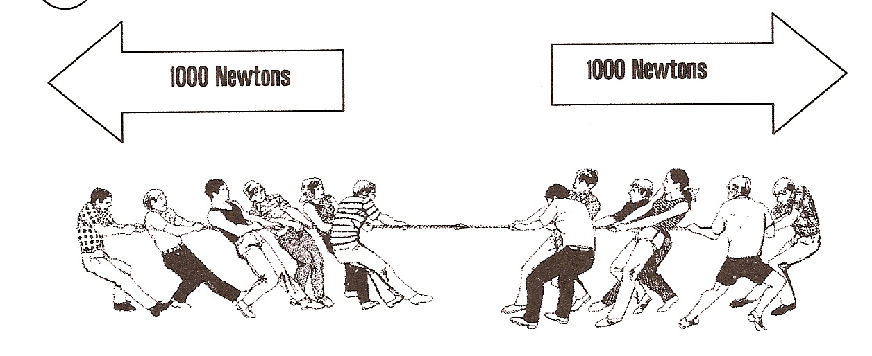

Questions:
1. How many people are pulling on each side? _____
2. Describe the size of the arrows in the picture.
_________________________________________
3. What is the force in each arrow? ___________
4. Are the forces balanced or unbalanced? _________
5. Which direction do you expect the rope to move? _____
6. What would have to change for the rope to move?
___________________________________________

Look at the picture below and answer the questions.

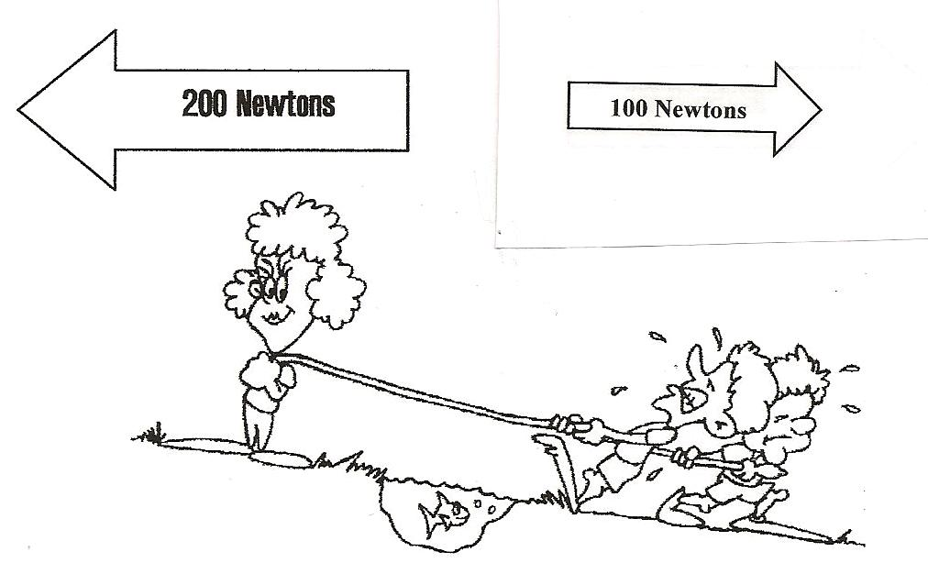

Questions:
1. How many people are pulling on the right side? _____
2. How many people are pulling on the left side? ______
3. Describe the arrows in the picture. _______________
______________________________________________
4. What is the force in the arrow to the right? __________
5. What is the force in the arrow to the left? ___________
6. Are the forces balanced or unbalanced? ____________
7. In what direction will the rope move? _______________

Net Forces

To find the net force when forces are acting in the same direction, simply add them together.
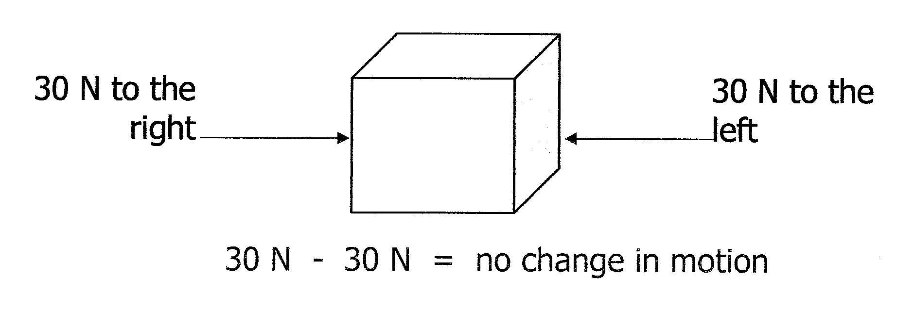
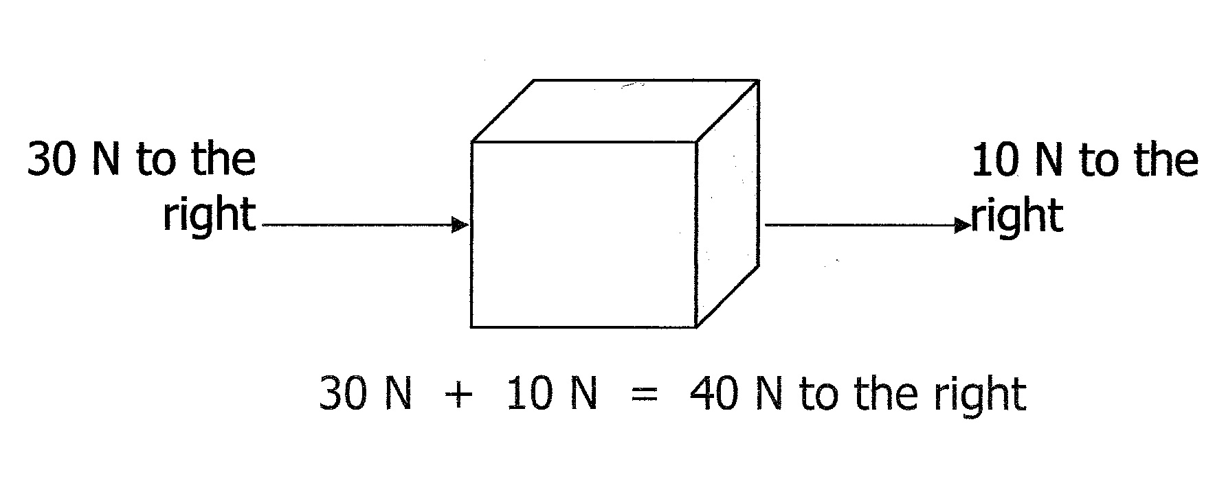
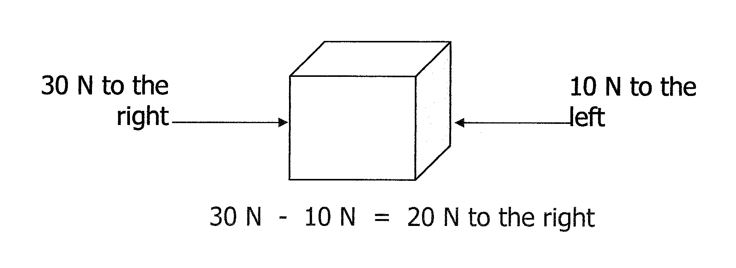

To find the net force when forces are acting in opposite directions, simply subtract the small force from the larger force.

When the net force is zero, the forces are balanced. Balanced forces do not cause a change in an object’s motion.

Materials: Net Forces Cards

What To Do:
1. Look at the cards you and your partner have been given.
2. Place the 5 “word” cards on your table.
3. Look at the “forces” cards and place them in the correct categories found on the word cards.
Questions:
1. Which “forces” cards belong in the category
Moves Up? ________________________________
2. Which “forces” cards belong in the category
Moves Down? ______________________________
3. Which “forces” cards belong in the category
Moves Left? _______________________________
4. Which “forces” cards belong in the category
Moves Right? ______________________________
5. Which “forces” cards belong in the category
Stays Still? ________________________________

6. Calculate the net force on card A. ______________
7. Are the forces balanced or unbalanced? _________
8. Does the object move or stay still? _____________
9. Calculate the net force on card C. ______________
10. Are the forced balanced or unbalanced? _______
11. Does the object move or stay still? _____________
12. Calculate the net force on card M. _____________
13. Are the forces balanced or unbalanced? _________
14. Does the object move or stay still? _____________
15. What happens to objects with unbalanced forces?
____________________________________________

Name _______________ period ____
EXIT TICKET
Balanced and Unbalanced Forces
1. The net force acting on the box is –

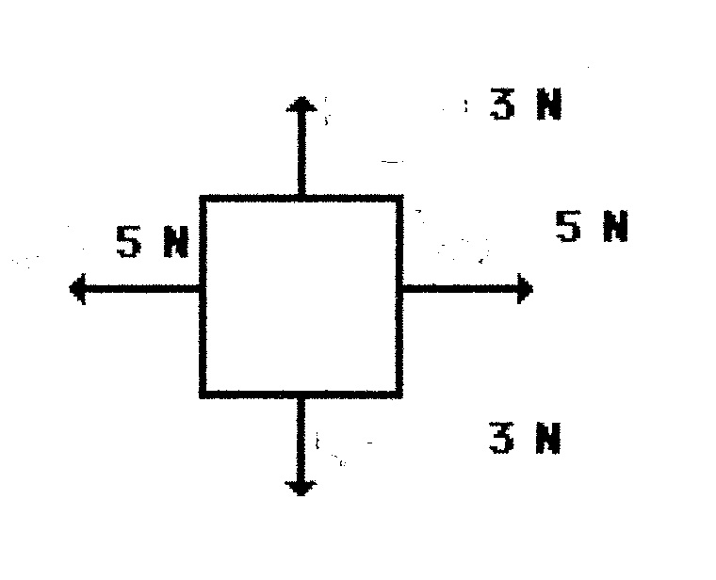
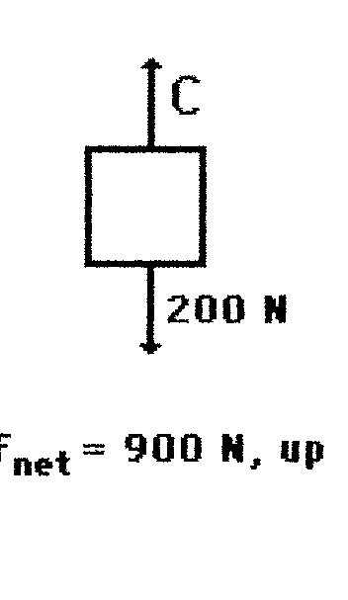
a. 0 N
b. 6 N
c. 10 N

2. The forces acting on this box are –

a. Balanced
b. Unbalanced
c. NonNewtonian

3. What will happen to the box?

a. It will move to the right.
b. It will move upwards.
c. It will not change its motion

4. The net force on the box to the right is 900 N. The down force is 200 N. How much force is acting in the direction of C?

a. 200 N
b. 1100 N
c. 700 N

5. The forces action on the box are-

a. Balanced
b. Unbalanced
c. NonNewtonian

Name _______________ period ____
EXIT TICKET
Balanced and Unbalanced Forces
1. The net force acting on the box is –

a. 0 N
b. 6 N
c. 10 N

2. The forces acting on this box are –

a. Balanced
b. Unbalanced
c. NonNewtonian

3. What will happen to the box?

a. It will move to the right.
b. It will move upwards.
c. It will not change its motion

4. The net force on the box to the right is 900 N. The down force is 200 N. How much force is acting in the direction of C?

a. 200 N
b. 1100 N
c. 700 N

5. The forces action on the box are-

a. Balanced
b. Unbalanced
c. NonNewtonian

