The Rock Cycle

The rock cycle is a never-ending process. Igneous rock forms from magma or lava. Weathering breaks igneous rock into sediments such as pebbles and sand. These small pieces are compacted and cemented under pressure into sedimentary rock. Under great heat and pressure inside the Earth’s crust, igneous and sedimentary rocks are changed into metamorphic rocks. These rocks are brought to the earth’s surface where they are weathered again into sediments to become sedimentary rocks.

Watch the video Starburst Rock Cycle Activity from www.missdoctorbailer.com

Materials: hot plate, scissors, 4 different colors of Starburst candy, plastic bag, aluminum foil, hot plate, heavy books

Part 1 Weathering Rocks into Sediments
What To Do:
1. Cut the Starburst candies into strips and then small
pieces and place them on top of the plastic bag.
2. Make some observations in the space below.
Draw and color what you see from the top.
Draw and color what you see from the side.

Part 2 Making Sedimentary Rock
1. Mix all your candies together and compact them
together by squeezing with your hand.
2. Make some observations below.

Draw and color what you see from the top.
Draw and color what you see from the side.

Part 3 Making Metamorphic Rock

1. Place the sedimentary rock into the plastic bag and apply some heat and pressure with your hands.
2. When it is soft and pliable, place some books on top of the candy in the plastic bag and apply some pressure.
3. Take the metamorphic rock out of the bag and fold it.
4. Apply more pressure with the books.
5. Make some observations below.

Draw and color what you see from the top.
Draw and color what you see from the side.

Part 4 Making Igneous Rock
Safety Concern: The hot plate will cause burns. Use it carefully.

1. Make a small boat of aluminum foil and place the metamorphic rock inside the boat.
2. Place the aluminum foil boat on the hot plate and allow to melt and bubble.
3. Take it off the hot plate and allow it to cool.

Draw and color what you see from the top.
Draw and color what you see from the side.

Questions:
1. What did your group do to model weathering rocks? ___________________
2. What did your group do to make the sedimentary rocks
stick together? _________________________________
3. What did your group do to make the metamorphic rocks
stick together? ________________________
4. What was the difference between what you did to the sedimentary rocks and the metamorphic rocks? _________________________________________

5. What did your group do to make the igneous rocks? ________________________________________

6. What was different between what you did to the metamorphic rocks and the igneous rocks? _________________________________________

What To Do:

1. Observe the diagram of the Rock Cycle below.
2. Answer the questions.

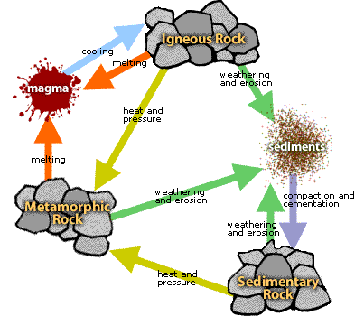
Questions:
1. Why do you think some steps have arrows going in both directions? _________________________________
2. What processes happen to all of the rocks in the diagram? _________________________________
3. When heat and pressure are placed on sedimentary rock what does it turn in to? ________________________

4. When heat and pressure are placed on igneous rock what
does it turn in to? __________________________________

Name ____________________ period _____
EXIT TICKET
The Rock Cycle
From what you did in this activity fill in the following flow chart. Use the words from the word bank

WORD BANK
Sedimentary Rocks
Metamorphic Rocks Igneous Rocks

Melting
Under Heat and Pressure
Weathering and Erosion
Sediments
Under Pressure

4. The diagram above is called
A. The Rocks and Minerals Cycle
B. The Mineral Cycle
C. The Rock Cycle

Name ____________________ period _____
EXIT TICKET
The Rock Cycle
From what you did in this activity fill in the following flow chart. Use the words from the word bank

WORD BANK

Sedimentary Rocks
Metamorphic Rocks Igneous Rocks

Melting
Under Heat and Pressure
Weathering and Erosion
Sediments
Under Pressure

4. The diagram below is called
A. The Rocks and Minerals Cycle
B. The Mineral Cycle
C. The Rock Cycle

