Why the Plates Move

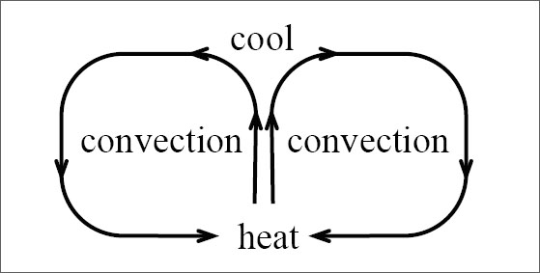
Last semester we learned how heat transfer made water and air move. As the water was heated it became less dense and rose to the top of the beaker. When the water, cooled, it became more dense and sank to the bottom of the beaker. This heating and cooling causes what is called convention currents.
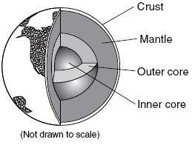
Do you remember what is at the center of the earth? There is a hot inner core and a hot outer core surrounding it. Do you remember the mantle? It has two parts and one is semi-solid. Because the core is hot, it heats up the mantle. The material in the mantle becomes less dense and rises to the top. Then the material cools off and sinks back to the bottom. This rising and sinking sets up convention currents in the mantle.
In the last lesson we learned about the theory of Continental Drift. Alfred Wegener proposed this theory but very few scientists accepted this theory because they couldn’t explain how the continents could move. When scientists figured out that the mantle has convection currents they thought back to Wegener and said this is what causes the continents move – Convection Currents! Let’s see how this works.

Watch the video, “Convergent and Divergent Plates” from www.missdoctorbailer.com
Write two things you learned from the video below.

Materials: Shoebox, sheet of paper, tape,
2 flat lumps of clay
What To Do:
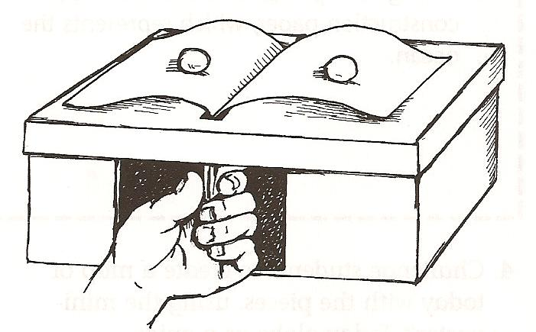
1. Your teacher will show you a shoebox with
a door in the side.
2. A sheet of paper is sticking out of the top of the shoebox.
3. Your teacher will place a lump of clay on the paper strip on each side.
4. The clay lumps represent continents, and the
paper strip represents the plates.
5. Your teacher will put their hand inside the
“door” and slowly push up the paper strip.
Observe what happens.
6. Your teacher will pull down on the paper.
Observe what happens.

Questions:
1. What happened when your teacher pushed up
the paper strip? _______________________________________
2. How is this like the continents spreading?
_______________________________________
3. What do you think your teacher’s hand
represents?
_________________________________________
4. What happened when your teacher pulled down
on the strip of paper? ______________________
5. How is this like the continents pushing together?
__________________________________________

There are three major types of plate boundaries. Use your textbook or the Internet to answer the questions.

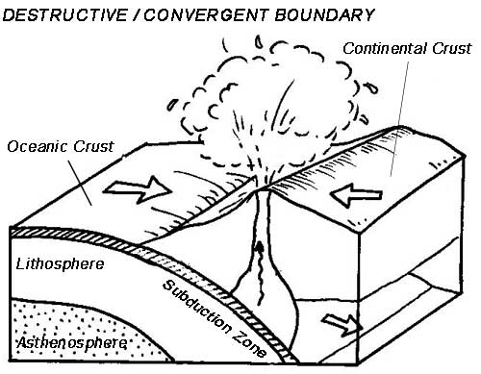
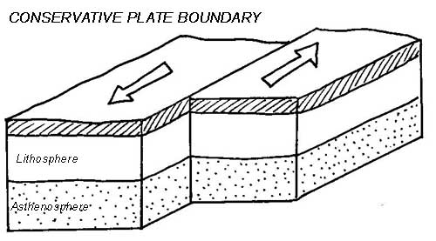
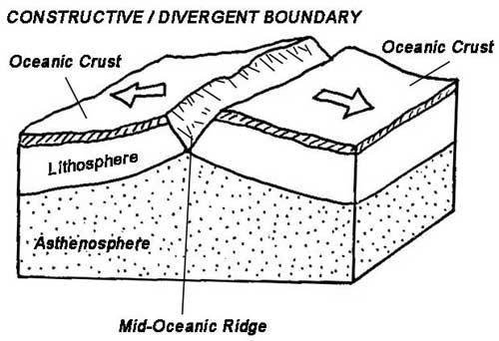
1. What type of Plate Boundary is shown?
______________________
2. What type of effects does this type of boundary have on the area around it?
_______________________
_______________________
1. What type of Plate Boundary is shown?
______________________
2. What type of effects does this type of boundary have on the area around it?
_______________________
_______________________
1. What type of Plate Boundary is shown?
______________________
2. What type of effects does this type of boundary have on the area around it?
_______________________
_______________________

Color the asthenosphere yellow and the lithosphere brown in each picture.

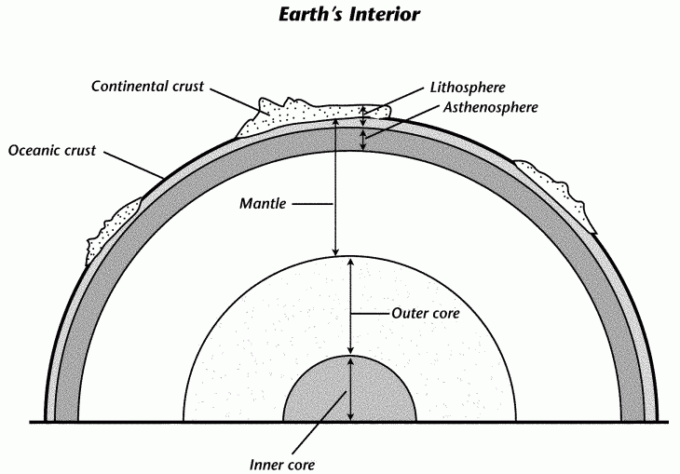

1. Color the asthenosphere yellow and the
lithosphere brown in the picture above.
2. Color the mantle red.
3. Draw convection currents in the mantle.
4. Color other parts different colors.

Name ____________________ period ______
EXIT TICKET
Why the Plates Move

1. Scientists think that the reason the plates move is because

A. The ocean waves push them
B. The gravity of the Sun
C. The convection currents

2. Which of the following is not a type of plate boundary?

A. Convergent
B. Transform
C. Normal
D. Divergent

3. What heats up the mantle?
A. The Sun
B. The Core
C. The Lithosphere

4. Why do cooler materials sink?

A. They are denser than the surrounding area
B. They are less dense than the surrounding area
C. They are the same density as the surrounding area

5. Where do the convection currents occur?

A. The mantle
B. The lithosphere
C. The asthenosphere

Name ____________________ period ______
EXIT TICKET
Why the Plates Move
1. Scientists think that the reason the plates move is because

A. The ocean waves push them
B. The gravity of the Sun
C. The convection currents

2. Which of the following is not a type of plate boundary?

A. Convergent
B. Transform
C. Normal
D. Divergent

3. What heats up the mantle?
A. The Sun
B. The Core
C. The Lithosphere

4. Why do cooler materials sink?

A. They are denser than the surrounding area
B. They are less dense than the surrounding area
C. They are the same density as the surrounding
area

5. Where do the convection currents occur?

A. The mantle
B. The lithosphere
C. The asthenosphere

