Jupiter and its Moons

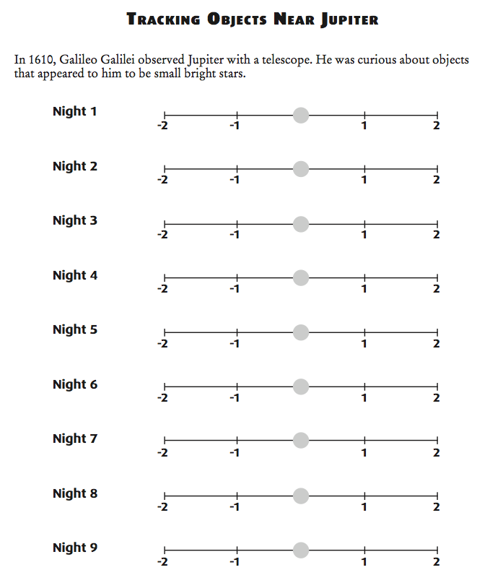
At the beginning of this unit we learned about Galileo’s discovery of the moons of Jupiter. He saw the four biggest moons although he didn’t know what he was seeing at the time. Because he had perfected the spyglass and called it a telescope he was able to observe objects no one else had ever seen.
He made drawings and kept notes like all good scientists do. He wrote that while observing the planet he notices four “specks” of light close to Jupiter. He thought these “stars” were unusual because they were in a neat little line. He also noted that these “star-like” objects move across the sky with Jupiter and appeared in different places around Jupiter each night. This is very unusual because stars never change position in relation to one another. Because he was the first to identify them, astronomers have named them the Galilean Moons.

Materials: JupMoons Tracking Power Point, colored pencils
What to Do:
1. Observe Night 1 on the power point. Notice that the “star like” objects have been colored so you can see them better.
2. You will be tracking one of the colors for nine nights by looking at this presentation, just like Galileo did through his telescope.
3. Each member of your group should pick one color star to track. Use a colored pencil – of the same color – to draw on the line for each “night”. Make an X where your star is located each night.
4. Draw a line from the X you made on Night 1 to the X you made on Night 2 and continue down through Night 9.
5. Compare your zigzag line with the members of your group.

Questions:
1. Why did Galileo look at Jupiter at night?
__________________________________________

2. What is causing the moons to change position each night? ______________________________

The picture below is from Galileo’s notebook. After he realized he was not looking at stars but at moons orbiting around Jupiter he used it as a model to support his idea that the solar system was heliocentric not geocentric.
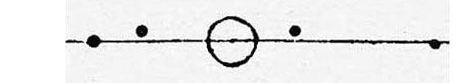

Io takes 2 days to orbit Jupiter, Europa takes 4 days, Ganymede takes 7 days and Calisto takes 17 days.

1. Which moon is the closest to Jupiter? ______________
2. Which moon is the farthest from Jupiter? ___________
3. Label the moons in the picture above.

Watch the video segment “Jupiter’s Moons” from www.missdoctorbailer.com Be sure to watch for the moons to pass in front and to the side of the planet.

Answer the questions below.

1. How many moons did you see? ______________

2. What were the black spots crossing Jupiter?
_____________________________________________

3. One moon came in from the right side and went behind the planet. Why didn’t it cross in front of the planet? ___________________________________________

Jupiter and Its Moons

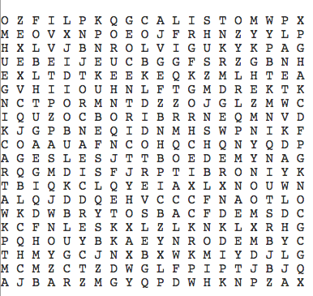

Calisto Europa Galileo
Ganymede Geocentric Heliocentric
Jupiter Model Moon
Notebook Orbit Planet
Sun Telescope Tracking

Name _______________ period_____
EXIT TICKET
Jupiter and its Moons
1. What is the largest planet in the solar system?

A. Earth
B. Mercury
C. Mars
D. Jupiter

2. How did Galileo use his discovery of the moons?

A. To show unusual stars
B. As evidence for the heliocentric model
C. As evidence for the geocentric model
D. To make money

3. Which of the following is NOT a moon of Jupiter?

A. Calisto
B. Ganymede
C. Io
D. Charon

4. How was Galileo able to see the moons of Jupiter?

A. Through a microscope
B. Through a telescope
C. Through a prism
D. Through a mirror

5. Jupiter has only four moons.

A. True
B. False

Name _______________ period_____
EXIT TICKET
Jupiter and its Moons
1. What is the largest planet in the solar system?

A. Earth
B. Mercury
C. Mars
D. Jupiter

2. How did Galileo use his discovery of the moons?

A. To show unusual stars
B. As evidence for the heliocentric model
C. As evidence for the geocentric model
D. To make money

3. Which of the following is NOT a moon of Jupiter?

A. Calisto
B. Ganymede
C. Io
D. Charon

4. How was Galileo able to see the moons of Jupiter?

A. Through a microscope
B. Through a telescope
C. Through a prism
D. Through a mirror

5. Jupiter has only four moons.

A. True
B. False

