More About Plate Boundaries
The earth has two kinds of crust: continental crust and oceanic crust. Continents are made of continental curst, which is made up of rocks that are less dense than those of oceanic crust. Plate boundaries occur where the edges of plates meet. You have learned about the three types of boundaries – convergent, divergent and transform. But different landforms happen if the boundaries are oceanic or continental. Let’s see what happens.
Watch the video: Plate Boundary Overview from www.missdoctorbailer.com and answer the following questions.
Convergent
Continental Crust collides with Continental Crust

1. What landforms are built? ___________________
2. Are volcanoes formed at this collision? _________
3. Where in the world has this happened? _____________

Divergent
Ocean Crust pulls apart from Ocean Crust

1. What landforms are built? ______________________
2. Where does this happen? ______________________
3. What causes the new crust to form? ______________

Convergent
Oceanic Crust collides with Continental Crust

1. What landforms are built? ____________________
2. Where does this happen? ____________________

Transform
Two plates slide side by side

1. What effects are felt here? __________________

Materials: colored pencils, Plate Boundary Map
What To Do:
1. Don’t glue in the map your teacher gives you until you are finished coloring it.
2. Find all the arrows on the map (10) and color them orange.
3. Find the Nazca Plate and lightly color it blue.
4. Find the South American Plate and color the continent green and the ocean blue.
5. Find the mid-Atlantic Ridge with the help of your teacher and trace it in red.
6. Color the ocean on either side of the mid-Atlantic Ridge blue.

Questions:
1. What type of crust can be found on the Nazca Plate?_______________________________
2. What type of crust can be found on the South American plate where it meets the Nazca Plate?
_____________________________________
3. Look at the arrows. What type of plate boundary would you expect to find here? _______________
4. What types of crust are colliding here?
_______________________________________
5. What landforms would you expect to find?
________________________________________
6. Find the mid-Atlantic Ridge. What type of crust is found on either side? _______________________
7. Look at the arrows. What type of plate boundary would you expect to find here? _______________
8. What type of crust is pulling apart here? ________
9. What is being created at this boundary? ________
10. Where on the map would you find a Continental Crust colliding with another continent? _________________________________________
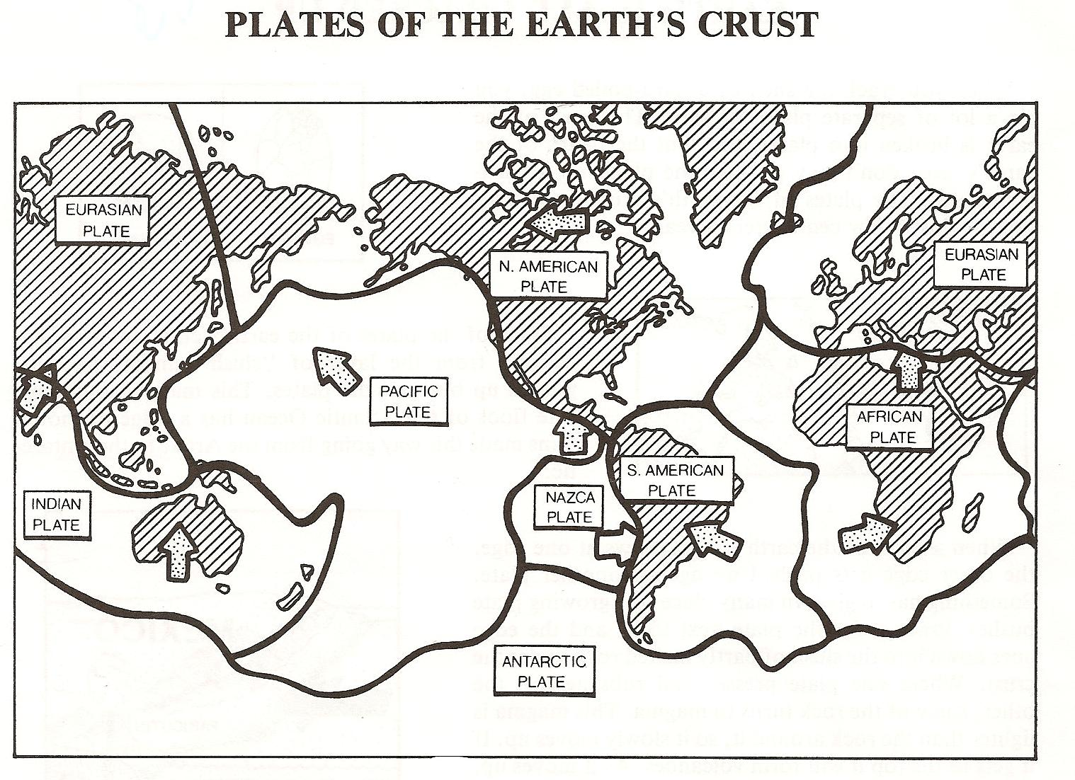

TECTONIC PLATES



Boundary Convection Currents
Convergent Density
Divergent Earthquakes
Mantle Heat Transfer
Mountains Inner Core
Transform Mid Atlantic Ridge
Volcanoes Outer Core
Tectonic Plates

Name ___________________ period ______
EXIT TICKET
More About Plate Boundaries

1. What happens at a divergent boundary?

A. Plates push together
B. Plate pull apart
C. Plates slide past each other

2. What types of crust occur on the earth?

A. Olympic and continental
B. Continental and oceanic
C. Oceanic and corporeal

3. What effects can be felt at transform boundaries?

A. geysers
B. hot springs
C. earthquakes

4. Where is new crust formed on the earth?

A. along mid-ocean planes
B. along mid-continent ridges
C. along mid-ocean ridges

5. Where do volcanoes form?

A. Where oceanic and oceanic crusts collide
B. Where oceanic and continental crusts collide
C. Where continental and continental crusts collide

Name ___________________ period ______
EXIT TICKET
More About Plate Boundaries

1. What happens at a divergent boundary?

A. Plates push together
B. Plate pull apart
C. Plates slide past each other

2. What types of crust occur on the earth?

A. Olympic and continental
B. Continental and oceanic
C. Oceanic and corporeal

3. What effects can be felt at transform boundaries?

A. geysers
B. hot springs
C. earthquakes

4. Where is new crust formed on the earth?

A. along mid-ocean planes
B. along mid-continent ridges
C. along mid-ocean ridges

5. Where do volcanoes form?

A. Where oceanic and oceanic crusts collide
B. Where oceanic and continental crusts collide
C. Where continental and continental crusts collide

