Finding Out About Asteroids

BEFORE this lesson on asteroids, check what you and your partner know by answering these questions. When you are finished with the lesson answer them again and see what you knew and what you have learned from the lesson.

Questions | What I know before the lesson | What I know after the lesson
1. What do they look like?
2. What are they made of?
3. How big are they?
4. Where can you find them?
5. Do they travel in a group or by themselves?

You have learned about the eight planets of our solar system. They can be divided into 2 groups, the Inner and Outer Planets. The Inner Planets are close to the sun and the Outer Planets are far from the sun. The Asteroid Belt separates them.
In the drawing you will notice that there is an Asteroid Belt between the planets Mars and Jupiter. Some asteroids are made of rock and some are made of metal. They orbit the sun but are too small to be considered planets. Asteroids are material left over from the formation of the solar system. One theory suggests that they are the remains of a planet that was destroyed in a collision long ago.
1. Label the 4 Inner Planets: Mercury, Venus, Earth, Mars
2. Label the Asteroid Belt.
3. Label the largest planet Jupiter.

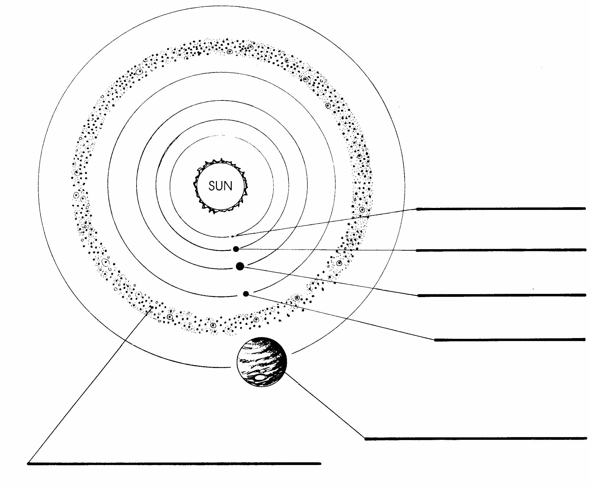

The first asteroid to be discovered was Ceres back in 1801 by an astronomer named Piazzi. The scientific community felt there should be a planet between Mars and Jupiter and Piazzi was studying that region of space with a telescope. He first called it a planet but the classification
was soon changed to asteroid because of their “starlike” appearance.
NASA has sent nine missions to planets outside the asteroid belt and there was concern, at first, that the space probes would encounter an asteroid that could do damage. Missions to the asteroid belt have found that Ceres - the largest asteroid- is about the size of Texas. They are not
very close together. If you were to stand on an asteroid
you would probably not see another one, so they are very
far apart.

Below you see the size of the first ten asteroids that were discovered back in the 1800s compared to our moon.

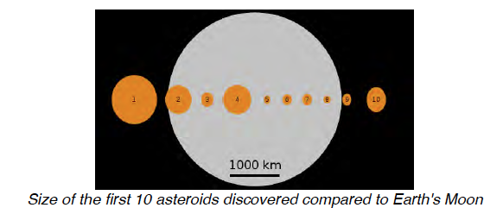
In the chart below you will find 5 asteroids that are big enough to be named. There have been several spacecraft
that have flown through the Asteroid Belt. 951 Gaspra and 243 Ida were visited by the Galileo spacecraft on its way to Jupiter. Both Gaspra and Ida are made of metal while the others listed are made of rock.

Number  of Discovery | Name | Radius  (km) | Discoverer | Date
4 | Vesta | 262.5 | H. Olbers | 1807
243 | Ida | 58 x 23 | J. Palisa | 1884
253 | Mathilde | 28.5 x 25 | J. Palisa | 1885
433 | Eros | 17.5 x 6.5 | G. Witt | 1893
951 | Gaspra | 17 x 10 | Neujmin | 1916
You may notice that some of the asteroids have 2 numbers
for their radius. This means they are not round. They have more of an oblong shape – like a potato- and so their radius
is expressed for the long side and the short side.

Answer the following questions using the chart.
1. Which asteroid in this list was found first? _________
2. In what year was it found? ________________

3. Who discovered more than one asteroid? _________
4. Why does Vesta have only 1 number for its radius?
_____________________________________________
Your teacher should show you some pictures of asteroids on
a power point from www.missdoctorbailer.com You should draw what the asteroids you observe look like in the boxes.

Be sure to show the radius of each of the asteroids.
Eros | Gaspra
Ida | Mathilde
Vesta | Draw and name your own asteroid.
NOW fill in the front page with facts you know
about asteroids.

Name ___________________________ period _____
EXIT TICKET
Finding out About Asteroids
1. Where are most asteroids found?

A. orbiting a planet
B. In the asteroid belt
C. on a collision course with Earth

2. Where do asteroids come from?

A. outside the solar system
B. leftover from the formation of the solar system
C. the sun

3. Why do some asteroids have two numbers for their radius?

A. They are perfectly round
B. They are square
C. They are oblong like a potato

Conclusion: (planets, inner, outer, asteroid belt, small,)

The ____________ in our Solar System can be divided into two groups, the ________ planets and the ________ planets. An _______ ________ separates the inner and outer planets. Asteroids orbit the sun but are too ________ to be considered planets.

Name ___________________________ period _____
EXIT TICKET
Finding out About Asteroids
1. Where are most asteroids found?

A. orbiting a planet
B. In the asteroid belt
C. on a collision course with Earth

2. Where do asteroids come from?

A. outside the solar system
B. leftover from the formation of the solar system
C. the sun

3. Why do some asteroids have two numbers for their radius?

A. They are perfectly round
B. They are square
C. They are oblong like a potato

Conclusion: (planets, inner, outer, asteroid belt, small,)

The ____________ in our Solar System can be divided into two groups, the ________ planets and the ________ planets. An _______ ________ separates the inner and outer planets. Asteroids orbit the sun but are too
________ to be considered planets.

