Geologic Faults

As you have learned the land on the Earth’s surface is broken into many different tectonic plates. The plates are moving very slowly in different directions. When two plates try to move past one another, the friction between them keeps them from moving. As a result, potential energy builds up. Eventually, the potential energy is converted to kinetic energy and the plates move causing an earthquake.
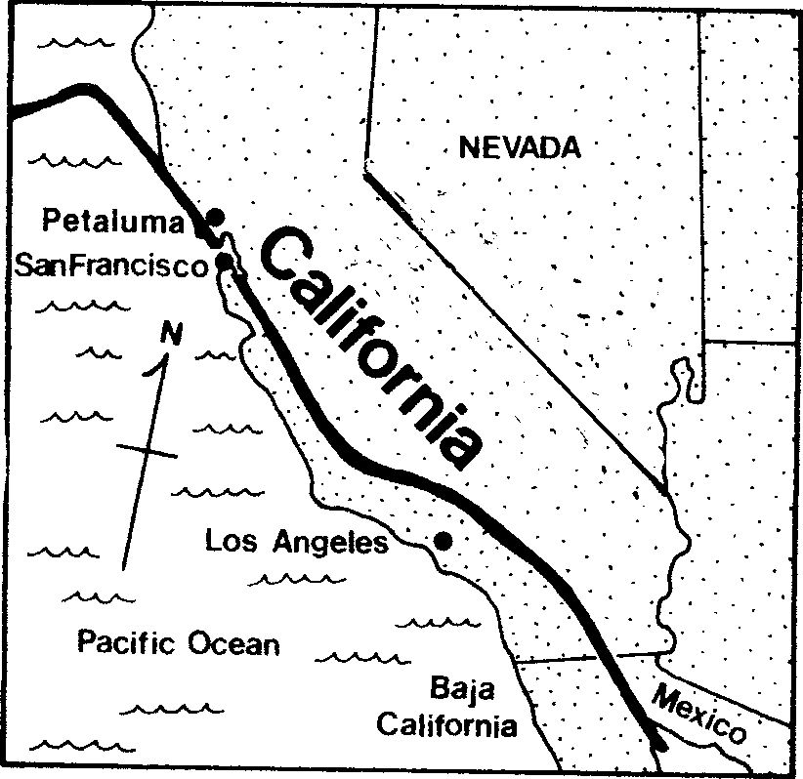
Most earthquakes take place along breaks in the earth’s crust called faults. The picture shows the San Andreas Fault. It is called a transform fault because it is at the plate boundary of the North American Plate and the Pacific Plate. There are many faults along the edge of each plate boundary.
Since faults are large cracks in the earth they sometimes allow magma from the mantle to rise up to the surface causing volcanoes. Scientists have discovered that they can tell where a plate boundary is located by looking for faults and volcanoes.

Materials: two sets of Road and River squares for each student (A and B), scissors, glue, colored pencils
What To Do:
1. Color and cut out the two sets of Road and River squares your teacher gives you.
2. Glue Set A side by side on the next page showing how the land would appear normally.
3. Write three sentences about what you observe.
4. Place Set B side by side and push them slightly in the direction of the arrows to show how the land can change after an earthquake.

5. Glue them into place on the next page.

6. Write three sentences about what you observe.

SET A - BEFORE

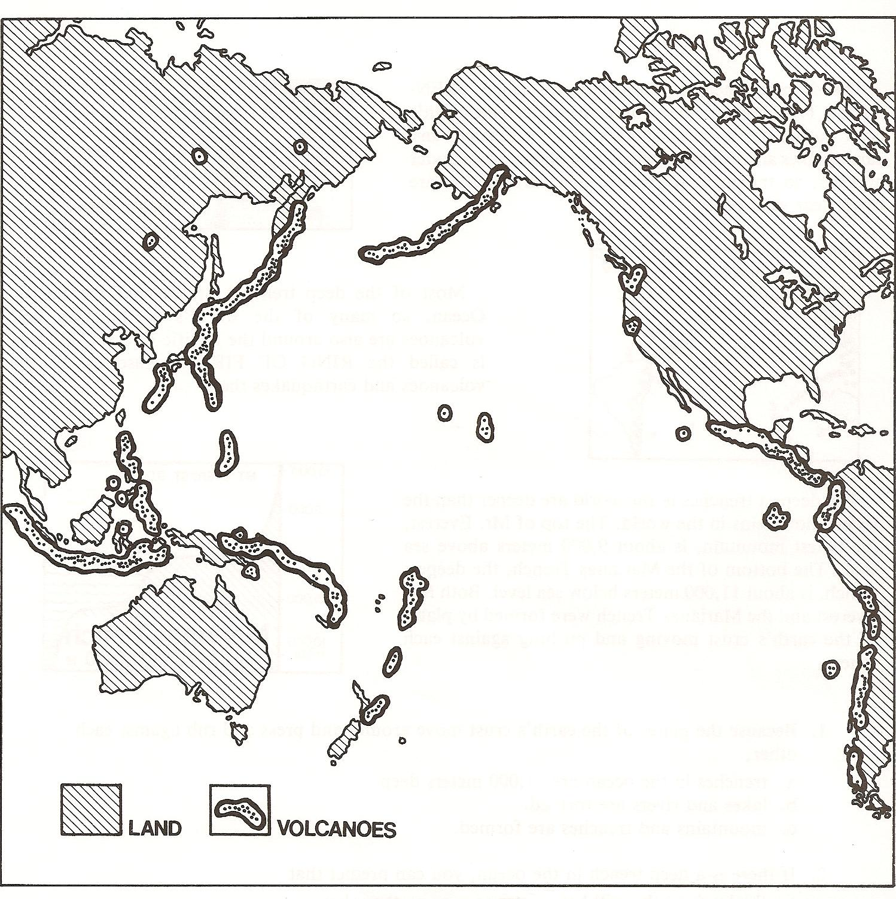
Volcanoes and earthquakes

SET B - AFTER

Questions:
1. What happened to the road after the earthquake?
_______________________________________________
2. What type of fault do the pictures represent? ________

Materials: colored pencils, Plate Boundary Map

from previous lesson.
What To Do:
1. Label the Pacific Ocean, and the continetns around it:
North America, South America, Australia and Asia.
2. Color the areas where volcanoes and earthquakes are
found either orange or red.
3. Compare this map with the Plate Boundary Map from the
previous lesson.

Questions:
1. Around which plate do most of the volcanoes and
earthquakes happen? _____________________________
2. What does this tell you about the edge of the plate
boundaries?______________________________________

Name __________________ period _____

EXIT TICKET
Geologic Faults
1. Where do most earthquakes occur?

A. in the Atlantic Ocean
B. in the middle of a continent
C. along the edge of a plate boundary

2. What causes earthquakes?

A. movement along a fault
B. a tsunami
C. steping on a fault

3. What evidence do scientists look for to determine the
location of a plate boundary?

A. lots of rocks
B. no rocks
C. faults and volcanoes

4. Where does magma come from?

A. lithosphere
B. core
C. mantle

5. What type of damage will an earthquake NOT cause?

A. cracks in the earth
B. the movement of roads and rivers
C. wind damage to houses

Name __________________ period _____

EXIT TICKET
Geologic Faults
1. Where do most earthquakes occur?

A. in the Atlantic Ocean
B. in the middle of a continent
C. along the edge of a plate boundary

2. What causes earthquakes?

A. movement along a fault
B. a tsunami
C. steping on a fault

3. What evidence do scientists look for to determine the
location of a plate boundary?

A. lots of rocks
B. no rocks
C. faults and volcanoes

4. Where does magma come from?

A. lithosphere
B. core
C. mantle

5. What type of damage will an earthquake NOT cause?

A. cracks in the earth
B. the movement of roads and rivers
C. wind damage to houses
