Observing a Comet

A comet is a small icy body that orbits around the Sun. Comets are made of ice, dust and rocky debris left over from the formation of the solar system. Comets revolve around the Sun in a very long elliptical orbit. This type of orbit brings them close to the Sun and takes them very far away. Some comets come close to the Sun about every 20 years. Others come around about every 200 years.
Comets have three parts, the nucleus, the coma and the tails. The nucleus is the solid center made up ice, gas and rocky debris. The coma is the gas and dust atmosphere around the nucleus, which happens with the comet gets close to the Sun and the comet begins to melt. Comets have three tails. The tails are formed when the solar wind from the Sun cause the coma to stream out behind the comet. The largest is the dust tail. It is the debris that is melting off of the nucleus. The ion and sodium tails are made from the solar wind. You should notice that the tail always points away from the Sun while the head always points toward the sun.

Your teacher will show you a video on comets from www.missdoctorbailer.com. In the space below write down 3 facts you learned about comets.

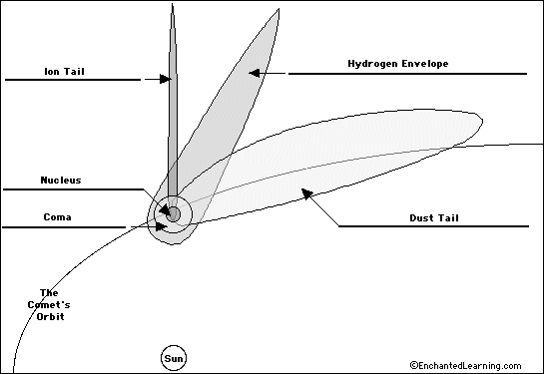
1. Color the nucleus black. 4. Color the sodium tail blue.
2. Color the coma yellow. 5. Color the dust tail red.
3. Color the ion tail green.
Sodium Tail

Materials: Styrofoam ball or sheet of copy paper, ribbon or Mylar gift strips, tape, wooden skewer, hairdryer or fan
What To Do:
1. Make a model of a comet using the materials above.
2. If using a sheet of paper make the comet the shape
you think your comet nucleus will have.
3. Place the ribbon/Mylar strips on top of the ball or
paper nucleus so the two pieces cross each other in an “X” and the lengths of all sides of the strips hang
down evenly.
4. Attach the strips to the ball or paper with the tape.
5. Assign a front for your comet and place a letter F on it. On the opposite side place a T for tail.
6. Mount the ball or molded paper on the skewer.
7. Use the hairdryer or fan to simulate the sun’s solar
energy as it meets the comet.

Questions:
1. What did you observe about the tail when it was heading to the sun? _____________________________
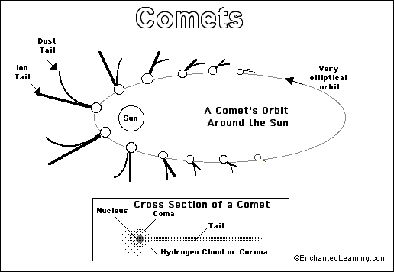
2. What did you observe about the tail when it was heading away from the sun? ______________________

Notice in the diagram above, the comet’s tail always points away from the Sun.

Questions:
1. Why does the comet have no tail when it is far from the
Sun?
________________________________________
2. Why do you think the comet’s tail always points away
from the Sun? __________________________________
3. Name the three tails of a comet. _________________________________________________
4. Draw and label the 3rd tails of the comet on the diagram above.

Materials: Famous Comets handout, glue, scissors

What To Do:
1. Cut out the rectangles on the Famous Comets handout along the bold lines. DO NOT cut the dotted lines!
2. Glue the Comet Shoemaker-Levy 9 to the bottom of your notebook page.
3. Run a line of glue on the BACK of the Anchor Tab on Comet Hyakutake. Line the bottom of the rectangle with the top of the bottom dotted line of Comet Shoemaker-Levy 9.
4. Continue until you have all Famous Comets glued in.
5. Answer the following questions.

Questions:
1. Why was Comet Hale-Bopp so bright?
____________________________________________
2. How did Comet Hale-Bopp get its name?
____________________________________________
3. Who was Comet Halley named for?
____________________________________________
4. When will Comet Halley return to the inner Solar System?
________________________________________________
5. When was Comet Swift-Tuttle first seen?
________________________________________________
6. How far away from Earth will it be when it next passes by? ___________________________________________
7. How was Comet Hyakutake discovered?
_______________________________________________
8. How long is Comet Hayakutake’s orbit?
_______________________________________________
9. Who discovered Comet Shoemaker-Levy 9?
_______________________________________________
10. What “first” was recorded with this comet?
_______________________________________________

Name __________________ period _____
EXIT TICKET
Observing a Comet
1. Which of the following is NOT a part of a comet?
A. tail
B. coma
C. nucleus
D. chromosphere

2. When do comets form their tail?
A. When they get close to the sun.
B. When they get far away from the sun
C. When they get close to a planet.
D. When they get close to an asteroid

3. Which of the following can be found in a comet?

A. gas and dust
B. liquid water and metal
C. living things and dust
D. liquid water and gas

Conclusion: ( ice, coma, melt, rocky debris, dust, solid)
A comet is made of __________, __________ and ________ _________. When they get close to the sun they begin to ___________. The ______ is the gas and dust atmosphere around the nucleus. The nucleus is the _________ center of the comet.

Name __________________ period _____
EXIT TICKET
Observing a Comet
1. Which of the following is NOT a part of a comet?
A. tail
B. coma
C. nucleus
D. chromosphere

2. When do comets form their tail?
A. When they get close to the sun.
B. When they get far away from the sun
C. When they get close to a planet.
D. When they get close to an asteroid

3. Which of the following can be found in a comet?

A. gas and dust
B. liquid water and metal
C. living things and dust
D. liquid water and gas

Conclusion: ( ice, coma, melt, rocky debris, dust, solid)
A comet is made of __________, __________ and ________ _________. When they get close to the sun
they begin to ___________. The ______ is the gas and dust atmosphere around the nucleus. The nucleus is the _________ center of the comet.

