Teacher Information
7th grade Unit 5
Plate Tectonics

Texas Essential Knowledge and Skills
(10) Earth and space. The student understands the causes and effects of plate tectonics. The student is expected to:
(A) describe the evidence that supports that Earth has changed over time, including fossil evidence, plate tectonics, and superposition; and
(B) describe how plate tectonics causes ocean basin formation, earthquakes, mountain building, and volcanic eruptions, including supervolcanoes and hot spots.
Activity 1 Layers of the Earth
Engage Materials: Layered wafer cookie for each student, paper towel for each student
Explore Materials: Colored pencils, scissors
Elaborate Video: “Structure of the Earth at https://www.youtube.com/watch?v=eXiVGEEPQ6c

Activity 2 What Fossils Tell Us
Explore Materials: Colored pencils, scissors, glue, World Map**, Fossil Evidence sheet, Continent Outline sheet
Elaborate Materials: paper plate, small shell or other hard object, ball of clay, bottle of white glue
Elaborate video: “Piecing Together the puzzle of continental Drift” from Encyclopedia Britannica found at https://www.britannica.com/video/discussion-some-evidence-Earth-continental-drift/-182285

**Make a class set of the World Map
Teacher Hint: After students have matched up the continents give them the Outline sheet and see if they can fit their continent into the outline. When the outline is cut out it will fit diagonally on the next page.

Activity 3 More Stores from Fossils
Explore Materials: Mason jar with lid, sand, soil, small rocks, scoops, colored pencils, scissors, tape (You could use different colors of sand)
Elaborate video: “Reading Earth’s Timeline: Fossils and Strata in Rock” found at https://www.youtube.com/watch?v=4YrJp4gnUrk

Activity 4 Identifying Tectonic Plates
Engage Materials: Milky Way fun size candy bar per student, paper towel
Explore Materials: Tectonic Plate map
Elaborate Materials: Tectonic Plate Map, colored pencils

Activity 5 Why the Plates Move

Engage video: “Continental Drift from Pangea to Today” from

https://www.youtube.com/watch?v=OGdPqpzYD4o
Explore Materials: shoebox prepared as shown below

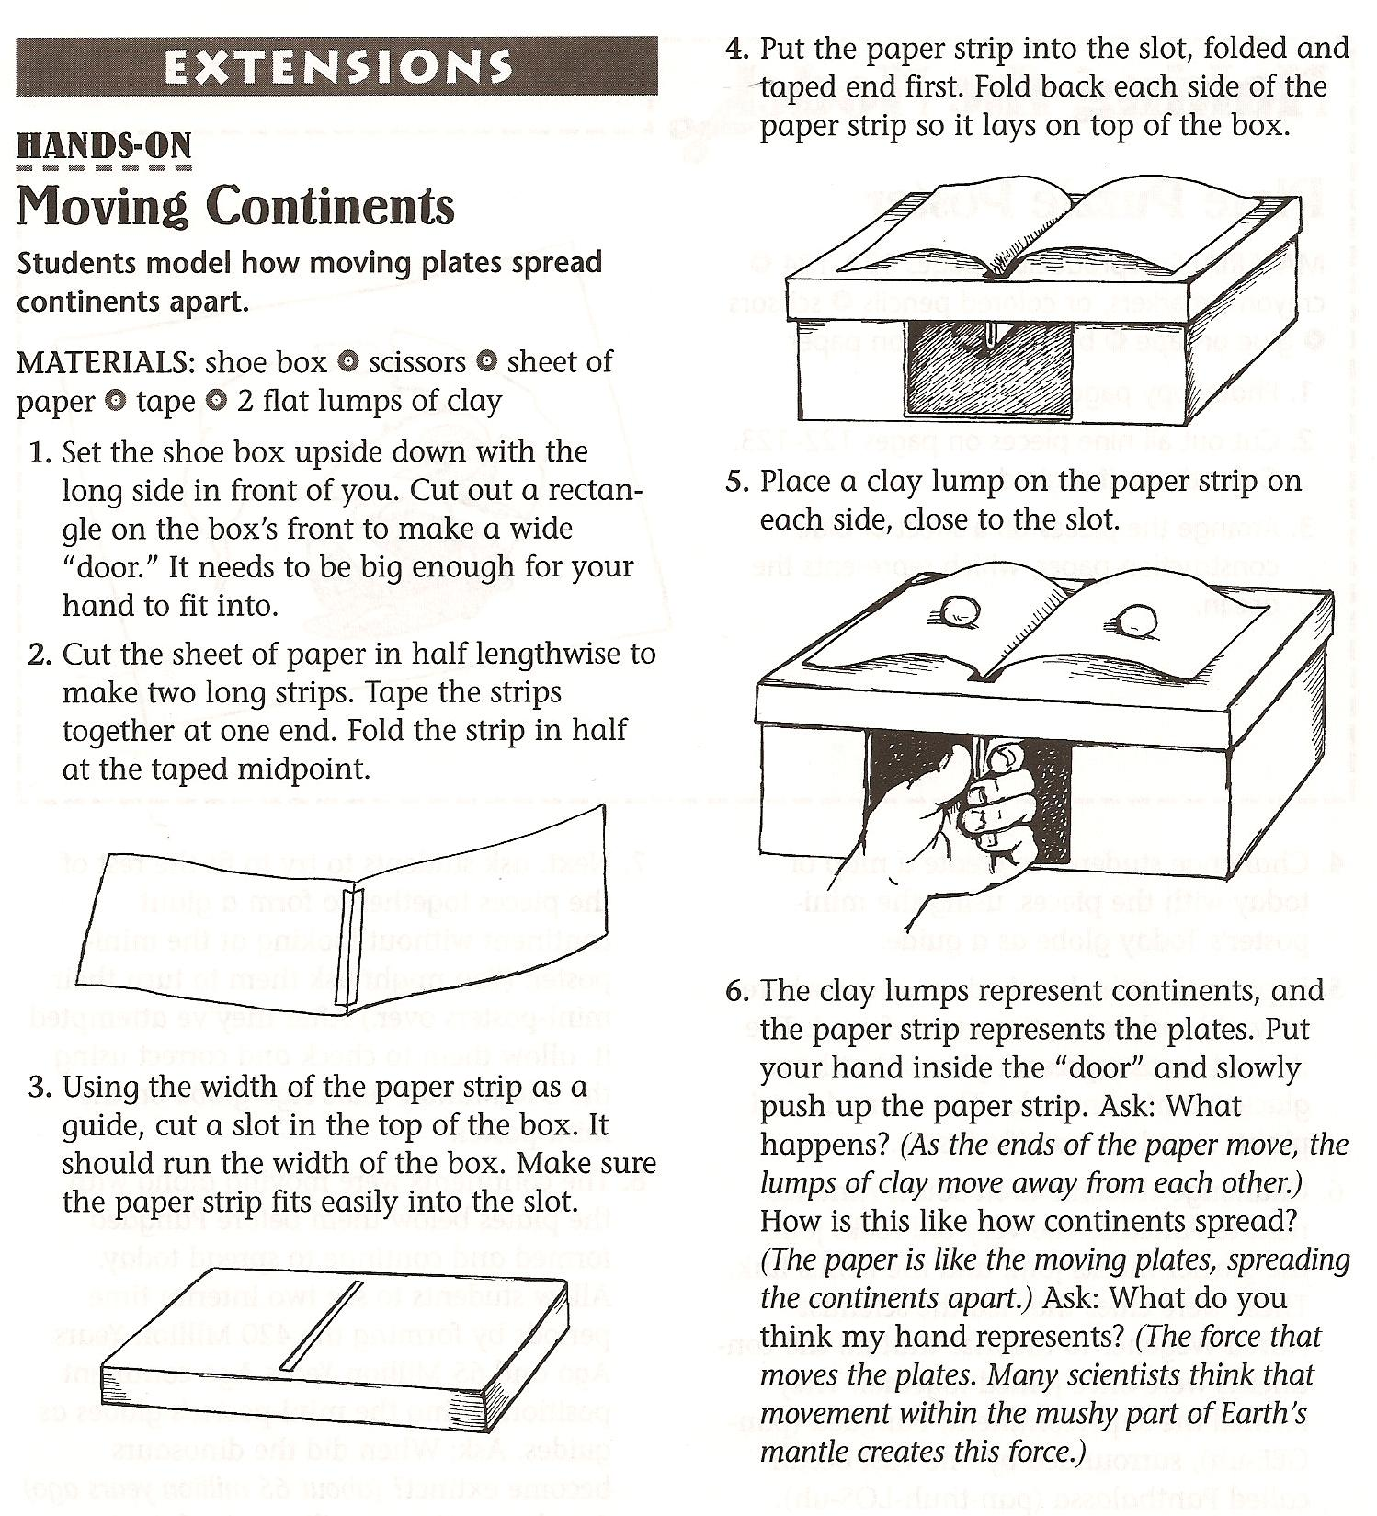

Explain Materials: colored pencils
Explain video: “Convection Currents Demo” found at https://www.youtube.com/shorts/iBkdwZIm-sQ
Elaborate video: “Convections Currents Explained: at https://www.youtube.com/watch?v=uPemeHLaxlE

Activity 6 Effect of Moving Plates
Engage Materials: Two sponges about the same size for each pair of students Explore Materials: colored pencils, Plate Boundary Map
Elaborate Power Point from www.missdoctorbailer.com

Activity 7 Geologic Faults
Engage Materials: Paper towel and 2 Graham Crackers per student
Explore Materials: two sets of Road and River squares for each student (A and B), scissors, glue, colored pencils
Elaborate video “G101 Plate Tectonics, San Andreas Fault” found at https://www.youtube.com/watch?v=g6LVyF1HI9w

Activity 8 Volcanic Eruptions
Engage Video: “Volcanic Eruptions” from National Geographic found at https://www.youtube.com/watch?v=CgpNqrR318U
Explore Materials: colored pencils, Plate Boundary Map from previous lesson
Explain videos: “Supervolcanoes 101” found at https://www.youtube.com/watch?v=kAlawvE8lVw
“Hotspot Volcanic Creation” from
https://www.youtube.com/watch?v=cLsT-HG3yw8

