Meteors and their Craters

When people of ancient times saw a streak of light moving across the sky, they thought a star was falling. While we still use the terms falling star and shooting star to describe these streaks, scientists today realize that these are actually meteors. Meteors are made up of stone and/or metallic pieces. Meteors can be the dust left over from comets, asteroids from the asteroid belt or other debris left over from the formation of the solar system. Meteors are smaller than asteroids.
Meteors have three possible stages. When they are far out in space and not yet in the Earth’s atmosphere, they are called meteoroids (like asteroids). If they enter into Earth’s atmosphere, they are called meteors. And, the few meteors that survive the journey and actually reach earth’s surface are called meteorites. If a meteorite strikes our planet, its impact may cause a large hole in the ground. This hole is known as a crater.

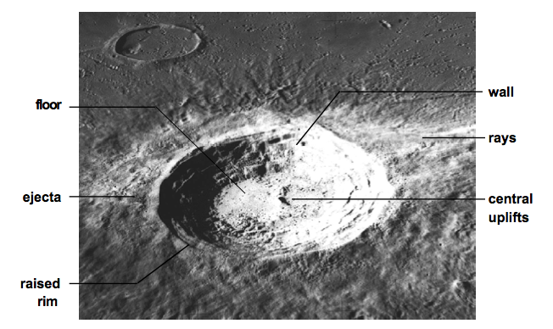

When the meteorite hits the ground something interesting happens. The soil below it explodes out of the crater and falls on top of the ground. This is called ejecta. Sometimes the ejecta spreads out evenly and sometimes it goes out in rays. Impact craters always have a raised rim, a wall and a floor.

Look for these structures in your impact craters.

Materials: Cocoa powder, flour, rectangular cake pan,
3 small rocks, 3 large rocks, newspaper, ruler

What To Do:

1. Your teacher will have filled the cake pan about ½ full of flour and spread out the cocoa powder on top in a thin layer using a ruler so the top is smooth.
2. Spread several sheets of newspaper on the floor and place the pan in the center of the newspaper.
3. Have a volunteer stand on a chair above the pan of flour.
4. The volunteer should drop a small rock into the pan.
DO NOT THROW THE ROCK!!!!

5. Repeat two more times with small rocks.
6. Draw and color what you see in the observations on the next page.
7. Measure the diameter of each crater in cm. Place the measurements in the table under each observation.
8. Smooth out the cocoa powder and flour and repeat with
3 large rocks.

Small Rock Craters

Crater 1 Drawing  Label the floor. | Crater 2 Drawing  Label the raised rim. | Crater 3 Drawing  Label the ejecta.
Crater Diameter: | Crater Diameter: | Crater Diameter:

Large Rocks Craters
Crater 1 Drawing  Label a ray of ejecta. | Crater 2 Drawing  Label the wall. | Crater 3 Drawing
Crater Diameter: | Crater Diameter: | Crater Diameter:
Questions:
1. What is the name of a piece of rock out in space? ___________________________
2. What is the name of a piece of rock from space that lands on the earth? _________
3. What is the name of the soil that has exploded out of a meteor crater? __________
4. What happened to the size of the crater with a larger rock? ____________________________________________

OUTER SPACE



Asteroid Coma Comet
Asteroid Belt Crater Dust
Comet Halley Ice Metal
Meteor Meteorite Moon
Meteoroid Nucleus Orbit
Planet Stone Tail

Name _____________________ period _____
EXIT TICKET
Meteors and their Craters
1. Which of the following is NOT a stage of a meteor?

A. meteor
B. meteoroid
C. meteored
D. meteorite

2. Large impact craters are typically caused by ________ meteorites.

A. large
B. small
C. medium
D. any size

Conclusion: (metal, stone, meteoroids, meteorites, meteors, craters)

Meteors can be made of __________ , ___________
or a combination of both. When they are out in space
they are called _____________. When they enter the
earth’s atmosphere they are called ______________.
When meteors actually hit the earth they are called ________________. When meteorites land on the
earth they can cause ___________.

Name _____________________ period _____
EXIT TICKET
Meteors and their Craters
1. Which of the following is NOT a stage of a meteor?

A. meteor
B. meteoroid
C. meteored
D. meteorite

2. Large impact craters are typically caused by ________ meteorites.

A. large
B. small
C. medium
D. any size

Conclusion: (metal, stone, meteoroids, meteorites,
meteors, craters)

Meteors can be made of __________ , ___________
or a combination of both. When they are out in space
they are called _____________. When they enter the earth’s atmosphere they are called ______________.
When meteors actually hit the earth they are called ________________. When meteorites land on the
earth they can cause ___________.

