Teacher Information
6th grade Unit 1– Matter and Energy - Atoms

Texas Essential Knowledge and Skills
(6) Matter and energy. The student knows that matter is made of atoms, can be classified according to its properties, and can undergo changes. The student is expected to:
(A) compare solids, liquids, and gases in terms of their structure, shape, volume, and kinetic energy of atoms and molecules;
(B) investigate the physical properties of matter to distinguish between pure substances, homogeneous mixtures (solutions), and heterogeneous mixtures;
(C) identify elements on the periodic table as metals, nonmetals, metalloids, and rare Earth elements based on their physical properties and importance to modern life;
(D) compare the density of substances relative to various fluids; and
(E) identify the formation of a new substance by using the evidence of a possible chemical change, including production of a gas, change in thermal energy, production of a precipitate, and color change.

Activity 1 Introducing the Periodic Table

Explore Materials: Copy of periodic table for each student, colored pencils

Make a foldable to glue in the notebook. Glue only on the anchor tabs.
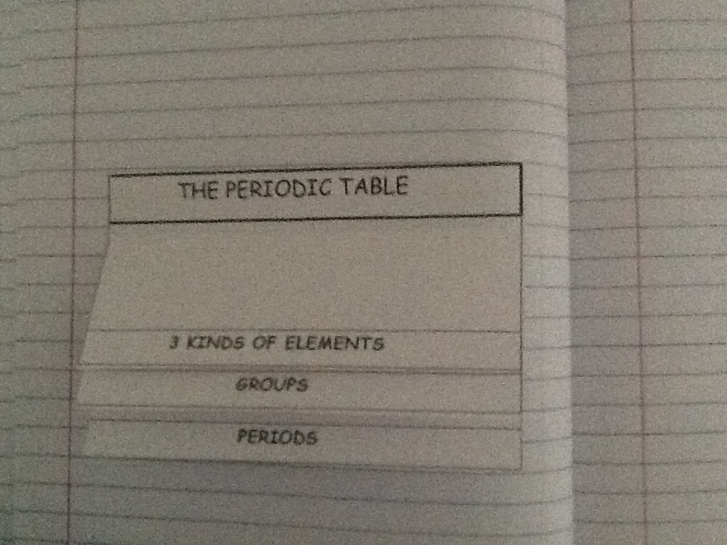
Anchor Tab

Activity 2 Physical Properties and Uses of Elements

Explore Materials for each lab table: Periodic Table, carbon (charcoal briquette), iron washer, lead, sulfur, copper, aluminum, magnet, conductivity tester

Activity 3 Comparing Solids, Liquids and Gases

Explore Materials: Balloon filled with water and frozen, Balloon filled with water, Balloon blown up by teacher or students. All should be about the same size.
Elaborate Materials: Beaker of water, bottle of food coloring

Activity 4 Comparing Densities of Objects in Various Fluids

Engage Materials: Teacher Demo - 500 mL beaker or small fish tank filled with water, 1 can Diet Coca Cola, 1 can regular Coca Cola
Explore Part 2 Materials: 500 mL graduated cylinder, or tall glass, lamp oil, 91% Isopropyl Alcohol, Vegetable Oil, water, food coloring, Dawn Dish Soap, light corn syrup, honey, screw, grape tomato, plastic bottle cap, ping pong ball

Activity 5 A Matter of Mixtures

Engage Materials: Bag of Chex Mix per table, paper towel
Explore Materials: cups or beakers, salt, water, oil, vinegar, dry lemonade mix,
sand, marbles, BBs, spoon.

Activity 6 Pure Substances

Explore Teacher Demo Materials: baking soda, Damp Rid, 2 -250 mL beakers with 50 mL of water, plastic spoon

Activity 7 Creating New Substances
Explore New Substance #1. Teacher Demo Materials: Beaker, vinegar, piece of steel wool, tongs,
New Substance #2 Per group Materials: baking soda, vinegar, portion cup, spoon, graduated cylinder
New Substance #3 Per group Materials: ammonia, portion cup, grape juice, graduated cylinder
New Substance #4 Per group Materials: beaker, water, Damp Rid (CaCl₂), spoon, thermometer, graduated cylinder

