6th grade Unit 10
Plate Tectonics

Objectives:
SCI6.10A Build a model to illustrate the structural layers of the Earth including the inner core, outer core, mantle, crust, asthenosphere and lithosphere.
SCI.6.10C Identify the major tectonic plates including Eurasian, African, Indo-Australian, Pacific, North American, and South American.
SCI.6.10D Describe how plate tectonics causes major geological events, such as ocean basins, earthquakes, volcanic eruptions, and mountain building.

All videos and power point can be found at www.missdoctorbailer.com

Activity 1 Layers of the Earth
Materials: Reading Cards - in PDFs for printing file, colored pencils, scissors

Focus: I can build a model to illustrate the layers of the Earth.
Language Objective: I can find out information and share it with my partners by reading and underlining important information.
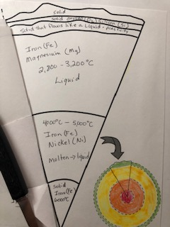
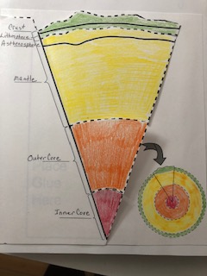

Activity 2 Identifying Tectonic Plates
Materials: none

Focus: I can identify the major tectonic plates of the world.
Language Objective: I can find out information and share it with my partners by listening to a video.

Activity 3 Effects of Tectonic Plates
Materials: Milky Way fun size candy bar per student, Power Point from website,
Tectonic Plate map from previous lesson.

Focus: I can describe how plate tectonics causes major geological events
Language Objective: I can gather information about tectonic plates by watching and listening to a power point presentation.

Activity 4 Continental Drift
Materials: Alfred Wegener Investigates Power Point, colored pencils, scissors, glue, World Map, Continent Sheet, Outline Sheet - all maps in PDFs for printing file

**Make a class set of the World Map
***After students have matched up the continents give them the Outline sheet and see if they can fit their continent into the outline. When the outline is cut out it will fit diagonally on the next page.

Focus: I can explain the theory of Continental Drift and identify the scientist who proposed it.

Language Objective: I can read and categorize information to create a map of Pangaea.

Activity 5 Why the Plates Move
Materials: colored pencils, shoebox prepared as shown below, video downloaded from website

Focus: I can describe how plate tectonics cause major geological events.
Language Objective: I can read and interpret information to classify plate boundaries.

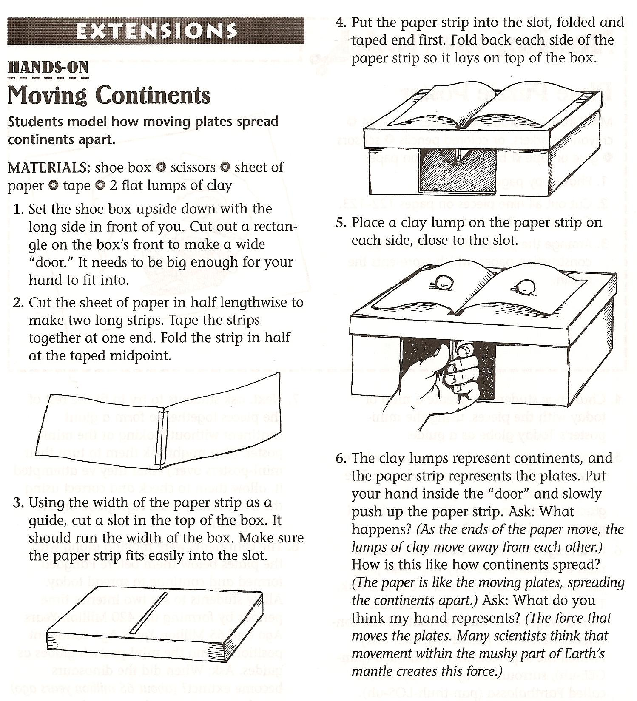

Activity 6 More Plate Boundaries

Materials: Plate Boundary Overview video from www.missdoctorbailer.com colored pencils, Plate Boundary Map

Focus: I can describe how plate tectonics causes major geological events, such as ocean basins, earthquakes, volcanic eruptions, and mountain building.

Language Objective: I can summarize a video by answering questions

Activity 7 Geologic Faults
Materials: two sets of Road and River squares for each student (A and B), scissors, glue, colored pencils, Plate Boundary Map from
previous lesson.

Focus: I can describe how plate tectonics causes major geological events, such as ocean basins, earthquakes, volcanic eruptions, and mountain building

Language Objective: I can read and follow directions.

