6th grade Unit 11
Space Science

Objectives
SCI.6.2D Construct tables, using repeated trials and means to organize data and identify patterns.
SCI.6.2E Analyze data to formulate reasonable explanations, communicate valid conclusions supported by the data, and predict trends.
SCI.6.3D Relate the impact of research on scientific thought and society including the history of science and contributions of scientists as related to the content.
SCI.6.11A Describe the physical properties, locations, and movements of the Sun, planets, Galilean moons, meteors, asteroids, and comets.
SCI.6.11B Understand that gravity is the force that governs the motion of our solar system.
SCI.6.11C Describe the history and future of space exploration including the types of equipment and transportation needed for space travel.

Activity 1 Ideas about the Solar System
Materials: Ideas Power Point from website, colored pencils

Focus: I can recognize the contributions of various astronomers on our knowledge of the solar system.

L.O. I can listen to a presentation and determine the ideas of various astronomers.

Activity 2 Our Closest Star
Materials: Life Cycle Power point from website, What Are Solar Flares from website, colored pencils

Focus: I can describe the physical properties of the Sun.
L.O.: I can read to learn and change that information into a diagram.

Activity 3 Exploring Our Solar System
Materials: Space School – Pluto from website, Solar system booklet, scissors, construction paper, glue, colored pencils, Planetary Facts Sheet

Focus: I can describe the physical properties and locations of the planets.
L.O.: I can read a chart for information.

Activity 4 Comparing the Sun and the Planets
Materials:
Part 1 Make a bulletin board display as shown on the last page. You will need it to complete the activity. Measurements are shown in the charts at the bottom.
Use a piece of string 10.9 meters long to show the sun.
This is almost 35 feet!
You might make Pluto but not post it.

Part 2 Calculators, modeling clay, toothpicks, tape scissors, Sun
made of yellow construction paper 25 cm diameter

Set up the sidewalk outside or the main hallway with these distances.

Planet | Scale Distance
Mercury | 38.7 cm
Venus | 72.3 cm
Earth | 1 m
Mars | 1.5 m
Jupiter | 5.2 m
Saturn | 9.5 m
Uranus | 19.2 m
Neptune | 30.1 m

Focus: I can compare the size of the sun to the planets in our solar system.

L.O.: I can work with my partners to construct a planet to scale.

Activity 5 What’s Gravity Got to do with it?
Materials:
- What is Gravity? video from website,
- small bowl, Saran wrap, size C or D battery, marble
- calculators, meter sticks

Focus: I can state that gravity is the force that governs the motion of our solar system.

L.O. I can work with my partners to determine how gravity affects weight and motion.

Activity 6 Jupiter and its Moons
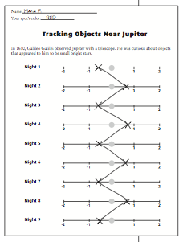
Materials: JupMoons Tracking Power Point from website, colored pencils, Jupiter and its Moons video from website

This diagram is an example of what student’s papers should look like. Each moon should have a slightly different zigzag line.

Focus: I can describe the physical properties and locations of the Galilean moons.

L.O. I can listen to a video and summarize my learning by writing interesting facts.

Activity 7 Finding Out About Asteroids
Materials: colored pencils, Asteroids power point from website

Focus: I can describe the physical properties and locations of asteroids.

L.O. I can read a chart and summarize the information by answering questions.

Activity 8 Observing a comet
Materials:
- Styrofoam ball or sheet of copy paper, ribbon or Mylar gift strips, tape, wooden skewer, hairdryer or fan
- Famous Comets handout, glue, scissors

On the next page you will see the Famous Comets handout cut and glued into the notebook. If printing so many pages is a problem, make a class set with the pages front and back and use in each class.

Focus: I can describe the physical properties and locations of comets.

L.O. I can listen to a video and summarize what I have learned by writing three facts about comets.

Famous Comets foldable

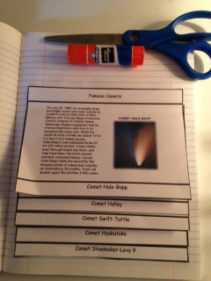

Activity 9 Meteors and their Craters
Materials: Cocoa powder, flour, rectangular cake pan, 3 small rocks,
3 large rocks, newspaper, ruler (1 pan set up per class)

Focus: I can describe the physical properties and locations of meteors.

L.O. I can read and summarize the information by answering questions.

Activity 10 History and Future of Space Exploration
Materials: Event Cards, computers with Internet access

Focus: I can describe the history and future of space exploration including the types of equipment and transportation needed for space travel.

L.O. I can read and organize events on a timeline.
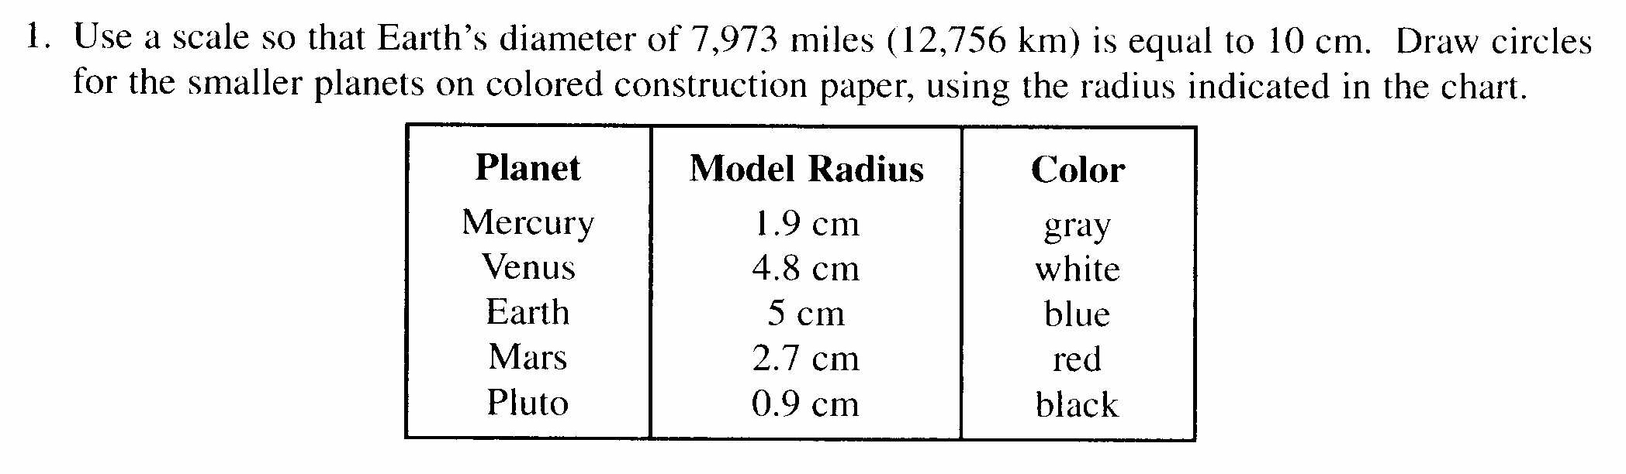
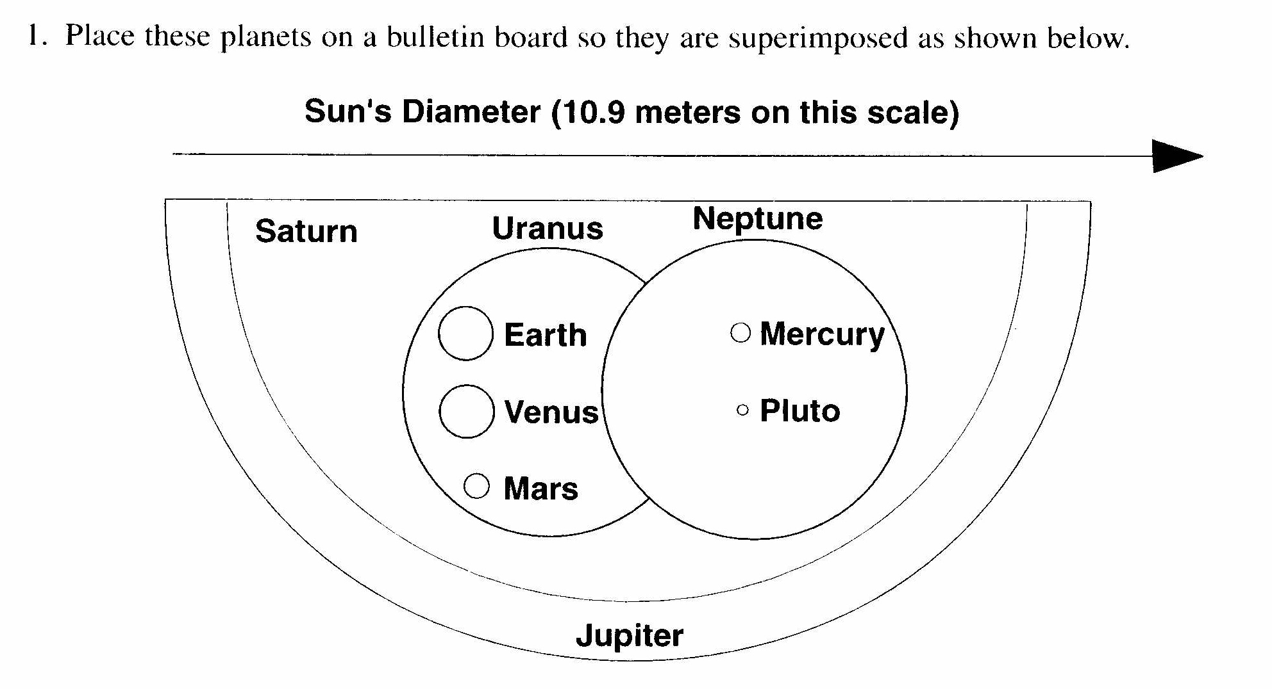
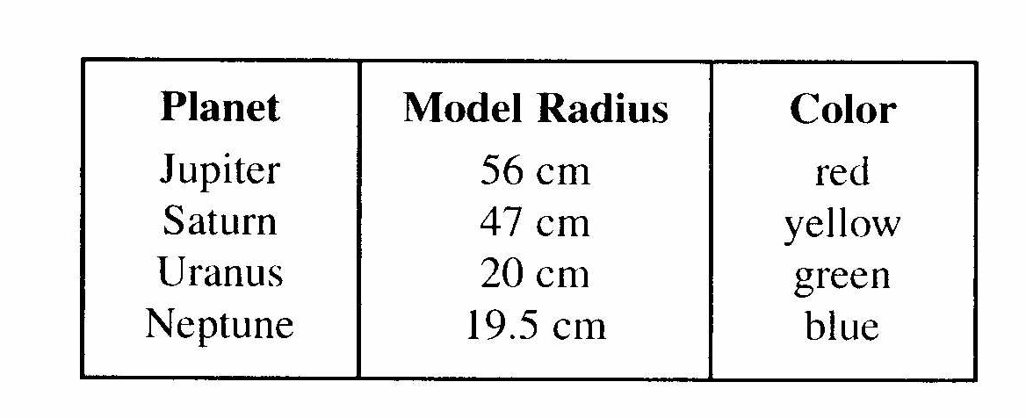
BULLETIN BOARD DISPLAY

