**Media release | Save the kebab**

23 March 2025  
For interview: Helen Curtis 0413 560 413

**'Save the Kebab' - City of Perth urged to restore iconic artwork ahead of $250k *Boonji Spaceman* spend**

Key points:

* The Perth arts community is calling on the City of Perth to restore *Ore Obelisk* and *Arch*, two significant cultural assets before spending $250k to install donated American artwork *Boonji Spaceman*.
* 'Save the Kebab' says installing *Boonji Spaceman* whilst *Ore Obelisk* sits in storage erodes Perth's cultural heritage and represents poor value to the people of Perth.

The Perth arts community is calling on the City of Perth to 'Save the Kebab' and reinstate *Ore Obelisk, a* public artwork affectionately known as'the kebab' that is set to be replaced by American artwork *Boonji Spaceman* at a cost of $250k to ratepayers.

*Boonji Spaceman* wasdonated to the City by New York artist Brendan Murphy in 2024. Self-taught, Murphy was a professional athlete and Wall Street trader before taking up art in the early 2000s. Editions of the seven-metre, chrome-finished spaceman statue can be seen in London, Oslo, Dubai and Antigua.

Murphy will be using the donated statue to promote the sale of NFTs at his exhibition at Gullotti Galleries later this year coinciding with the installation of the statue. Gullotti Galleries is not within the City of Perth area of authority.

*Ore Obelisk* is a 15-metre artwork by artist Paul Ritter. It was commissioned in 1971 to celebrate Western Australia’s mining heritage and mark the state’s one-millionth resident. A much-loved landmark in Stirling Gardens for 50 years, 'the kebab' features stacked spheres of ore from across the State. The artwork has been in storage since it was removed for conservation in 2021.

Perth arts sector leader and 'Save the Kebab' spokesperson Helen Curtis spent thirteen years developing the arts program at the City of Perth. She says the decision to install *Boonji Spaceman* in place of *Ore Obelisk* shows deep disrespect for Perth's cultural heritage, represents poor value and directly contradicts the City's public art policies.

“The story *Ore Obelisk* tells will forever be important to Western Australia,” says Curtis. “The *Obelisk* commemorates a moment in which the state reached the million milestone and it profiles the mining industry, which has, like it or not, made us what we are. This was an incredible moment of optimism, when the young city was growing and tremendously energetic.”

Says Curtis. "*Boonji Spaceman* is a generic, mass-produced sculpture with no connection to our people or place."

She adds, “This is about respecting and preserving works that tells Perth’s story. The City's arts policies are designed to preserve and maintain significant public artworks, engage local artists, and ensure transparency in acquisitions. *Boonji Spaceman* fails on all counts."

A 2021 structural report costed the restoration of *Ore Obelisk* at $118,000 - less than half of what the City has flagged to install *Boonji Spaceman*.​ Lord Mayor Zempilas said in a media release that the cost of transporting and installing the statue was [a small price to pay](https://perth.wa.gov.au/news-and-updates/all-news/boonji-spaceman-statue-set-to-land-in-perth) for a world-class attraction for the City.

“The City of Lights connection is simply a convenient way to frame the acquisition of

something that has nothing to do with us as Western Australians,” argues Curtis.

“Locating *Boonji Spaceman* in Stirling Gardens — Perth’s oldest public gardens — makes no sense.”

Several other artworks of cultural significance are also in storage, including *Arch* by Lorenna Grant. Installed in 2009 as part of the award-winning Northbridge Piazza redevelopment, *Arch* was one of the city’s most innovative and instantly recognisable public artworks and was internationally celebrated. *Arch* was removed by the City of Perth for maintenance in 2023, with no commitment to reinstatement.

The fight to save The Kebab is coinciding with the battle to prevent the Boonji Spaceman being put in its place. No decision has been made about where Murphy’s piece, which is part of a greater project involving cryptocurrency-like Non-Fungible Tokens or NFTs and firmly embedded within the world of commercial art, but Curtis and others are firm in their belief it should not be placed in front of a civic building.

"It's disgraceful that our city's cultural heritage is being quietly erased and replaced with imported art that serves largely to promote the foreign artist who gifted it," Curtis concludes. "The $250k required to install *Boonji Spaceman* would be better spent bringing back the kebab and properly maintaining what exists."

*'Save the Kebab' is collecting signatures to present in a submission to the Perth City Council meeting on 25 March.*

- Ends -

**For media inquiries, contact:**  
Helen Curtis  
savethekebab.perth@gmail.com  
0413 560 413

Instagram @savethekebab

**About the** [***Ore Obelisk***](https://www.dropbox.com/scl/fi/154d4c8uiu3nuxfift1jc/The-Ore-Obelisk-in-Perth-1971.pdf?rlkey=b1xlvggdcbb9d5qkdeqwm4szc&dl=0)

The *Ore Obelisk* was designed by Paul Ritter and installed in 1971. It was commissioned to mark Western Australia’s one-millionth resident, serving as a symbol of the state’s economic strength and rich geological heritage. Its placement in Stirling Gardens, directly adjacent to Council House, reinforced its role as a civic landmark, physically and conceptually tied to the seat of local government.

The *Ore Obelisk* and Council House are intrinsically linked, representing a bold vision for Perth’s modern identity in the late 20th century. Council House was completed in 1963 and was a radical architectural statement of its time - a modernist glass and steel structure that embodied a progressive, forward-looking Perth.

The *Ore Obelisk* complemented this ethos, celebrating Western Australia’s resources and prosperity at a time when the mining industry was booming and reshaping the state’s economy. The artwork’s vertical layers of ore, sourced from across Western Australia, visually represented the materials that built the state’s wealth - standing as a civic tribute to the industry that fuelled Perth’s growth.

Together, Council House and the *Ore Obelisk* tell a story of Perth’s ambition, innovation, and confidence on the global stage. The obelisk’s removal in 2021 severed a vital connection between the city’s architectural and industrial heritage.

Restoring the *Ore Obelisk* is important to preserving the deep connection between place, industry, and civic pride.

**About Boonji Spaceman**

The *Boonji Spaceman* is being used to promote [an exhibition](https://www.instagram.com/gullottigalleries_official/p/C8yLoUJPwGt/) that will take place later this year at [Gullotti Galleries](https://www.instagram.com/gullottigalleries_official/) in Cottesloe.

Gullotti Galleries is in Cottesloe, not in the CBD, and not within the City of Perth’s area of authority.

The *Boonji Spaceman* is part of Brendan Murphy’s [*Boonji Project*](https://www.boonjiproject.com/) a “collection of 11,111 unique digital Non-Fungible Tokens launched on the Ethereum blockchain.”

Spaceman statues can be seen in London, Oslo, Dubai and Antigua.

An excerpt from [Town & Country magazine](https://www.townandcountrymag.com/leisure/arts-and-culture/a36424415/brendan-murphy-artist-interview-antigua-spaceman/) says, Murphy “played professional basketball in Europe before moving to New York City in the Nineties to be a trader on Wall Street. After September 11th, he decided finance wasn’t for him and started pursuing art. “My paintings were terrible but I had a lot of rich friends,” he says. By Murphy’s own estimation, his relationships and his time are his currencies. The former is fueled by his natural modesty and what-you-see-is-what-you-get attitude.”

**About Helen Curtis**

Helen Curtis has over two decades of experience as visual arts sector leader. She worked at the City of Perth for 13 years where she developed the arts and culture team and program. In 2014, she founded Apparatus, a creative consultancy specialising in art and cultural services. Apparatus has delivered many significant public art projects that have become beloved statewide landmarks and worked with major institutions on their art collections.

Images are available [**here**](https://www.dropbox.com/scl/fo/n5o1g00jc8fkcsx88bzuv/ANAHLXGM-y7z0QunMou_mLA?rlkey=3n0mcd15n0fyyauanp1krc39h&dl=0)

**Restore the *Ore Obelisk*: A Lost Landmark of Perth’s Civic and Cultural Heritage**

The Ore Obelisk and Council House are intrinsically linked, both representing a bold vision for Perth’s modern identity in the late 20th century.

Designed by Paul Ritter and installed in 1971, the *Ore Obelisk* was commissioned to mark Western Australia’s one-millionth resident, serving as a symbol of the state’s economic strength and rich geological heritage. Its placement in Stirling Gardens, directly adjacent to Council House, reinforced its role as a civic landmark, physically and conceptually tied to the seat of local government.

Council House itself, completed in 1963, was a radical architectural statement of its time - a modernist glass and steel structure that embodied a progressive, forward-looking Perth. The *Ore Obelisk* complemented this ethos, celebrating Western Australia’s resources and prosperity at a time when the mining industry was booming and reshaping the state’s economy. The artwork’s vertical layers of ore, sourced from across Western Australia, visually represented the very materials that built the state’s wealth - standing as a civic tribute to the industry that fuelled Perth’s growth.

Together, Council House and the *Ore Obelisk* told a story of Perth’s ambition, innovation, and confidence on the global stage. The obelisk’s removal in 2021 severed a vital connection between the city’s architectural and industrial heritage. Rather than being reinstated, it has been sidelined, while a commercially produced, editioned sculpture with no local relevance - *Boonji Spaceman -* is being prioritised.

“This isn’t about rejecting new art—it’s about respecting and preserving the art that tells Perth’s story,” says Curtis “*Boonji Spaceman* is not unique to our city. The *Ore Obelisk* is. Yet one is being celebrated, while the other is quietly erased. We call on the City of Perth to immediately commit to reinstating the *Ore Obelisk* and to stop prioritising imported spectacle over Perth’s own cultural legacy. The community deserves transparency, accountability, and a public art strategy that values our history, our artists, and our city.”

If Council House is a monument to civic progress, then the *Ore Obelisk* was its cultural counterpart - a symbol of Perth’s unique identity, rooted in its land and history.

Restoring the *Ore Obelisk* is not just about reinstating an artwork; it’s about preserving the deep connection between place, industry, and civic pride.

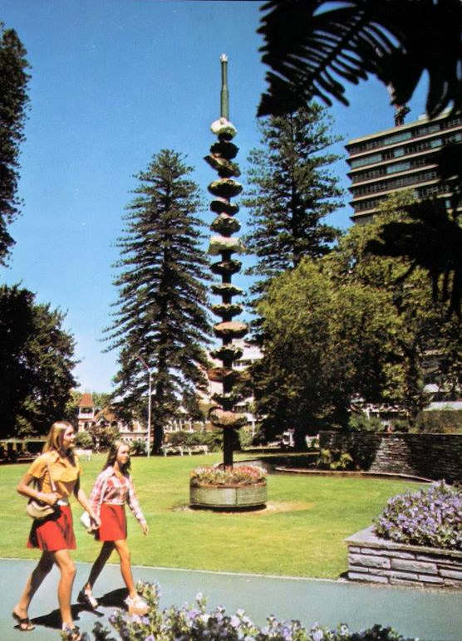

*Ore Obelisk* by Paul Ritter, Stirling Gardens, 1971. Image: (Museum of Perth)

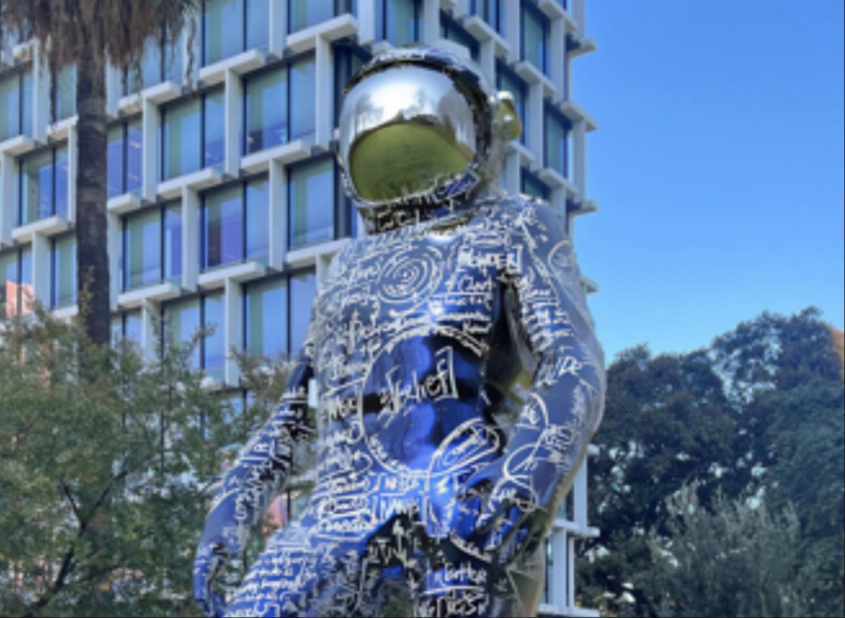

*City of Perth facebook*

**A Short History of the Ore Obelisk**

The *Ore Obelisk*, a striking 15m high public artwork, stood for fifty years in Perth’s Stirling Gardens as a monument to Western Australia’s mining industry and economic expansion. Conceived by architect and planner Paul Ritter, the sculpture commemorates the state’s growth following the mining boom and the milestone of reaching one million residents.

Colloquially referred to as the *Kebab* due to its stacked rock formations, the *Ore Obelisk* was constructed using 15 different ores, each sourced from significant mining regions across WA.

"The Obelisk… is one of the sculptures most connected to Council House. It was created to commemorate the mineral and energy boom that began in the 1960s and the large development projects in the north west of the State that were directed from Perth.

Ore Obelisk was conceived by Paul Ritter, Director of the Planned Environment and Educational Research Institute and represented the idea of mirroring what was happening under the ground and the optimism of the mining boom. From the steel base a 45 ft high (13.7 metres) oil drilling pipe threads 15 different ores and is capped by a drill bit.

The Chamber of Mines obtained ores from many of the main mining companies then operating and transported them via truck, thousands of miles to Perth. Many other companies contributed to the project and the Perth City Council contributed the site at the front of Stirling Gardens near the ornamental pool. It took 12 hours to erect, after which Ore Obelisk was formally unveiled on 23 July 1971.

In 1997 Ore Obelisk was refurbished and a 16th layer, a diamond rock, was added to acknowledge the diamond industry in WA.” (50 Years: Council House)

The structure was topped with a glass polyhedron in 1997, added by Ritter and then-Lord Mayor Peter Nattrass to symbolise the diamond industry’s importance to the state. The artwork sought to embody the harmony between mining and the natural environment.

Over time, Ore Obelisk began to deteriorate due to exposure to the elements. By 2021, structural inspections revealed severe degradation, particularly in the concrete-bonded conglomerate sections, which had become fragile and prone to failure. Some rocks could be removed by hand, and significant structural risks were identified. The City of Perth commissioned a report confirming the risk of rock and glass falls, leading to the immediate barricading of the area for public safety.

Just shy of its 50th anniversary, in July 2021, the *Ore Obelisk* was dismantled and removed. The City announced that the artwork would be placed in offsite storage while options for conservation, decommissioning, or replacement were considered. Concerns arose that it would remain indefinitely in storage, as no formal plans were made public.

Today, the fate of the *Ore Obelisk* remains uncertain. The removal of such a historically significant public artwork has sparked debate on the preservation of Perth’s cultural landmarks and the responsibility of city authorities to maintain and restore them.

**About the artist:**

"Paul Ritter (6 April 1925 - 14 June 2010) was a Western Australian architect, town planner,

sociologist, artist and author. In his roles as the first city planner of the City of Perth and

subsequent two decades spent serving as Councillor for East Perth, Ritter is remembered as a brilliant, eccentric and often controversial public figure who consistently fought to preserve and enhance the character and vitality of the central city district. Today he is primarily remembered for his involvement in preserving many of Perth's heritage buildings at a time of rapid redevelopment and preventing the construction of an eight-lane freeway on the Swan River foreshore.

Ritter was born in Prague on 6 April 1925 to Jewish parents Carl Ritter and Elsa (née

Schnabel). In 1939, at the age of 13, Ritter was evacuated from Czechoslovakia to England via the Kindertransport. He graduated as a Bachelor of Architecture and Master of Civic Design from the University of Liverpool. In 1946 he married fellow-graduate Jean Patricia Finch with whom he eventually had five daughters and two sons.

From 1954 to 1964, Paul and Jean Ritter ran the Ritter Press in Nottingham, where Paul taught at the School of Architecture from 1952 to 1964, when the School moved to the University, and a new professor was appointed.

Mr W A Mcl Green, Town Clerk of Perth City Council (PCC), invited Ritter to head the Council's newly formed Department of Planning. Ritter accepted, and after migrating with his family to Perth in late 1964, began work as Perth's first City Planner in May of the following year." (50 Years: Council House)

**The Ores**

From top to bottom the ores and where they are from

* Dodecahedron (Diamond) Kimberley Region
* Magnesite (Magnesium) Ravensthorpe
* Manganese Ore (Manganese) Woodie Woodie
* Quartz Dolerite (Silver) Kalgoorlie
* Cassiterite (Tin) Shaw River
* Hematite (Iron) Mt Whaleback
* Galena (Lead) Northampton
* Supergene (Nickel) Kambalda
* Nickel Sulphides (Nickel) Kambalda
* Quartz Dolerite (Gold) Kalgoorlie
* Spodumene (Lithium) Ravensthorpe
* Bauxite (Aluminium) Jarrahdale
* Chalcocite (Copper) Ravensthorpe
* Jaspilite (Iron) Koolyanobbing
* Azurite & Malachite (Copper) Thaduna
* Hematite (Iron) Koolyanobbing

**Photos:**

1. Girls on the lawn in front of the Obelisk, 1975, Stevenson, Kinder and Scott, SLWA 347261PD

2. Paul Ritter (left) and Lord Mayor Dr Peter Nattrass inspect the diamond rock added to Ore Obelisk in March 1997.

3. Removal of the Ore Obelisk, July 2021.

4. The Ore Obelisk in Stirling Gardens, St George's Terrace, Perth, December 1980, State Library of Western Australia (311040PD)

**Acknowledgements**

Many thanks to the Museum of Perth

A history of Ore Obelisk from 50 Years: Council House, 1963-2013, Perth, Western Australia : City of Perth, 2013

**A Short History of The Arch**

Lorenna Grant’s *The Arch* was an iconic public artwork that graced Northbridge for 15 years, standing as both a sculptural landmark and a cultural symbol. Installed in 2009 at the intersection of Lake and James Streets, the 8.5-metre-high and 10-metre-wide artwork was commissioned by the City of Perth to coincide with the opening of the Northbridge Piazza. The sculpture was designed as a bold and dynamic reflection of the eclectic, multicultural, and lively atmosphere of Northbridge, one of Perth’s most renowned entertainment and cultural precincts​“The Arch” by Lorenna G….

Constructed with a striking combination of steel and Alucobond aluminium composite cladding, *The Arch* was fabricated by DENMAC, a Perth-based company specializing in architectural metalwork. The artwork was conceptualized as a ‘guardian’ of the area—a powerful, feminine presence stepping forward with confidence, embodying the vibrant, diverse, and sometimes gritty energy of Northbridge​“The Arch” by Lorenna G…. More than just an aesthetic feature, *The Arch*also played a practical role in traffic calming, helping to slow vehicles at the busy roundabout and providing a symbolic ‘arm’ over pedestrians participating in social justice rallies, including Gay Pride and protest marches​Submission - New Vision….

Despite its significance, *The Arch* suffered from structural wear over time, particularly rust damage at its lower sections. By late 2023, the City of Perth removed the artwork, citing corrosion issues as the reason. However, this decision was met with public outcry, as many Northbridge residents and visitors had grown attached to the sculpture as an integral part of the urban landscape. The removal was also controversial because Grant had offered a cost-effective repair plan, but the City instead opted to place the artwork in storage with no immediate plans for restoration​What happened to the No….

In response, Grant proposed a “New Vision” for *The Arch*, suggesting two options: a full reinstatement at an alternative location for $193,000 or a partial reinstallation as an “archaeological relic” for $51,500. The latter option would preserve elements of the original sculpture in Northbridge, paying tribute to its legacy and the cultural identity it had helped shape​Submission - New Vision…. However, despite these efforts, the City of Perth declined to allocate funding for the project, leaving the future of *The Arch* uncertain.

The removal of *The Arch* was further criticized when it was revealed that the City had spent $250,000 to transport and install an astronaut sculpture from the U.S. during the same period, highlighting a disparity in funding priorities for local artists​What happened to the No…. Grant and her supporters continue to advocate for the artwork’s reinstatement, emphasizing its historical and cultural value to the city.

Even in its absence, *The Arch* remains a significant piece of Perth’s artistic heritage. It embodied movement, change, and resilience, much like the ever-evolving landscape of Northbridge itself. Whether reinstalled or remembered in archival form, *The Arch* is a testament to the power of public art in shaping community identity and urban storytelling.

**About the artist:**

Lorenna Grant is a celebrated Australian artist known for her dynamic public artworks that explore movement, identity, and the interplay between urban environments and human experience. Born with a passion for the arts, Grant initially pursued creative expression through weaving, ceramics, and poetry before formally studying art at the age of 30​Artist Profile - Lorenn…. Her career took off after winning two prestigious artist residencies—one with the National Australia Council in Milan and another in Barcelona and Switzerland. Shortly thereafter, she secured her first public art commission with the Department of Education​Artist Profile - Lorenn….

Grant’s public artworks are deeply influenced by place, culture, and narrative. She integrates her pieces into the landscape, using a multidisciplinary approach that combines sculpture, architecture, and urban design. Over the years, she has worked on more than 40 major projects, including *Mulla Mulla* in Karratha, *The Goal Keeper* at Ernest Johnson Reserve, and numerous works throughout Perth’s urban fabric​Artist Profile - Lorenn….

A former lecturer at Edith Cowan University and the University of Western Australia, Grant has also played a significant role in mentoring emerging artists. Her work with DENMAC has resulted in some of Perth’s most iconic sculptures, with *The Arch* being one of her most recognized pieces​Artist Profile - Lorenn…. Despite challenges in the public art sector, Grant remains committed to creating works that provoke thought, inspire connection, and contribute to the cultural identity of the spaces they inhabit.

**Photos:**

1. The Arch_Lorenna GRANT

**Acknowledgements**

Many thanks to the Museum of Perth

A history of the Obelisk from 50 Years: Council House, 1963-2013, Perth, Western Australia : City of Perth, 2013

