**Media release | Save the kebab**

11 March 2025  
For interview: Helen Curtis 0413 560 413

**'Save the Kebab' - City of Perth urged to restore iconic artwork ahead of $250k *Boonji Spaceman* spend**

Key points:

* The Perth arts community is calling on the City of Perth to reinstate *Ore Obelisk,* a public artwork affectionately known as'the kebab',before spending $250k to install American artwork *Boonji Spaceman* in its place.
* 'Save the Kebab' says installing *Boonji Spaceman* whilst *Ore Obelisk* sits in storage erodes Perth's cultural heritage and represents poor value to the people of Perth.

The Perth arts community is calling on the City of Perth to 'Save the Kebab' and reinstate *Ore Obelisk, a* public artwork affectionately known as'the kebab' that is set to be replaced by American artwork *Boonji Spaceman* at a cost of $250k to ratepayers.

*Boonji Spaceman* wasgifted to the city by New York artist Brendan Murphy in 2024. Self-taught, Murphy was a professional athlete and Wall Street trader before taking up art in the early 2000s. Editions of the seven-metre, chrome-finished spaceman statue can be seen in London, Oslo, Dubai and Antigua.

*Ore Obelisk* is a 15-metre artwork by artist Paul Ritter. It was commissioned in 1971 to celebrate Western Australia’s mining heritage and mark the state’s one-millionth resident. A much-loved landmark in Stirling Gardens for 50 years, 'the kebab' features stacked spheres of ore from across the State. The artwork has been in storage since it was removed for conservation in 2021.

Perth arts sector leader and 'Save the Kebab' spokesperson Helen Curtis spent thirteen years developing the arts program at the City of Perth. She says the decision to install *Boonji Spaceman* in place of *Ore Obelisk* shows deep disrespect for Perth's cultural heritage, represents poor value and directly contradicts the City's public art policies.

"*Ore Obelisk* is a landmark piece of West Australian history that recognises the importance of the mining industry to the State," says Curtis. "*Boonji Spaceman* is a generic, mass-produced sculpture with no connection to our people or place."

“This isn’t about rejecting new art," she adds. "It’s about respecting and preserving art that tells Perth’s story. The City's arts policies are designed to preserve and maintain significant public artworks, engage local artists, and ensure transparency in acquisitions. *Boonji Spaceman* fails on all counts."

A 2021 structural report costed the restoration of *Ore Obelisk* at $118,000 - less than half of what the City has flagged to install *Boonji Spaceman*.​ Lord Mayor Zempilas said in a media release that the cost of transporting and installing the statue was [a small price to pay](https://perth.wa.gov.au/news-and-updates/all-news/boonji-spaceman-statue-set-to-land-in-perth) for a world-class attraction for the City.

Curtis disagrees. “This isn’t just about one artwork,” she says. “It’s about the thread of history that runs through our city and records its evolution. Perth deserves quality public art that amplifies our stories and supports our artists, not pieces parachuted in for Instagram.”

Several other artworks of cultural significance are also in storage, including *Arch* by Lorenna Grant. Installed in 2009 as part of the award-winning Northbridge Piazza redevelopment, *Arch* was one of the city’s most innovative and instantly recognisable public artworks and was internationally celebrated. *Arch* was removed by the City of Perth for maintenance in 2023, with no commitment to reinstatement.

"It's disgraceful that our city's cultural heritage is being quietly erased and replaced with imported art that serves largely to promote the foreign artist who gifted it," Curtis concludes. "The $250k required to install *Boonji Spaceman* would be better spent bringing back the kebab and properly maintaining what exists."

*(finish on what happens next - for example,*

*'Save the Kebab' is collecting signatures from the Perth arts community to present in a submission to the Perth City Council meeting on x March.*

- Ends -

**For media inquiries, contact:**  
Helen Curtis  
savethekebab.perth@gmail.com  
0413 560 413

Instagram @savethekebab

**About the *Ore Obelisk***

The *Ore Obelisk* was designed by Paul Ritter and installed in 1971. It was commissioned to mark Western Australia’s one-millionth resident, serving as a symbol of the state’s economic strength and rich geological heritage. Its placement in Stirling Gardens, directly adjacent to Council House, reinforced its role as a civic landmark, physically and conceptually tied to the seat of local government.

The *Ore Obelisk* and Council House are intrinsically linked, representing a bold vision for Perth’s modern identity in the late 20th century. Council House was completed in 1963 and was a radical architectural statement of its time - a modernist glass and steel structure that embodied a progressive, forward-looking Perth.

The *Ore Obelisk* complemented this ethos, celebrating Western Australia’s resources and prosperity at a time when the mining industry was booming and reshaping the state’s economy. The artwork’s vertical layers of ore, sourced from across Western Australia, visually represented the materials that built the state’s wealth - standing as a civic tribute to the industry that fuelled Perth’s growth.

Together, Council House and the *Ore Obelisk* tell a story of Perth’s ambition, innovation, and confidence on the global stage. The obelisk’s removal in 2021 severed a vital connection between the city’s architectural and industrial heritage.

Restoring the *Ore Obelisk* is important to preserving the deep connection between place, industry, and civic pride.

**About Boonji Spaceman**

(insert)

**About Helen Curtis**

Helen Curtis has over two decades of experience as visual arts sector leader and educator. She worked at the City of Perth for 13 years where she developed the arts team and program. In 2014 she founded APPARATUS, a creative consultancy specialising in art and integrated design within the public realm. APPARATUS has delivered many significant public art projects that have become beloved statewide landmarks.

Images are available **here** (insert link or attach to email)

**Restore the *Ore Obelisk*: A Lost Landmark of Perth’s Civic and Cultural Heritage**

The Ore Obelisk and Council House are intrinsically linked, both representing a bold vision for Perth’s modern identity in the late 20th century.

Designed by Paul Ritter and installed in 1971, the *Ore Obelisk* was commissioned to mark Western Australia’s one-millionth resident, serving as a symbol of the state’s economic strength and rich geological heritage. Its placement in Stirling Gardens, directly adjacent to Council House, reinforced its role as a civic landmark, physically and conceptually tied to the seat of local government.

Council House itself, completed in 1963, was a radical architectural statement of its time - a modernist glass and steel structure that embodied a progressive, forward-looking Perth. The *Ore Obelisk* complemented this ethos, celebrating Western Australia’s resources and prosperity at a time when the mining industry was booming and reshaping the state’s economy. The artwork’s vertical layers of ore, sourced from across Western Australia, visually represented the very materials that built the state’s wealth - standing as a civic tribute to the industry that fuelled Perth’s growth.

Together, Council House and the *Ore Obelisk* told a story of Perth’s ambition, innovation, and confidence on the global stage. The obelisk’s removal in 2021 severed a vital connection between the city’s architectural and industrial heritage. Rather than being reinstated, it has been sidelined, while a commercially produced, editioned sculpture with no local relevance - *Boonji Spaceman -* is being prioritised.

“This isn’t about rejecting new art—it’s about respecting and preserving the art that tells Perth’s story,” says [Spokesperson Name]. “*Boonji Spaceman* is not unique to our city. The *Ore Obelisk* is. Yet one is being celebrated, while the other is quietly erased. We call on the City of Perth to immediately commit to reinstating the *Ore Obelisk* and to stop prioritising imported spectacle over Perth’s own cultural legacy. The community deserves transparency, accountability, and a public art strategy that values our history, our artists, and our city.”

If Council House is a monument to civic progress, then the *Ore Obelisk* was its cultural counterpart - a symbol of Perth’s unique identity, rooted in its land and history.

Restoring the *Ore Obelisk* is not just about reinstating an artwork; it’s about preserving the deep connection between place, industry, and civic pride.

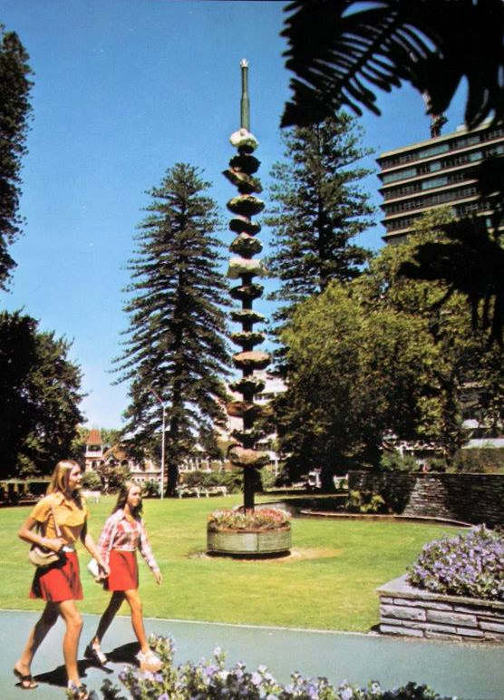

*Ore Obelisk* by Paul Ritter, Stirling Gardens, 1971. Image: (Museum of Perth)

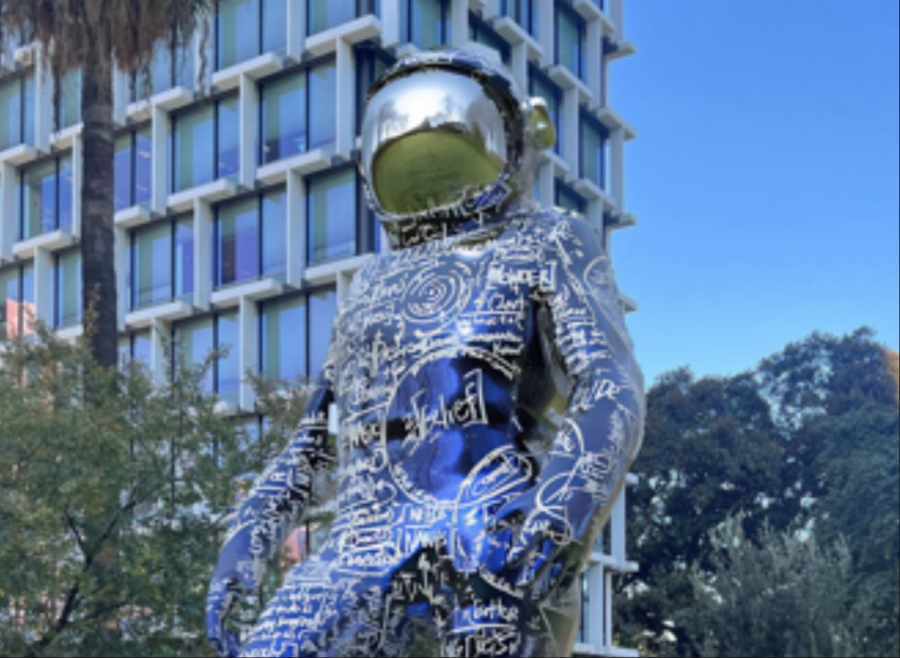

*City of Perth facebook*

**A Short History of the Ore Obelisk**

The *Ore Obelisk*, a striking 15m high public artwork, stood for fifty years in Perth’s Stirling Gardens as a monument to Western Australia’s mining industry and economic expansion. Conceived by architect and planner Paul Ritter, the sculpture commemorates the state’s growth following the mining boom and the milestone of reaching one million residents.

Colloquially referred to as the *Kebab* due to its stacked rock formations, the *Ore Obelisk* was constructed using 15 different ores, each sourced from significant mining regions across WA.

"The Obelisk… is one of the sculptures most connected to Council House. It was created to commemorate the mineral and energy boom that began in the 1960s and the large development projects in the north west of the State that were directed from Perth.

The Obelisk was conceived by Paul Ritter, Director of the Planned Environment and Educational Research Institute and represented the idea of mirroring what was happening under the ground and the optimism of the mining boom. From the steel base a 45 ft high (13.7 metres) oil drilling pipe threads 15 different ores and is capped by a drill bit.

The Chamber of Mines obtained ores from many of the main mining companies then operating and transported them via truck, thousands of miles to Perth. Many other companies contributed to the project and the Perth City Council contributed the site at the front of Stirling Gardens near the ornamental pool. It took 12 hours to erect, after which The Obelisk was formally unveiled on 23 July 1971.

In 1997 The Obelisk was refurbished and a 16th layer, a diamond rock, was added to acknowledge the diamond industry in WA.” (50 Years: Council House)

The structure was topped with a glass polyhedron in 1997, added by Ritter and then-Lord Mayor Peter Nattrass to symbolise the diamond industry’s importance to the state. The artwork sought to embody the harmony between mining and the natural environment.

Over time, the obelisk began to deteriorate due to exposure to the elements. By 2021, structural inspections revealed severe degradation, particularly in the concrete-bonded conglomerate sections, which had become fragile and prone to failure. Some rocks could be removed by hand, and significant structural risks were identified. The City of Perth commissioned a report confirming the risk of rock and glass falls, leading to the immediate barricading of the area for public safety.

Just shy of its 50th anniversary, in July 2021, the *Ore Obelisk* was dismantled and removed. The City announced that the artwork would be placed in offsite storage while options for conservation, decommissioning, or replacement were considered. Concerns arose that it would remain indefinitely in storage, as no formal plans were made public.

Today, the fate of the *Ore Obelisk* remains uncertain. The removal of such a historically significant public artwork has sparked debate on the preservation of Perth’s cultural landmarks and the responsibility of city authorities to maintain and restore them.

**About the artist:**

"Paul Ritter (6 April 1925 - 14 June 2010) was a Western Australian architect, town planner,

sociologist, artist and author. In his roles as the first city planner of the City of Perth and

subsequent two decades spent serving as Councillor for East Perth, Ritter is remembered as a brilliant, eccentric and often controversial public figure who consistently fought to preserve and enhance the character and vitality of the central city district. Today he is primarily remembered for his involvement in preserving many of Perth's heritage buildings at a time of rapid redevelopment and preventing the construction of an eight-lane freeway on the Swan River foreshore.

Ritter was born in Prague on 6 April 1925 to Jewish parents Carl Ritter and Elsa (née

Schnabel). In 1939, at the age of 13, Ritter was evacuated from Czechoslovakia to England via the Kindertransport. He graduated as a Bachelor of Architecture and Master of Civic Design from the University of Liverpool. In 1946 he married fellow-graduate Jean Patricia Finch with whom he eventually had five daughters and two sons.

From 1954 to 1964, Paul and Jean Ritter ran the Ritter Press in Nottingham, where Paul taught at the School of Architecture from 1952 to 1964, when the School moved to the University, and a new professor was appointed.

Mr W A Mcl Green, Town Clerk of Perth City Council (PCC), invited Ritter to head the Council's newly formed Department of Planning. Ritter accepted, and after migrating with his family to Perth in late 1964, began work as Perth's first City Planner in May of the following year." (50 Years: Council House)

**The Ores**

From top to bottom the ores and where they are from

* Dodecahedron (Diamond) Kimberley Region
* Magnesite (Magnesium) Ravensthorpe
* Manganese Ore (Manganese) Woodie Woodie
* Quartz Dolerite (Silver) Kalgoorlie
* Cassiterite (Tin) Shaw River
* Hematite (Iron) Mt Whaleback
* Galena (Lead) Northampton
* Supergene (Nickel) Kambalda
* Nickel Sulphides (Nickel) Kambalda
* Quartz Dolerite (Gold) Kalgoorlie
* Spodumene (Lithium) Ravensthorpe
* Bauxite (Aluminium) Jarrahdale
* Chalcocite (Copper) Ravensthorpe
* Jaspilite (Iron) Koolyanobbing
* Azurite & Malachite (Copper) Thaduna
* Hematite (Iron) Koolyanobbing

**Photos:**

1. Girls on the lawn in front of the Obelisk, 1975, Stevenson, Kinder and Scott, SLWA 347261PD

2. Paul Ritter (left) and Lord Mayor Dr Peter Nattrass inspect the diamond rock added to the Obelisk in March 1997.

3. Removal of the Ore Obelisk, July 2021.

4. The Ore Obelisk in Stirling Gardens, St George's Terrace, Perth, December 1980, State Library of Western Australia (311040PD)

**Acknowledgements**

Many thanks to the Museum of Perth

A history of the Obelisk from 50 Years: Council House, 1963-2013, Perth, Western Australia : City of Perth, 2013

