Brown Cow
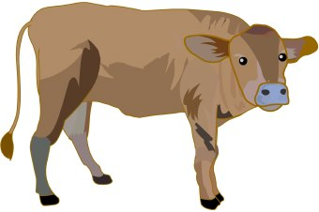
Kids Menu

Cheese Pizza

Sausages & Gravy

Chicken Nuggets

Cheese Burger

Fish fingers

All served with chips and garden peas

(Please let your server know if you would prefer
beans or mash potato Instead.)

All £4.95 each

Childrens Ice Cream £1.95

