BROWN COW

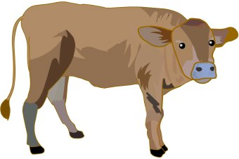
Menu
(Available Weekdays to Saturday 12pm – 8pm)

Starters

Soup of the day, crusty bread roll £3.95

Creamy Garlic Mushrooms, Crusty Bread Roll £4.50

Nacho's Topped with Cheese & Salsa £3.50
Sharer Nacho's £5

Breaded Brie Wedges, Salad & Chutney £4.50

BBQ or Salt & Pepper Chicken Wings £4.95

Garlic Bread £2.95

Cheesy Garlic Bread £3.50

Brussels Pate, Homemade chutney, toast, salad garnish £4.00

Prawn cocktail, crisp lettuce, marie rose, cucumber, tomato,
brown bread & butter £4.95

Cheese & Bacon Croquettes,
tomato chutney & salad garnish £ 3.50

