Contents:
As presented below, this is a report completed as part of my a-level media studies coursework. The report involved investigating numerous sectors in the film industry- ranging from production companies to ideologies/themes in different film genres. This was done in order to plan and create my own marketing materials for a unique film idea, from a professional standpoint.
Media Coursework
Research
Media Language
In film marketing materials, and in particular romance/drama films, typical conventions of film posters are blue/dark colours, and there is usually 2 people on screen. When referring to my own products marketing material, despite my genre of choice being romance/drama I don’t intend on following the colour palette theme most of these posters have. With my overall theme following ‘old money’ and more of a vintage style I think a dark colour palette would create a misleading image of what type of film I am making- and instead I am more drawn to warmer, neutral colours.
Focusing more on the codes and conventions of the romance/drama genre (which’s the chosen genre for my product); there is commonly a central love story involving conflicting viewpoints; real life situations in which the audience can relate to; character development; events which move the audience emotionally and a form of realisation at the end. With one of the conventions being that there is an event the audience can relate to, this links to Stuart Halls reception theory and is the preferred reading for these types of movies. In terms of representation, women have frequently been represented as passive rather than active and are portrayed as objects- whereas men have been represented as more dominated yet isolated and ‘without emotion’. With this changing most recently in the 21st century, I hope to contribute to this and create a romance/drama film which represents a female protagonist who allows themselves not to be controlled by their male partner- while also showing examples of some traditional representations in a way that the audience can recognise how they are an issue.
Industry context- Chosen production company is ‘Paramount Pictures Cooperation’
Paramount Pictures Cooperation are a motion pictures company, formally known as Famous Players Film Company and founded by Adolph Zukor in 1912. Across paramount’s UK studio they have various divisions: Paramount- pictures international ,home entertainment, television distribution, licencing inc., digital entertainment, studio group, famous productions and parks & resorts. With the organisation being vertically integrated, I found it would be a good option for my product to be produced by as all stages of production could be done with them. In addition to this, paramount is able to rent out different divisions and studios to other organisations as a way to earn money. In terms of distribution specifically, Paramount’s parent company Viacom enable paramount to use their resources to transfer their products to tv networks like MTV, Nickelodeon, BET’s, VH1s, spike, comedy central etc. Through distributing onto these niche networks provided by Viacom, it also allows them to market and promote their products at the same time as they’re reaching a wide variety of different audiences. In addition to this, Paramount are a subsidiary to Universal International Pictures, which distribute Paramount’s films outside the United States and Canada.
Due to them being a large organisation, paramount have frequently faced regulation issues surrounding their products being illegally streamed/ pirated. To overcome this, they are part of the Motion Picture Association of America to protect them from copyright issues and pirating. Consumers may have an issue with this however as they will be unable to access paramount’s products without a fee- this links to Livingstone and Lunt’s theory that citizen are in conflict with the needs of the consumer, because protection can limit freedom.
Targeting and addressing audience
From looking at drama/romance films, that I feel my product is most similar to, the age ratings have frequently ranged from 12-15. This led me to initially plan on having my film rated as a 12, however I found this wouldn’t give me as much freedom and may cause it to be too immature to fit the 16-25 age target audience brief. Due to this, the age rating will be a 15. The film will also follow a young woman navigating her life as she struggles with marriage, while including an ‘old money’, vintage style which would typically appeal to a female/feminine, young audience. Through targeting young women, those with a similar story to the protagonist in this story may identify with them and inspire them to imitate their behaviour and make a positive change on their life. This links to Albert Banduras media effects theory which states that media can implant ideas into the audience and cause them to acquire attitudes through identification. To attract and address this audience, marketing materials will be promoted through social media as young people will be most familiar with it and therefore be able to connect with it more.

Statement of Aims and Intentions
With my target audience being young feminine women, I’ve found from research that traditionalist views have associated women with soft, neutral colours, jewellery, flowers, elegancy and that they were known to be involved with only one man and to be fully committed to him. With my film being set during times where traditional views were heavily encouraged, I aim to present these within my images to set the scene. However, due to my film being released now, when there are more modern views, I don’t want to only show these as it’ll overly stereotype and generalise the female audience. When researching romance/drama films through the female gaze (as opposed to the typical male perspective), posters frequently showed the female lead as the sole focus. With that said, I intend to do something similar in order to appeal to a female audience seeking this type of societal change (femininity).
In addition to this, in terms of the genre being romance/drama, I’ve researched conventions of these film posters and found that there is either a main character with their love interest or just the main character being the focus. Therefore, I plan to do this- but while also attempting to create more of an emphasis on the female character- to suggest they are the main focus in the story. When looking at colours in romance drama films in my research I found darker colour palettes frequently being used, which I didn’t feel conformed to my film. This led me to focusing more on just romance film posters, where I noticed colour palettes that I felt more fitted to my idea. Colours I noticed typically are reds, blues or whites, or there is a specific colour palette used across the entire poster (for example neutrals). Extra elements to these posters also are skies/sunsets and there is frequently a type of glow/ fade across the image. To show that my film fits into this genre, I plan to take this research and use a neutral colour palette, along with light blue tones. This way, it’ll come across very soft and appealing to look at- which is typically associated with romance/love.
Linking back to drama film posters, I’ve also recognised that characters are frequently looking away from the camera and looking disengaged with the audience. By doing this it creates mystery and uncertainty surrounding the character- so I plan to do something like this to conform to the genre, while also suggesting some form of conflict/struggle concerning them.
In terms of the style of my media product, through researching various media products like for example, The Great Gatsby and ‘Old Money’ by Lana Del Ray- which explore themes like aristocracy/ old wealth- it has enabled me to discovery what type of elements I should present in my product. In ‘Old Money’ the opening line ‘Blue hydrangeas’ is referring to The Great Gatsby which frequently features hydrangeas. After further research into this, I’d found blue hydrangeas are a symbol of regret and seeking apology. From this, I intend on featuring them in my DVD poster with a male character holding them up- this would represent him attempting to apologise after choosing money over his own wife (reflecting the plot of my film). The Old Money CD cover, along with a large amount of Lana Del Rays music, also consists of having
an old video style overlay- so I intend on giving my own posters a similar filter as a way to further suggest the film is set in the past.
Planning
Name | Age rating | Genre | Production Company
The Art of Liberation | 15 | Romance/Drama | Paramount Pictures Corporation

Equipment
- To take images: Camera- Canon EOS 1300D, or an iPhone if needed
- Lighting: with photos taken outcome, I plan to rely on natural lighting- however for indoor photoshoots artificial lighting will be my primary focus to avoid any undesirable shadows natural lighting may cause.
Programmes
- To edit images: adobe lightroom, photoshop and procreate will be used, as well as mobile editing apps like Dazz cam and Snapseed.
- When creating the overall film posters, the main programmes I plan to focus on using will be adobe photoshop and procreate.
Project plan
In terms of location, I plan to take a majority of my images at Cliveden as I’ve found the grounds and Cliveden house to fit the rich/old theme of my film. Due to them being part of the national trust, I had assumed there would be some legal guidelines behind shooting at this location- and after researching them I had found that for student filming and photography they do request you to email them details of the shoot. If there are complications surrounding this, I instead plan on doing the shoot in Cookham village, as I’ve found there are a large amount of public, unrestricted areas which also have similar locations to Cliveden. In terms of my second location, I will take images in a family member’s home as much of their furnishing is archaic and they have a large amount of silver décor- with silver symbolising wealth and femininity the combination will set the scene for when the film is set, and the social class I am representing.
When?
I originally planned on getting my shoot done on the weekend of 1st/2nd of October, however recently I’ve found the weather will not be sufficient enough for my shoot (it is forecasted to be cloudy and thus there will not be enough natural lighting)- so I plan on doing it the following weekend (8/9th October)
Movie Posters and clothing.
From looking at similar marketing materials, I have found that the characters frequently have very simplistic outfits- in neutral colours like white and beige- followed by accessories like pearl necklaces. From this I’ve found that through dressing someone in light ‘fresh’ colours it makes them appear richer as they look more polished. With this, I plan on dressing my characters in a similar way to fit the theme of my film.
MOOD BOARD
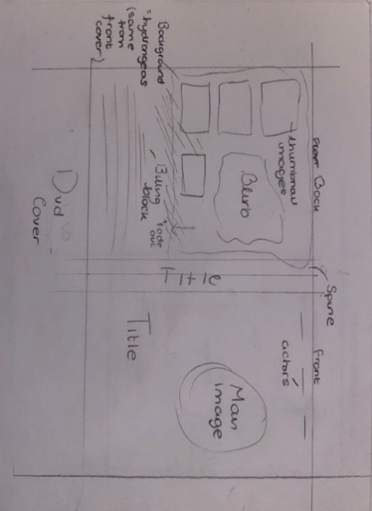
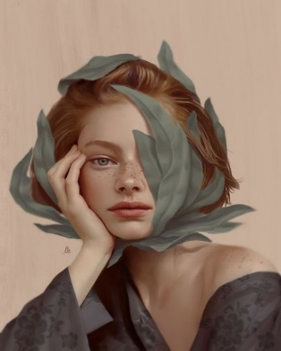
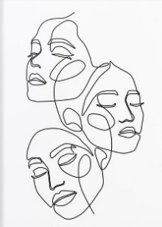
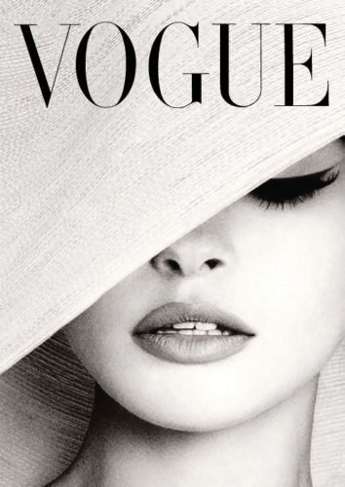
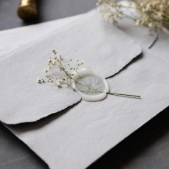
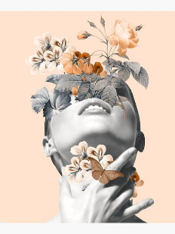
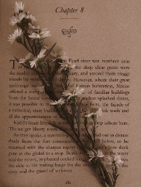
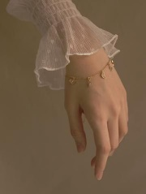
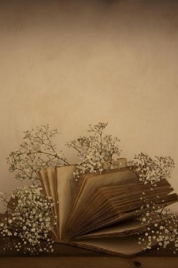
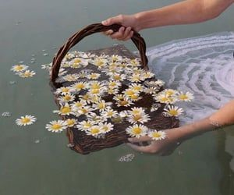
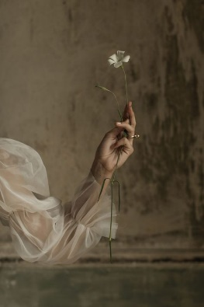
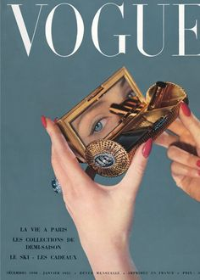
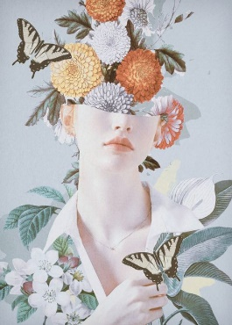
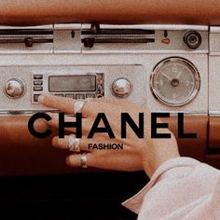
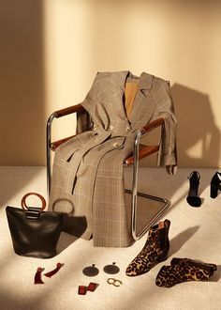
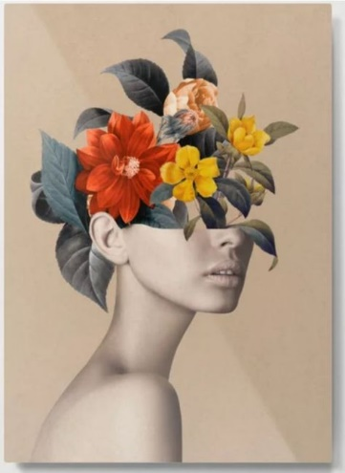
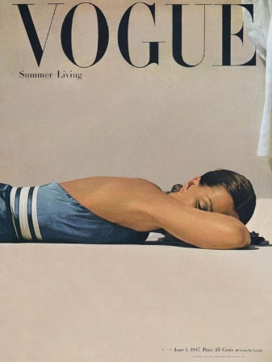
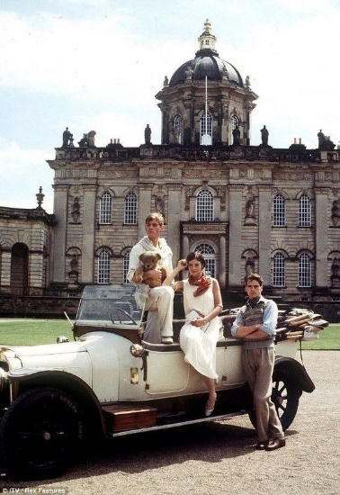
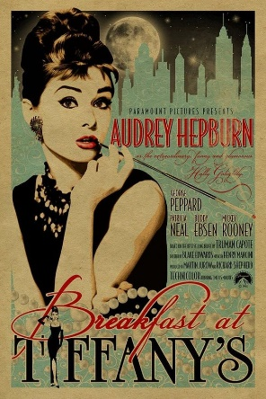
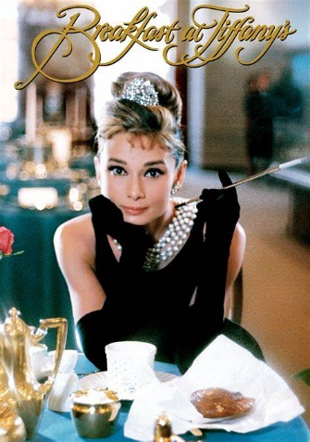
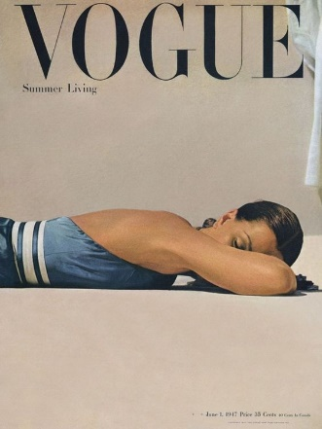
DVD cover
Old DVD cover plan
For my DVD cover, I will photograph the female character from more up close, and of their face/ top half of body. I plan on them looking back at the camera, while leaning on either a wall or on a balcony at Cliveden manor house. Through having them leaning on something I think it’ll present them as stressed/tense which would set the tone for what they experience throughout the film.

New Plan
Rather than going ahead with this initial plan, I wanted to create more artistic posters as I felt like this would give me more creative freedom to involve symbolism. Therefore, in this poster I now intend on photographing my main female character against a blank wall (instead of location 1) and then using photoshop to edit flowers around their face and on their face. By doing this It will link with my abroad poster and suggests the man (the flowers) is overconsuming her life and taking over. Many would also associate flowers with romance and love, which conforms to the romance genre, as well as femininity which may attract my target audience.
In terms of thumbnail images for the back of the DVD cover, I plan on using my second location and photographing my female lead character with an additional character (to suggest a figure of support throughout the film). I also will experiment with photographing different objects and elements which I believe link to the style and genre of my film.
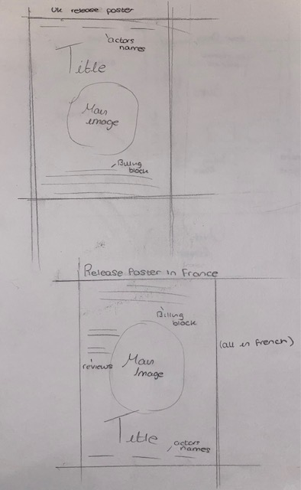
#
UK release poster
For my first film poster, I plan to involve suggestion of a male character. When researching different flowers, I found that blue hydrangeas symbolise regret/ apology and a desire for forgiveness- so through photographing a part of the male character holding this flower it’ll have a hidden meaning towards his role in the film.
More specifically, to suggest this male character I plan on photographing a man’s suit put up onto a chair- in the structure of how somebody would actually sit. With this I will then position fake flowers (white and blue hydrangeas) coming out of top of the suit, along with printed fake money in the pockets of the suit, and also around it.
By not showing the man’s face, I aim to suggest that his large amount of wealth has dehumanized him and left him somewhat heartless. I also think this would add mystery as the viewer won’t know what facial expression he is making, which conforms to a large number of posters in the drama genre.
Extra
For continuity across all my posters/ DVD covers, I plan to have a consistent colour palette of blue, beige and white. I also plan to repeatedly use a selection of flowers- hopefully being blue and white hydrangeas, vines and various types of plants. To access these flowers and photograph them, I plan to purchase fake flowers as I won’t have the concern of damaging them (like I would with real ones)- and therefore I will have more creative freedom with what I do with them.
I’ve frequently seen this being done on multiple forms of art and I think the outcomes appear very elegant and romantic. With these I then plan to flip the male character upside down and place them above the female character, so they are contrasting in some way. I think this will help imply that there is conflict and bias involved in the story- and both characters may not see eye to eye.
To achieve this, I plan on taking photographs of both my male and female actors, and then use procreate to trace the outlines of their faces.

Overseas release poster
For my final poster, which would be released in France, I plan on involving both the male and female characters. I think by doing this it would create a different approach to my last 2 plans (which only have one of the main characters in the cover), and also show a relationship between the 2 main characters.
The main plot of this film is based around relationship issues between the 2 characters, so I think it would be important to suggest some relationship to imply this- while also implying it is a romance/ drama film.
With this being said, my plan for the overseas poster is to also take an artistic approach like my other posters and draw the outlines of both the male and female characters.

TITLE

Final Outcomes
UK release poster
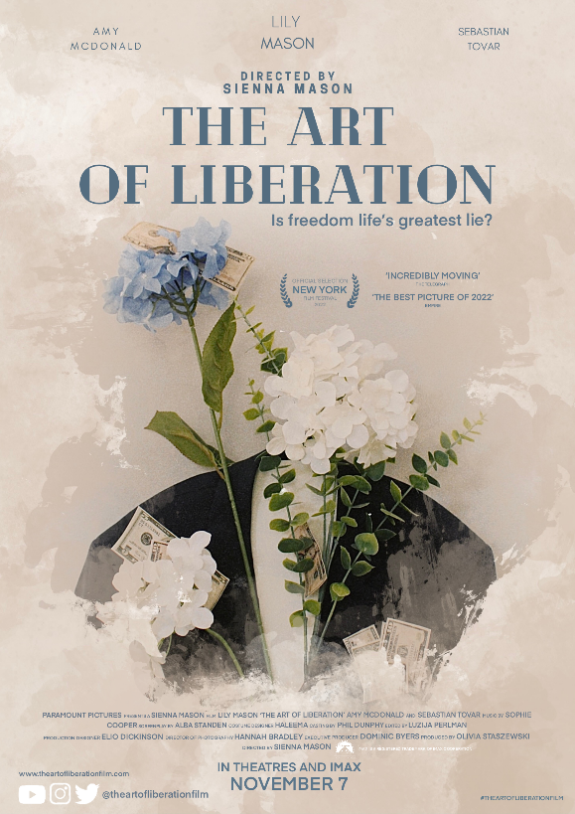
When setting up this photoshoot, I came up with the idea of merging the blue hydrangea with printed money. I found as though this could symbolise the idea that despite the male character seeking forgiveness from his wife for his selfish actions, he is still overruled by wealth and wealth will always remain his priority.

Constructing the design of this poster involved me finding with ways of filling up the space. I found simply have just the one image on its own appeared too empty and bland, so I decided to experiment on procreate by drawing around the subject with various brush tools and colours. I initially created a white background around the subject- but later added neutral tones to it so it blended more with my original image. I found this to be really effective, and in a way framed my subject to draw attention to it.

Overseas release poster
Whilst my initial idea was to simply create the outline and do no more, I had a similar issue to my previous poster and felt as though it was too empty and bland. This led me to create a background like my UK release poster and I used the ‘Terraleah’ tool on procreate to blend neutral colours in a visually textured way. I really like the outcome this created, and I think it is far more interesting to look at, as opposed to if I was to use a simple block coloured background.
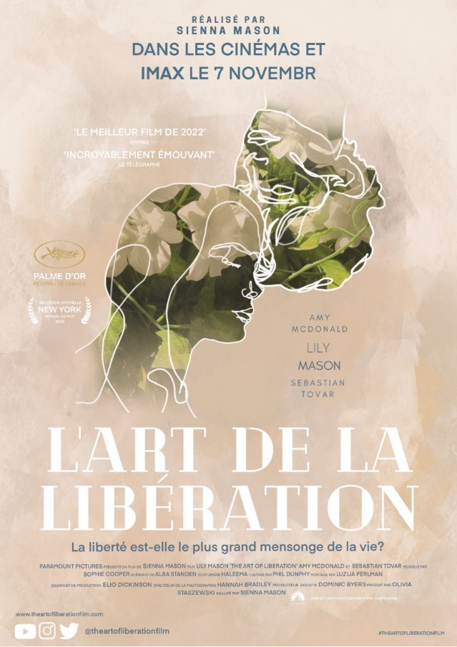

In addition to this aspect to my plan, I also did not set of with the intention of putting flowers inside the faces of both my characters. By simply having the outline I found that the subject (the outline) did not stand out as much as it should’ve. I also found that my poster lacked continuity, and so by combining the flowers with the outline it both drew attention to the outlines and also created this continuity (as all my posters now had similar flowers)

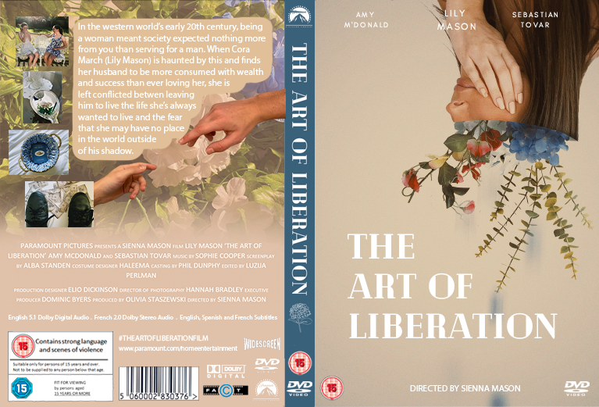
As a whole
Overall, I am extremely happy with these outcomes. I think I successfully applied my research and created marketing materials that both present my idea, and also conform to my choice of genre and time era. In addition to this, I am especially happy with my editing skills. I massively wanted to create visually beautiful and appealing pieces of work and with my editing skill I feel as though I was able to take my plan and accurately create this envision.
My plan for the main image was that I’d edit flowers around the woman’s face, I later decided to approach this in a way that looked like flowers were coming out of them. I think this ended out really successful, I especially like the way I decided to put the art upside down- as a way to symbolise a release/ setting themselves free from their husband (the male character). This thus links to the films name ‘The Art of Liberation’, meaning ‘the action of setting someone free from imprisonment, slavery, or oppression; release’. In this films case, the woman is being attempting to be set free from her husband, and the oppression women face- which I think this DVD cover successfully communicates.
One thing I would however change about this DVD cover is that, while it still conforms to the colour palettes, I intended on using, I feel as though the tones of beige are far darker than my other 2 posters. As a result, I think this has made my 2 posters look more similar than this DVD cover- and so it stands out awkwardly. Therefore, if I was to further edit these, I would lighten the colour palette on the DVD cover- to allow all 3 outcomes to complement each-other equally.
I wrote the blurb with the intention to show hints of important aspect of the film- the main character, the conflict and the time era. I think I successfully debriefed these to target the correct audience, while also leaving room for enigma and mystery within the plot.
DVD cover
With blue hydrangeas playing a huge part in symbolism in these outcomes, I decided to put an outline of one onto the spine as way of it becoming part of the film’s identity.

