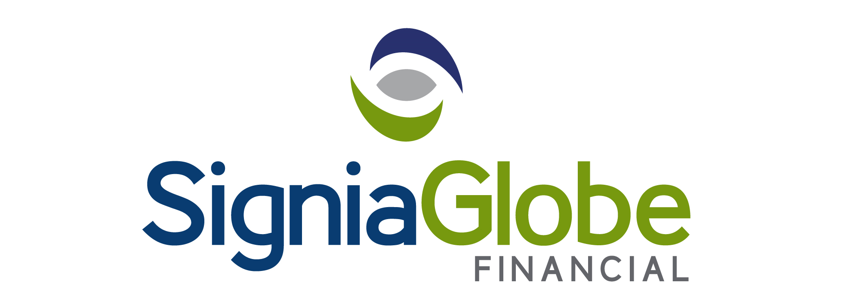
2025 SIGNIAGLOBE NATIONAL DINGHY CHAMPIONSHIPS

Organising Authority

THE BARBADOS SAILING ASSOCIATION INC

NOTICE OF RACE

- The Championships will be governed by the WS Racing Rules of Sailing 2025 - 2028, the Class Rules and the Sailing Instructions.

- The classes to race are as follows:

ILCA 7 (Laser Standard) ILCA 6 (Laser Radial) ILCA 4 (Laser 4.7)

O’Pen Skiff Sunfish Optimist

A minimum of three boats constitutes a class.

- Racing will take place on Sunday, 14th September, Sunday, 21st September, Sunday, 5th October and Sunday, 19th October, 2025.

- All sailors must be paid up members of the Barbados Sailing Association in order to compete.

- Registration and Skipper’s Briefing will take place at 5:30pm on Friday, 12th September in the Gazebo of the Barbados Yacht Club. All competitors must attend, and be registered and entry fees paid before competing.

- No race will start before 10.00 am on race day. The Race Committee will attempt to run a minimum of twenty races for each class over the four race days. A total of five races constitutes a Championship.

- The LOW POINT SCORING SYSTEM will be used. Prizes will be given for the overall top three boats in each class at the conclusion of the Championships.

- An entry fee of $40.00 per boat is to be paid upon registration.

- For information, please contact Anne Tindale at tindale@caribsurf.com

1st September, 2025

