Performance Management Reengagement Guide
A Modern Approach to Motivating Managers and Employees

Introduction
The effective implementation of a Performance Management Plan (PMP) is crucial for aligning individuals and groups efforts and results with organizational goals. The process of engaging in a PMP can become viewed as strictly task oriented and a burden from employees and managers, while it competes with other priorities. This leaves even the most well planned PMP at risk for realizing the expected performance growth. This guide offers a foundational revisit and reimagined, people-centered approach to performance management, making it more effective, energizing, and sustainable.
Employee Performance Management is a continuous, strategic process that aligns individual contributions with organizational goals by setting clear expectations, providing ongoing feedback, recognizing achievements, and supporting employee growth and development. It involves collaboratively establishing performance objectives, regularly assessing progress, addressing performance gaps, and fostering a culture of accountability and improvement.
Unlike traditional approaches that focus solely on annual evaluations or corrective action, modern performance management emphasizes real-time dialogue, coaching, and development. It is both a leadership discipline and a cultural practice that drives individual success, team effectiveness, and long-term organizational performance.

Section 1: Core Pillars of Effective Performance Management
Before reimagining the PMP process, it’s vital to revisit what makes performance management work and what any PMP is designed to achieve. The most effective systems are typically built on five core conceptual pillars:
- Clarity of Expectations
  - Defined goals, behaviors, and success metrics tied to company outcomes.
- Frequent, Meaningful Feedback
  - Timely feedback focused on impact, not just evaluation.
- Continuous Development
  - Focus on growth, learning, and readiness for future roles.
- Recognition & Accountability
  - Celebrate wins and address challenges promptly and respectfully.
- Alignment
  - Ensure individual efforts directly support team and organizational priorities.
These pillars form the foundation for a high-impact performance approach. These pillars also assist in defensibility for an organization's decisions concerning performance management.

Section 2: Positive Reinforcement & Behavioral Science in Performance
To drive behavior, organizations must understand what motivates people—and how to sustain that motivation over time.
- Positive Reinforcement: People are more likely to repeat behaviors that are rewarded or recognized. Regular acknowledgment of effort and achievement boosts engagement and builds a culture of excellence.
- Behavioral Nudges: Small prompts, reminders, and default behaviors embedded in the system (e.g., a monthly reflection reminder) can gently guide employees and managers to adopt new habits.
- Growth Mindset: Encouraging learning from mistakes and celebrating progress helps shift performance conversations from fear-based to future-focused.
Key Takeaway: Lasting behavior change comes from consistent positive reinforcement, not punitive correction or ignoring unwanted behaviors and their manifestation.

Section 3: Generational Differences & Tailored Performance Approaches
Different generations bring unique expectations, values, and preferences to the workplace, and also bring unique expectations when it pertains to managing not only their performance, but also the performance of their colleagues. Below are a series of tables that show different generational perceptions and how they relate to performance management. These tables were crafted by various themes throughout the workforce and are not intended to be all encompassing, nor positive or negative in any way. Rather, the tables are used to highlight the differences amongst generations and their impact.
Generation | Key Traits | Performance Preferences
Baby Boomers | Loyal, experienced, value structure | Prefer formal reviews and recognition for dedication
Gen X | Independent, pragmatic | Appreciate autonomy, timely feedback, and transparency
Millennials | Purpose-driven, tech-savvy | Thrive on regular check-ins, coaching, and career path clarity
Gen Z | Digital natives, value authenticity | Expect immediate feedback, purpose-driven work, and inclusive dialogue

Generational Perceptions of the Workplace & Performance Management Barriers
Different generations also typically have different if not competing perceptions of the workplace and which can impact and create barriers to effective performance management. Below is a table of perceived flaws and barriers that each generation tends to have as a group towards the workplace.

Generation | Perceived Flaws in the Workplace / Barriers | Impact on Engagement with Traditional Performance Management
Baby Boomers | Lack of formality and respect for tenure; discomfort with rapid change or constant reinvention | May feel overlooked or undervalued in feedback systems focused on real-time input or tech-driven reviews; prefer structure and consistency that many modern systems bypass
Gen X | Micromanagement and lack of autonomy; distrust of corporate agendas | Skeptical of rigid performance processes and systems perceived as disingenuous; prefer candid, practical feedback over formal reviews or corporate language
Millennials | Slow decision-making, lack of purpose, limited growth opportunities | May disengage from annual review cycles that don’t reflect fast-paced learning or provide frequent coaching and development pathways
Gen Z | Hierarchical systems, lack of inclusivity, and feedback delays | Struggle with outdated or opaque systems that don’t offer transparency, two-way dialogue, or fast feedback loops; crave interactive and digital-first solutions

Workplace Perceptions of Generational Flaws & Their Impact on Performance Management
The workplace also has perceptions of each generation that can also impact and create barriers to effective performance management. Below is a table of perceived flaws and barriers that the workplace typically gives each generation as workers.

Generation | How the Workplace Perceives This Generation (Flaws/Barriers) | Barrier Created in Traditional Performance Management
Baby Boomers | Resistant to change, less tech-savvy, slow to adapt, nearing retirement | May be excluded from tech-driven tools or development opportunities due to assumptions they’re not interested or able to grow
Gen X | Cynical, disengaged, lone wolves, not as vocal about needs | Often overlooked in feedback loops or recognition programs; assumed to "self-manage" without support or coaching
Millennials | Entitled, overly sensitive, need constant praise, disloyal | Feedback systems may be stripped of depth or frequency to “toughen” Millennials, causing disengagement and missed development opportunities
Gen Z | Easily distracted, too informal, lack work ethic, overly reliant on tech | Their desire for transparency, feedback, and flexibility may be dismissed as immaturity or neediness, reducing inclusion in meaningful development conversations

Guiding Insights: Biases and generational stereotypes can shape how performance management systems are applied or withheld. These perceptions often become self-fulfilling prophecies, limiting growth and engagement across all age groups. These perceptions can also lead inadvertently to systematic age discrimination practices and the erosion of employee engagement.
One-size-fits-all doesn’t work, each individual is unique regardless of generation or group. Consider offering flexible formats for feedback, development conversations, and goal-setting, especially in multi-generational teams. Focus on the foundational intent of performance management and use the generational tendencies to explore potential gaps or initial approaches to performance plans.

Section 4: Why Performance Management Plans Fail to Meet Expectations
Despite the time, tools, and effort companies invest in performance management, many systems fall short of delivering meaningful results. The reasons are often rooted in both structural design flaws and human behavior. Understanding these pitfalls is essential to building a better approach.

1. It's Treated as a Compliance Exercise, Not a Strategic Tool
When performance management is approached as a box to check—often for legal or HR compliance—it becomes disengaging and disconnected from actual performance. Managers rush through it, and employees see little value in participating.
Impact: Superficial reviews, low-quality feedback, and disengaged employees.

2. Lack of Real-Time Feedback and Coaching
Annual or semi-annual reviews are too infrequent to support growth in real time. Employees are left guessing how they're doing, while managers miss opportunities to guide and course-correct throughout the year.
Impact: Surprises during reviews, delayed development, and decreased motivation.

3. Goals Are Vague or Misaligned
When goals are unclear, generic, or disconnected from team or business priorities, employees struggle to see how their work matters.
Impact: Low ownership, unclear expectations, and misdirected effort.

4. Managers Aren’t Trained or Empowered
Many managers feel unprepared to deliver feedback, facilitate development conversations, or manage underperformance constructively. Without training or support, they avoid tough conversations or go through the motions.
Impact: Inconsistent experiences, trust erosion, and underdeveloped talent.

5. One-Size-Fits-All Structure
Performance systems that treat all roles, levels, or generations the same ignore the need for personalization. High performers, early-career employees, and senior leaders often need different kinds of feedback and support.
Impact: Generic processes that feel impersonal and irrelevant.

6. Focused on Ratings, Not Growth
Overemphasis on ratings or rankings can create anxiety, competition, and resistance—especially if performance data is tied solely to compensation. It often discourages open dialogue and fails to develop potential.
Impact: Fear-based behavior, box-checking, and stifled growth mindset.

7. Minimal Follow-Up or Action
Even well-run reviews can lose impact if there's no follow-up. Development plans go untouched, goals are forgotten, and feedback becomes irrelevant without reinforcement.
Impact: Frustration, cynicism, and no visible return on the effort.

8. Cultural Disconnect
If the performance process doesn't align with company culture—such as valuing collaboration but rewarding only individual output—it creates confusion and disengagement.
Impact: Mixed messages, eroded trust, and disengaged teams.
Guiding Insights: Performance management fails when it's reduced to a transactional task. To succeed, it must be meaningful, personalized, consistent, and embedded into the daily rhythm of work. Rebuilding trust in the process starts with acknowledging what's not working, and intentionally designing something better.

Section 5: The Performance Evolution Cycle
The Performance Evolution Cycle is a conceptual model that illustrates how employees and managers typically evolve in their mindset toward performance management. It reflects the cultural and behavioral shifts that occur as organizations move from traditional, compliance-driven systems to modern, engagement-focused approaches.
This cycle includes four key stages:
- Suspicion – Employees view performance management as punitive, biased, or disconnected from their actual work.
- Acceptance – People begin to comply with the process, but often without emotional buy-in or deep engagement.
- Reception – Individuals start to see the value of regular feedback and development conversations.
- Advocacy – Performance management is embraced as a meaningful, trusted, and essential part of growth and success.
Organizations must identify where their workforce currently sits in this cycle to effectively tailor communication, training, and rollout strategies. The goal is to steadily move from suspicion to advocacy—where performance management becomes a natural, empowering part of the employee experience.

Section 5: Foundational Principles for Development
To re-engage employees and managers in performance management, organizations must ground their strategy in core principles that shift mindsets and drive meaningful behavior. These principles are not just philosophical, they require intentional actions, systems, and conversations to take root and grow.
Understand Where the Workforce Is in the Performance Evolution Cycle: Assess employees' and managers’ mindset toward performance management to better shape the transition.
Organizations often roll out new performance processes assuming everyone is equally ready. In reality, employees and managers vary in their experience, trust, and comfort with feedback. Understanding where your workforce is on the Performance Evolution Cycle—from suspicion, to acceptance, to reception and then advocacy—is critical.
How to Instill This Principle:
- Survey employees and managers on their current perceptions:
Do they view performance reviews as helpful or punitive?
Do they feel feedback is fair and consistent?
- Use focus groups or interviews to understand cultural blockers.
- Tailor rollout plans based on readiness (e.g., start with champions or pilot groups).
- Reinforce early wins and stories of impact to shift perceptions over time.
Shift from Evaluation to Enablement: Focus on growth and potential rather than just past performance.
Traditional performance reviews often concentrate on what an employee did wrong or didn’t do. A modern approach views performance as dynamic and anchored in strengths, guided by feedback, and aimed at future potential.
How to Instill This Principle:
- Frame conversations around strengths, learning, and opportunities.
- Use future-focused questions: “Where do you want to grow?” or “What’s one new skill you’d like to build?”
- Replace numeric ratings with development conversations and qualitative feedback.
- Train managers to shift from being evaluators to coaches.
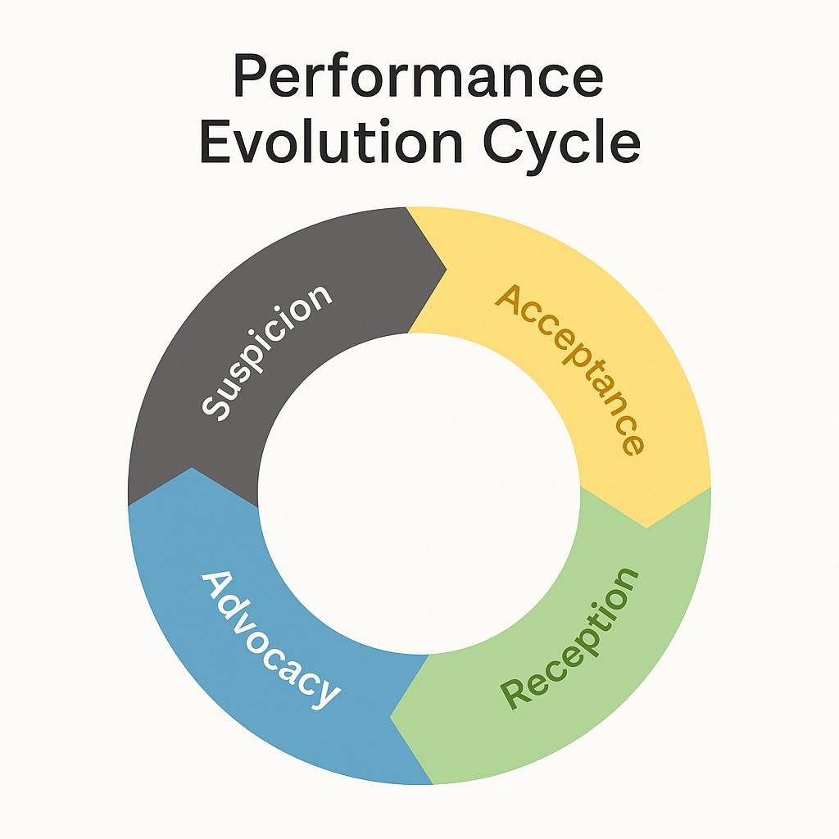

Make It Continuous: Move away from annual reviews to ongoing, meaningful conversations.
Employees’ needs, contributions, and challenges evolve constantly. Feedback and goal tracking must keep pace to remain relevant and impactful.
How to Instill This Principle:
- Implement monthly or quarterly check-ins with simple templates or prompts.
- Use technology to log feedback moments and goal progress in real time.
- Encourage “micro-feedback” after key projects, presentations, or milestones.
- Reinforce that feedback is a dialogue, not a one-time event.
Empower Everyone: Encourage co-ownership of performance discussions between employees and managers.
Performance should never feel like something done to an employee—it should feel like something created with them. Ownership increases engagement, accountability, and trust.
How to Instill This Principle:
- Encourage employees to prepare their own reflections and goals in advance of check-ins.
- Create shared performance documents or dashboards both manager and employee update.
- Include “employee voice” questions in the process: “What support do you need from me?” or “How would you assess your progress?”
- Train managers to listen and adapt during performance conversations—not just deliver.

Section 6: 8 Re-engagement Strategies

1. Transition to Ongoing Conversations
- Action: Implement quarterly or monthly check-ins.
- Support Tool: Use short, consistent conversation templates.
- Impact: Builds trust and allows real-time alignment.

2. Co-Create Goals
- Action: Facilitate collaborative goal-setting sessions between employees and managers.
- Support Tool: Goal alignment worksheets or digital tracking tools.
- Impact: Increases ownership and clarity of expectations.

3. Rebrand the Process
- Action: Rename the program (e.g., Growth Dialogues, Impact Sessions).
- Support Tool: Internal branding campaign and messaging.
- Impact: Creates a fresh perception and emotional reset.

4. Visualize Progress
- Action: Visualize goals and recognize achievements using badges, points, or leaderboards.
- Support Tool: Recognition platform or a simple tracker in shared dashboards.
- Impact: Adds motivation, encourages progress, and creates momentum.

5. Train and Support Managers
- Action: Provide coaching resources and templates for performance conversations.
- Support Tool: Quick reference guides, coaching toolkits, and scenario-based training.
- Impact: Reduces burden, increases confidence, and improves consistency.

6. Introduce Real-Time Peer Feedback
- Action: Establish a simple peer feedback process (monthly or per project).
- Support Tool: Lightweight forms or integrations in collaboration tools like Slack or Teams.
- Impact: Offers broader perspective, encourages collaboration, and reduces bias.

7. Link to Development Opportunities
- Action: Connect performance conversations to learning resources, mentorships, and career paths.
- Support Tool: Development plan templates or learning pathways mapped to roles.
- Impact: Enhances employee motivation and long-term commitment.

8. Let Employees Start the Conversation
- Action: Begin performance check-ins with employee self-reflection.
- Support Tool: Self-review prompts like:
  - What accomplishments are you proud of?
  - What challenges did you face?
  - What support do you need to improve?
- Impact: Empowers employees, fosters ownership, and encourages self-awareness.

Section 7: Implementation Plan
Phase | Steps | Suggested Timeline
1. Assess | Review current PM process and gather employee/manager feedback | Weeks 1–2
2. Design | Customize tools, rename the program, and define check-in cadence | Weeks 3–4
3. Train | Train managers and employees on new expectations and tools | Weeks 5–6
4. Launch | Roll out the new system with excitement and clarity | Week 7
5. Reinforce | Monitor adoption, provide ongoing support, and celebrate early wins | Week 8+

Closing Thought
Reimagining performance management is not just about process change—it’s about reshaping culture. When done right, performance management becomes a powerful lever to fuel employee growth, strengthen manager-employee relationships, and drive business results.

Crafted from best practices outlined by SHRM, Gallup, and modern performance management research.
The Performance Evolution Cycle™ is a proprietary framework developed by Prairie Business Evolutions, LLC to help organizations assess and evolve employee mindsets toward performance management. It draws inspiration from change management and behavioral psychology principles, adapted for the modern workplace.

