Artificial Intelligence in Human Resources
Tier 0 - What is AI in HR

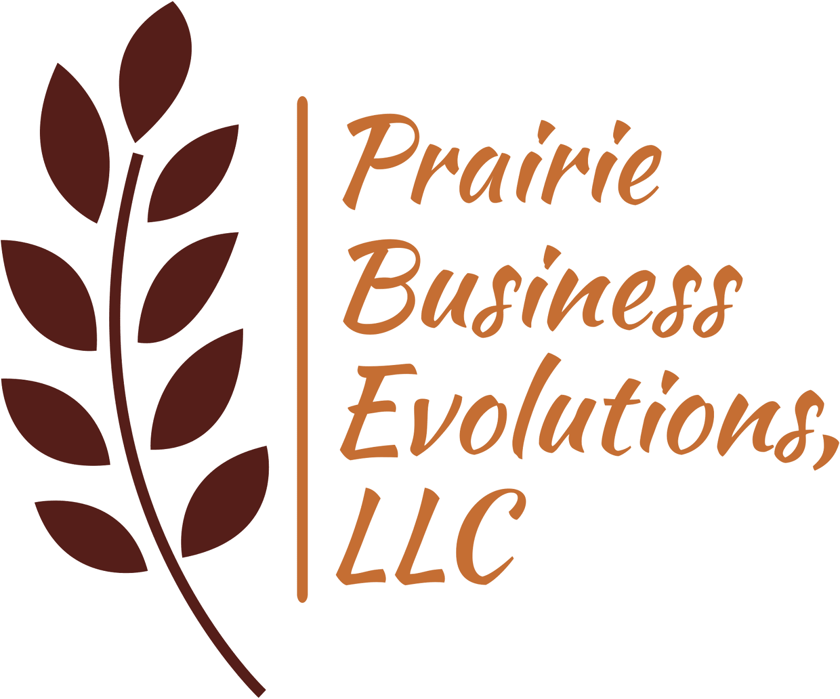

Executive Summary
As organizations navigate the transformative potential of artificial intelligence (AI), Human Resources stands at a unique intersection of opportunity and responsibility. The Tier 0: What is AI in HR Toolkit is the first step in a tiered maturity and governance framework designed to guide HR and executive leaders through a progressive, intentional journey of AI adoption.
Tier 0 focuses on orientation and strategic reflection. It is not about choosing tools or launching pilots, it is about building a shared understanding of what AI is, how it works, and how it can (and should) enhance the organization’s people function. This phase is essential to prevent misaligned, fear-driven, or trend-chasing implementations that may compromise workforce trust or dilute long-term value.
This toolkit offers HR leaders:
- A clear, accessible overview of AI fundamentals, process flows, and terminology
- Practical insights into how AI is already being used across HR domains
- Strategic framing of why AI matters to the future of workforce planning, experience, and capability
- A maturity model (Tiers 0–VI) that helps organizations assess their current state and chart a responsible, scalable path forward
- A Guided Mind Map Workshop to help teams uncover AI opportunities across major HR functions, from compensation to workforce management
- A robust AI Glossary demystifying technical terms in plain language for business leaders
Tier 0 ends with a mindset shift: AI is not here to replace HR, but to augment its impact. With the right purpose, governance, and preparation, AI can help HR evolve into a more strategic, data-driven, and human-centered function.
This toolkit sets the stage for deeper exploration and future Tier workshops where HR will move from reflection to action, piloting AI, scaling intelligently, and embedding governance and ethical standards along the way.

Table of Contents
Executive Summary 2
Table of Contents 3
Tier 0: AI Orientation for HR Leaders 4
Purpose of Tier 0 4
Section 1: What is AI? A Leader’s Overview 4
AI Process Flow (High Level Steps) 5
Section 2: How AI Is Already Being Used in HR 6
Section 3: Why AI Matters for the Future of HR 7
Section 4: Core Considerations Before You Begin 8
Section 5: Maturity Tiers and What the Path Forward Might Look Like 8
Appendix I - AI Capability Discovery Mind Map Workshop Template 12
Guided Mind Map Workshop Template 12
Objective: 12
Workshop Materials 12
Mind Map Structure Per HR Domain 13
1. Benefits, Compensation, and Total Rewards 13
2. Recruitment and Talent Acquisition 14
3. Labor Relations 14
4. Employee Relations 14
5. HR Operations and Data 15
6. Workforce Management and Job Classification 15
7. Training and Development 15
8. HR Strategy 15
Appendix II - AI Glossary for HR and Business Leaders 17

Tier 0: AI Orientation for HR Leaders
Understanding AI, Its Role in HR, and the Path Forward

Purpose of Tier 0
Before implementing AI, HR leaders must:
- Understand what AI is (and isn’t)
- Learn how AI is already influencing HR practices
- Identify opportunities and risks
- Build a shared vision for how AI can enhance, not replace, the people function

Section 1: What is AI? A Leader’s Overview
Break it down simply and practically:
- AI Defined: The ability of machines to simulate human-like intelligence — recognizing patterns, making decisions, generating content, etc.
- Types of AI Used in HR:
  - Machine Learning – prediction, classification (e.g., turnover risk, employee success prediction, compensation analysis)
  - Natural Language Processing (NLP) – parsing resumes, analyzing survey responses
  - Generative AI – creating job descriptions, training materials, policy drafts
  - Automation – scheduling, workflows, candidate outreach

AI Process Flow (High Level Steps)

Step | Description and Outcome
1- User Input (Prompt) | The user enters a question, instruction, or text (e.g., "Write a job description for a Financial Specialist", or “Conduct a compensation equity analysis on this dataset”).  The input prompt lays the foundation for the response and is one of the most important aspects of valid and reliable AI usage.
2- AI Receives Prompt | The AI model receives your input and prepares to process it using trained data.
3- Prompt is Processed (Tokenized) | The input is broken down into smaller units called tokens (usually words or sub-words), so the model can understand structure and meaning.
4- AI Predicts Next Words Using Patterns | Based on millions (or billions) of training examples, the AI predicts the most likely next word or token, one at a time, using probability and pattern recognition.
5- Response is Formed | The AI builds the output word-by-word, guided by:  - Training data  - Rules set by developers (e.g., ethical filters)  - The context of the conversation  - System instructions or tone settings
6- Response Delivered | The full response is packaged and sent back to the user in seconds — and the cycle can continue with a follow-up prompt.

AI ≠ Magic. It’s data + math + patterns leading to outcomes based on probability — all shaped by how it’s built and used.

Section 2: How AI Is Already Being Used in HR
Practical, real-world examples by HR function:
Function | Current Use of AI | Example Tools/Tasks
Recruitment | Resume parsing, candidate screening and scoring, automated outreach | Paradox, HireVue, Eightfold
Learning & Development | Personalized learning paths, skills matching | EdCast, Degreed
Performance Management | Predictive performance modeling, bias detection | Betterworks, Lattice (enhanced w/ AI)
Engagement | Sentiment analysis from surveys or chats | CultureAmp, Peakon
Workforce Planning | Attrition prediction, headcount modeling | Visier, org.ai
AI in HR is happening now — but smart leaders choose where, why, and how.

Section 3: Why AI Matters for the Future of HR
Frame it around strategic value:
- Improve decision-making with real-time data insights
- Automate low-value tasks so HR can focus on strategy
- Enhance employee experience with personalized support
- Predict needs before problems escalate
- Scale talent programs without scaling headcount
AI should not replace HR — it should augment HR’s impact, that decision on “how” depends on us.

Section 4: Core Considerations Before You Begin
Key pillars to reflect on:
- Purpose Alignment – Are you solving a business problem or chasing a trend?
- Data Readiness – Is your people data clean, structured, and governed?
- Ethics & Equity – Will AI increase or decrease fairness?
- Governance and Framework – How will will govern and write policies and procedures around AI usage and reliance in our workforce?
- Capability Building – Does your HR team understand how to lead in an AI-enabled world?

Section 5: Maturity Tiers and What the Path Forward Might Look Like
Understand the maturity and governance level of AI enhanced workforce.
Organizational AI Maturity and Governance Tiers
Tier 0 - Foundational Knowledge
Organizations are beginning to understand the capabilities and operational working of AI tools.
Tier I - AI Absent
No AI integration in business operations nor reflected in the strategic plan.
- External/Internal Customer Impact: Fully human-driven; missed opportunities for efficiency and responsiveness.
- Positive/Negative Impact: None / Potential Competitive and technological lag.
- Workforce Readiness: No AI exposure or preparedness.
- HR Recommendations:
  - Educate leadership on AI trends.
  - Conduct readiness assessments.
  - Promote foundational digital literacy.
Tier II - Initial AI Adoption
Basic AI tools implemented for customer service and low-risk internal tasks.
- External/Internal Customer Impact: AI chatbots, virtual assistants; some automation benefits.
- Positive/Negative Impact: Faster service / Incomplete automation and user resistance.
- Workforce Readiness: Informal AI exposure begins; emerging change resistance.
- HR Recommendations:
  - Identify impacted roles.
  - Offer AI introduction training.
  - Launch small-scale pilots with cross-functional support.
Tier III - Functional Automation
AI used to enhance business processes across departments.
- External/Internal Customer Impact: Consistent service delivery, productivity increases.
- Positive/Negative Impact: Efficiency gains / Job insecurity, fragmented rollouts.
- Workforce Readiness: Emerging skills required; early role evolution.
- HR Recommendations:
  - Develop AI training programs with L&D.
  - Support job redesign and performance expectations.
  - Lead communication and change readiness strategies.
Tier IV - Integrated Intelligence
AI supports real-time decision-making across functions.
- External/Internal Customer Impact: Personalized, real-time engagement; data-informed experiences.
- Positive/Negative Impact: Enhanced satisfaction / Bias risk, dependence on models.
- Workforce Readiness: Judgment-based roles increase; cross-functional collaboration grows.
- HR Recommendations:
  - Formalize AI-enhanced career paths.
  - Embed AI ethics and literacy across learning programs.
  - Align policies with cross-departmental use of AI.
Tier V - Strategic AI Governance
AI use is guided by formal governance structures aligned to ethics and compliance.
- External/Internal Customer Impact: Transparent, auditable AI usage; higher trust.
- Positive/Negative Impact: Trust and alignment / Innovation slowdown, resource strain.
- Workforce Readiness: Employees understand and oversee AI influence in workflows.
- HR Recommendations:
  - Establish AI governance and ethics committees.
  - Update HR policies with AI impact assessments.
  - Promote inclusive and transparent AI practices.
Tier VI - AI Driven Organization
AI is fully embedded into organizational strategy, growth, and workforce design.
- External/Internal Customer Impact: Seamless, adaptive, intelligent experiences.
- Positive/Negative Impact: Competitive leadership / Complexity, continual upskilling required.
- Workforce Readiness: New roles emerge; agile, lifelong learners thrive.
- HR Recommendations:
  - Redesign talent models to center on adaptability and AI fluency.
  - Co-lead innovation labs and continuous learning ecosystems.
  - Embed human-AI collaboration into leadership development.

Visualize a maturity journey:
Phase | Focus | Leader Actions
Phase 0 | Orientation & Reflection | Build awareness, assess readiness
Phase 1 | Pilot Use Cases | Small-scale AI pilots tied to real pain points
Phase 2 | Scale Responsibly | Measure impact, address risks, expand adoption
Phase 3 | AI-Embedded HR | AI becomes part of how HR operates daily

Appendix I - AI Capability Discovery Mind Map Workshop Template

AI Capability Discovery for HR Teams

Guided Mind Map Workshop Template

Objective:
To help HR professionals visualize their current work across major HR domains, assess immediate AI opportunities (including free tools), and identify what functions AI can reasonably support in the short term (2 years) and long term (5 years). The end goal: define a clear, customized AI implementation purpose and roadmap.

Workshop Materials
- Digital whiteboard or large paper mind map templates (one per HR domain)
- Sticky notes or editable text boxes (color-coded for time horizons)
- Markers (in-person) or digital annotation tools (online)
- Optional: Reference handouts with AI tool examples by function

Mind Map Structure Per HR Domain
Each HR domain gets its own mind map with this 4-part structure radiating from the center:

[HR Function]
What We Do Now
What AI Can Do Now
What AI Could Do In 2 Years
What AI Could Do In 5 Years
Use this format eight times — once for each major HR domain below:

1. Benefits, Compensation, and Total Rewards
Start Here:
- What routine tasks are performed (e.g., market benchmarking, comp analysis, benefit admin)?
- What strategic planning do you do here?
AI Considerations:
- Now: ChatGPT to draft comp philosophy docs, benefits FAQs, plan comparisons
- 2 Years: Predictive pay equity audits, reward personalization
- 5 Years: AI-driven comp planning and fully automated total rewards customization

2. Recruitment and Talent Acquisition
- Current: Screening, interviews, scheduling, onboarding
- Now: AI chatbots, resume parsing, auto interview schedulers
- 2 Years: Predictive hiring success scoring, custom outreach scripts
- 5 Years: AI-run sourcing, dynamic job-post optimization, cultural fit modeling

3. Labor Relations
- Current: Contract management, grievance tracking, union negotiations
- Now: ChatGPT to summarize CBAs, prep talking points, track grievances
- 2 Years: NLP tools scanning policy/language for risk
- 5 Years: AI support during negotiations with live data risk prompts

4. Employee Relations
- Current: Investigations, complaints tracking, documentation
- Now: Drafting letters/responses, chatbot triage tools
- 2 Years: Sentiment analysis, ER case predictors
- 5 Years: Predictive risk profiling, culture health dashboards

5. HR Operations and Data
- Current: Record keeping, policy updating, HRIS maintenance
- Now: ChatGPT to write policies, AI chatbots for HR helpdesk
- 2 Years: AI-assisted audit compliance, smart dashboards
- 5 Years: Autonomous policy adaptation, real-time anomaly detection

6. Workforce Management and Job Classification
- Current: Org structure design, position management, workforce planning
- Now: Auto-generating job descriptions, org chart tools
- 2 Years: Predictive role creation based on business needs
- 5 Years: Dynamic workforce modeling, AI-generated org structures

7. Training and Development
- Current: Content creation, tracking training completions, skill mapping
- Now: Personalized course recommendations, auto-generated training content
- 2 Years: Adaptive learning paths powered by performance data
- 5 Years: AI career pathing, automated coaching insights

8. HR Strategy
- Current: Workforce strategy, DEI, leadership development, succession planning
- Now: AI-generated strategic proposals, DEI tracking tools
- 2 Years: Predictive succession maps, scenario modeling
- 5 Years: AI-led strategic workforce planning engine

Workshop Flow (90 minutes)
Time | Activity
10 min | Intro & Objectives – Explain AI mindset shift: augment, not replace
20 min | Current State Mapping – Break into groups and map “What We Do Now” for each HR domain
20 min | AI Now – What can be done now with free or low-cost tools like ChatGPT, Claude, Excel AI add-ons, etc.
20 min | 2- & 5-Year Projection – What tasks can transition to AI over time? Discuss feasibility, concerns
10 min | Share Out – Each group presents highlights
10 min | Closing Reflection – “What’s one thing we should prioritize or pilot first?”

Optional Additions
To prepare for future Tier progression these additions can be added as a resource or further mind mapping.

- AI Implementation Mind Map Pack (PDF or slides)
- How the workforce and job roles will change
- Upskilling needed for impacted roles
- Custom AI Opportunity Report per HR Function (auto-generated summary from workshop)
- Prioritized AI Pilot Ideas (low risk, high return)

Appendix II - AI Glossary for HR and Business Leaders

Plain-language definitions to support understanding and alignment during AI implementation

Foundational Concepts
Artificial Intelligence (AI): The use of computer systems to perform tasks that typically require human intelligence, such as reasoning, learning, decision-making, or generating content.
Machine Learning (ML): A subset of AI where computers learn patterns from data and improve their performance over time without being explicitly programmed.
Deep Learning: A more advanced type of machine learning that uses neural networks with multiple layers to analyze complex data (e.g., images, voice, natural language).
Natural Language Processing (NLP): The branch of AI focused on understanding and generating human language (e.g., chatbots, resume parsing).
Generative AI: AI that can create new content, such as text, images, code, or audio, based on patterns it learned during training (e.g., ChatGPT, DALL·E).

AI Interactions and Outputs
Prompt: The input you give an AI system — a question, request, or command. The better your prompt, the better the AI response.
Token: A piece of text (word or sub-word) that AI breaks input and output into for processing. Used to calculate cost and manage length.
Inference: The process of an AI model using learned data to generate a prediction or response.
Model: The trained AI system that processes prompts and generates outputs. Different models have different capabilities (e.g., GPT-4, BERT, Claude).

Data-Related Terms
Training Data: The historical data AI uses to learn patterns. If biased or incomplete, it can lead to poor or unfair AI outcomes.
Structured Data: Organized data in rows and columns (e.g., spreadsheets, HRIS tables).
Unstructured Data: Free-form data like emails, audio files, or PDFs — harder for AI to interpret without preprocessing.
Labeling: The process of categorizing data (e.g., “this email is a resignation”) to train or improve a machine learning model.
Bias (in AI): Systematic errors in predictions or decisions caused by flawed training data or model assumptions — often leads to unfair outcomes.
Drift: When an AI model becomes less accurate over time because real-world data has changed since it was trained.

Ethics and Governance
Explainability: The ability to understand and explain how an AI made a decision. Important for trust, compliance, and fairness.
Transparency: The degree to which an AI model’s design, data, and reasoning are open and understandable to users or auditors.
Fairness: Ensuring AI outcomes do not systematically disadvantage individuals or groups.
Disparate Impact: Unintentional discrimination that occurs when AI outputs disadvantage protected groups, even if the model wasn’t explicitly biased.
Governance: The policies, standards, and oversight processes that guide how AI is developed, implemented, and monitored.

Automation & Tools
Chatbot: A conversational AI tool that interacts with users through text or voice, often used for FAQs, scheduling, or HR helpdesk support.
AI Agent: An AI system that can take action or complete tasks based on rules or goals (e.g., answering emails, managing a calendar).
Automation: Using technology to perform repetitive tasks with minimal human input (e.g., resume screening, benefits enrollment).
RPA (Robotic Process Automation): Software that mimics human actions to automate rule-based business tasks — often used with AI in back-office functions.

Performance and Measurement
Accuracy: The percentage of correct predictions or outputs an AI system generates.
Confidence Score: A measure of how certain the AI is about its output (e.g., 92% sure a candidate will accept a job offer).
Precision/Recall: Metrics used to evaluate AI performance, especially for classification tasks (e.g., identifying good-fit candidates).
Human-in-the-Loop (HITL): A system where human judgment is integrated into the AI decision-making process, especially when accuracy or ethics are critical.

Emerging & Strategic Terms
AI Maturity: The level of AI adoption, integration, and understanding across an organization — from experimentation to transformation.
Synthetic Data: Artificial data generated by AI to train or test models when real data is unavailable or sensitive.
Digital Twin: A virtual representation of a person or process — increasingly used for modeling employee workflows or workforce planning.
AI-Augmented Workforce: A model where humans and AI collaborate — AI handles routine tasks while humans focus on strategy, empathy, and decision-making.

