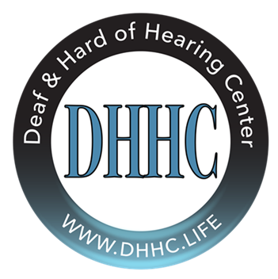
The Deaf & Hard of Hearing Center
1860 Boy Scout Drive, B208, Fort Myers, FL 33907
239-461-0334 (voice) 239-247-5821 (VP) 239-461-0434 (fax)
www.dhhc.life
DHHC Membership: October 1, 2020- September 30, 2021

Name:

Address:

City, State & Zip:

Phone: Email:

Membership Fee:
❑ New Individual Membership $40.00  Renew Individual Membership $25.00

❑ New Family Membership $50.00  Renew Family Membership $35.00

❑ Snowbird Membership $25.00

Donation:
❑ $25.00  $50.00  $100.00  $500.00  Other $

TOTAL:
Please make checks payable to: DHHC.
(MasterCard, Visa, and Discover also accepted)

❑ I would like to receive email updates!
THANK YOU FOR YOUR SUPPORT!

Your DHHC Membership Includes:
- Discounts at all DHHC events and fundraisers
- Free use of DHHC event space (some restrictions apply)
- Interpreter at large community events
- Special updates on DHHC happenings
- DHHC membership card

