ROCKY POINT FIRE & EMS
25600 Rocky Point Road-Klamath Falls, OR 97601
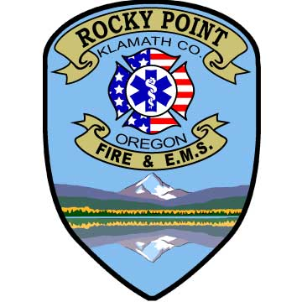

Fire Chief Board Members
Diann Walker-Pope Bruce Harp
Ph: 541-356-2100 Pat O Shay
Fax: 541-356-2340 David Carpenter Jennifer Pickle
Chief@rpfire .com Theresa Peterson

Rocky Point Fire and EMS Board Meeting Minutes
December 12, 2022

The meeting was called to order at 10:01 am in the Aspen room of the fire station.
In attendance were four board members, (Jennifer Pickle called in) Chief Diann Walker Pope, and many community members. Bruce Harp led the flag salute. Ten or so people were in the audience.

Recognition of Guests: N/A

Minutes of Previous Meeting:
David Carpenter makes motion to approve minutes from November. Pat O’shay makes motion to second approval. Unanimously passes.

Treasurer’s Report: Brief report. Treasure report: 272,954.78. Pat O’shay has some ideas on raising money. David Carpenter motions to approve minutes. Bruce Harp 2nds. Passes unanimously.

Board of Director’s Report:

SB 1582 Would add 7 miles to Hwy. and Westside.

Old Business:

Shane Pickle has put in for a 10-space storage area for RV’s. Phase 2 the fire dept will comment and suggest a 2000-gallon water tank for fire. That is a recommendation for RP dept. Jennifer pickle abstains from conversation.

Quality Electric has the bid for electrical for living quarters.
Approved United Mechanical for the splitter.
Final approval for septic paid and reimbursed.
Stairs and deck of sleeping quarters being worked on.

New Business:
Sleeping quarters usage policy. Guidelines for what they can and can’t do. It is an operational guideline and does not need board approval.

Aspen Room Name Change:

The Board approved “The Aspen Room” name change to be “Rocky point Fire & EMS training room”. Pat O’shay motions to close aspen room and rename to RP Fire & EMS training room. Bruce 2nds motion. Passes Unanimously. The facility “use and agreement policy” is null & void.

Chief’s Report:

RP Fire received a VFA grant. Chief ordered 6 officer Radio’s, hand tools etc.. that will be here in March.

Mitigation committee formed to work with emergency management. Rita Donato, Kathy Gilder, Del Ramsdale, Jerry Higgins, Larry Dugger, George Gregory, David Reed, and Whitt Simpson.

Open house is planned for mobile when finished.

Bake sale and quilt raised 2,161.00.

Structure fire Nov. 18th on N Street. Dustin W. and David C. responded. Red Cross assisted the family. RP fire assisted in boarding windows ect.

Burn on Mr. Hurst property.

RP Volunteer Christmas party December 17th.

Nov. calls, 8 MVA’s, 1 PA, 1SF, 2 ALS.

No training until first Tuesday in January.

Paid staff grant again the summer for 35,000. Last year it helped staff 3 part-time fire fighters.

2022 RP fire received roughly 250,000.00 in grants.

EF recovery 10,742.37

GADCS-Ground-Ambulance-Data-Collection-System
This is a survey on what Medicare pays. They pick roughly 2400 ambulance services around the United States. They are wanting to track ambulance pay in and pay out for 2023.

BBQ ad hoc COMMITTEE REPORT:
Donation letters about to be printed and going out soon.

Volunteers’ Association Report:

Good and Welfare:
Comments and Concerns on Fire Department Subject- 3-minute limit per person.

David Carpenter motions for adjournment Bruce Harp seconds. Unanimously.

The next regularly scheduled meeting is set for January 9th, 2022 @ 10:00 a.m.

Submitted by Theresa Peterson, Board Secretary

