FORM NOTICE OF BUDGET HEARING OR-LB-1 Oregon Department of Revenue
A public meeting of the ____________________________ will be held on ______________________at ________ at_______________a.m.
(Governing body) (Date) p.m.
__________________________________________________________, Oregon. The purpose of this meeting is to discuss the budget for the
(Location)
fiscal year beginning July 1, 20______ as approved by the_____________________________________ Budget Committee. A summary of
(Municipal corporation)
the budget is presented below. A copy of the budget may be inspected or obtained at _________________________________________
(Street address)
________________________between the hours of _______ a.m., and _______ p.m., or online at _______________________________ This budget is for an annual; biennial budget period. This budget was prepared on a basis of accounting that is: the same as; different than the preceding year. If different, the major changes and their effect on the budget are:

Contact | Telephone number | E-mail
FINANCIAL SUMMARY—RESOURCES
TOTAL OF ALL FUNDS | Actual Amounts 20____–20____ | Adopted Budget This Year: 20____–20____ | Approved Budget Next Year: 20____–20____
1. Beginning Fund Balance/Net Working Capital ........................................ 2. Fees, Licenses, Permits, Fines, Assessments & Other Service Charges ... 3. Federal, State & all Other Grants, Gifts, Allocations & Donations ........... 4. Revenue from Bonds & Other Debt ......................................................... 5. Interfund Transfers/Internal Service Reimbursements ............................ 6. All Other Resources Except Current Year Property Taxes ....................... 7. Current Year Property Taxes Estimated to be Received ..........................
8. Total Resources—add lines 1 through 7 ................................................
FINANCIAL SUMMARY—REQUIREMENTS BY OBJECT CLASSIFICATION
- Personnel Services ..................................................................................
- Materials and Services ............................................................................ 11. Capital Outlay .......................................................................................... 12. Debt Service ............................................................................................ 13. Interfund Transfers ................................................................................... 14. Contingencies .......................................................................................... 15. Special Payments ....................................................................................
- Unappropriated Ending Balance and Reserved for Future Expenditure ....
- Total Requirements—add lines 9 through 16 ........................................
FINANCIAL SUMMARY—REQUIREMENTS AND FULL-TIME EQUIVALENT EMPLOYEES (FTE) BY ORGANIZATIONAL UNIT OR PROGRAM*
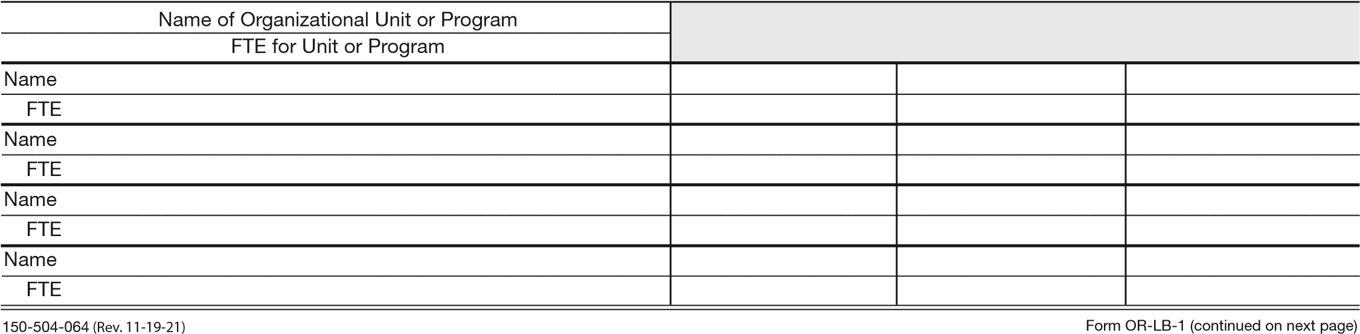
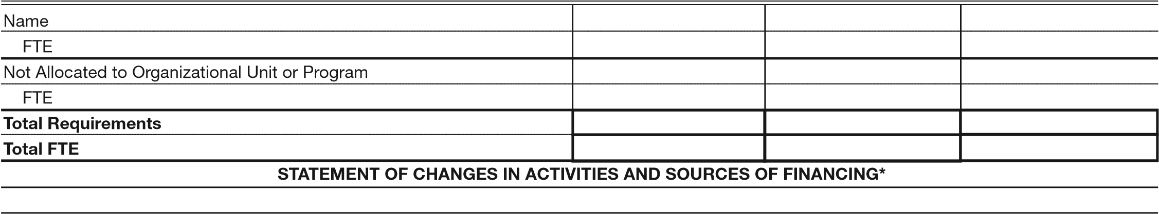

PROPERTY TAX LEVIES
 | Rate or Amount Imposed | Rate or Amount Imposed | Rate or Amount Approved
Permanent Rate Levy ............ (Rate Limit___________Per $1000)
Local Option Levy .......................................................................................
Levy for General Obligation Bonds ...............................................
STATEMENT OF INDEBTEDNESS
Long Term Debt | Estimated Debt Outstanding on July 1 | Estimated Debt Authorized, but not Incurred on July 1
General Obligation Bonds ..............................................................
Other Bonds ...................................................................................
Other Borrowings ...........................................................................
Total ...............................................................................................
*If more space is needed to complete any section of this form, use the space below or add sheets.

150-504-064 (Rev. 11-19-21) Form OR-LB-1 (continued from previous page)

