How to Setup ‘Scan to FTP’ for a PC
Items Needed for scan to FTP to work
- Installation of FTP Utility (and point it to the C: drive)
- Acquiring IP address of Computer
- Adding 1 touch button to MFP
- Add “scans” folder to C: drive and create Desktop shortcut.
Link to FTP software.
http://konica-minolta-ftp-utility.software.informer.com/download/
Installing the Ftp Utility Software
- Double click on the “FtpUtilitySetup.exe” File
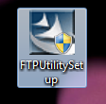
- A windows popup similar to the one below will show up, click “Yes”. 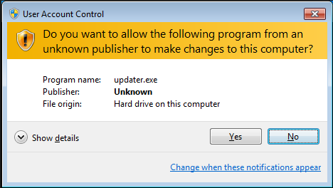
- The following loading screen will come up. 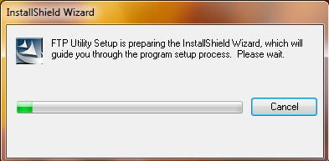
- After that the FTP install wizard comes up. Click “Next”. 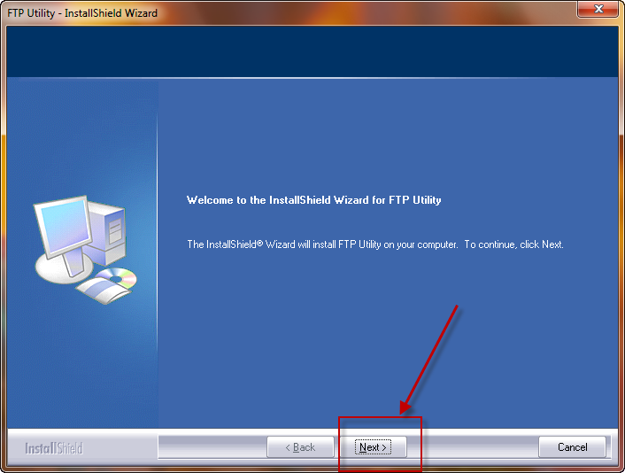
- Click “Yes” on the following screen.
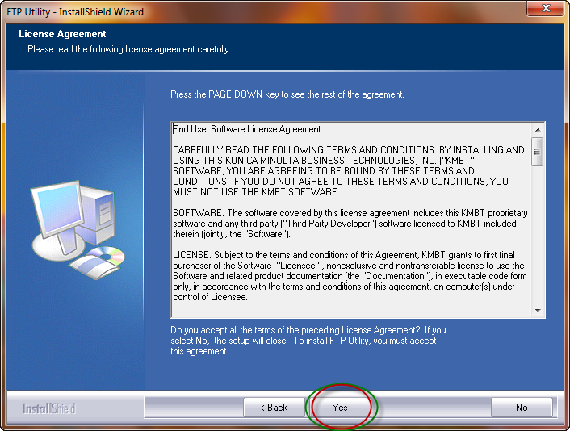
- Click “Next”
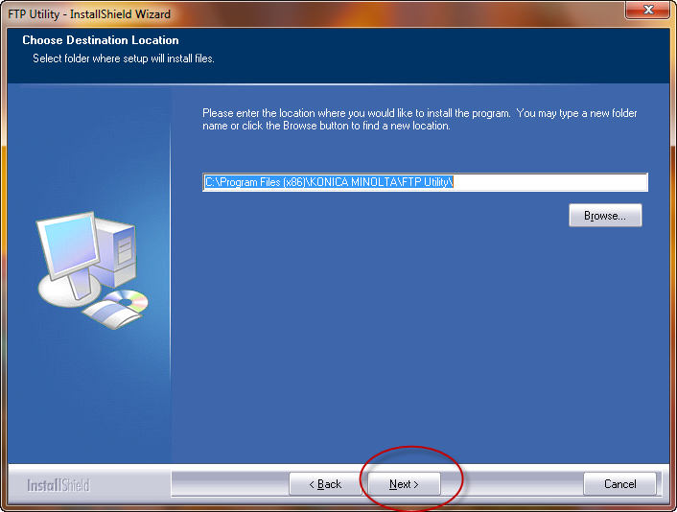
- You will get the following Loading screen.
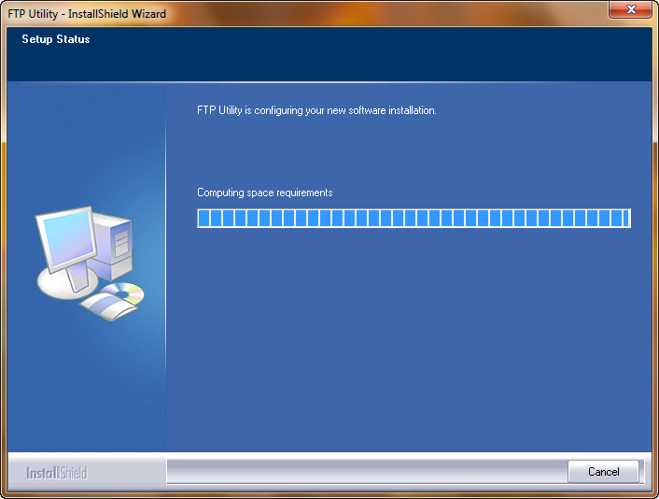
- On the next screen, remove the check mark from the “Register shortcut file on Desktop” and click “Next”.
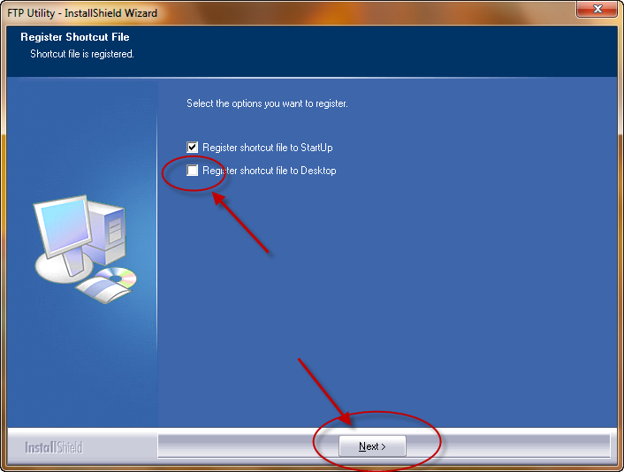
- Click “Finish”
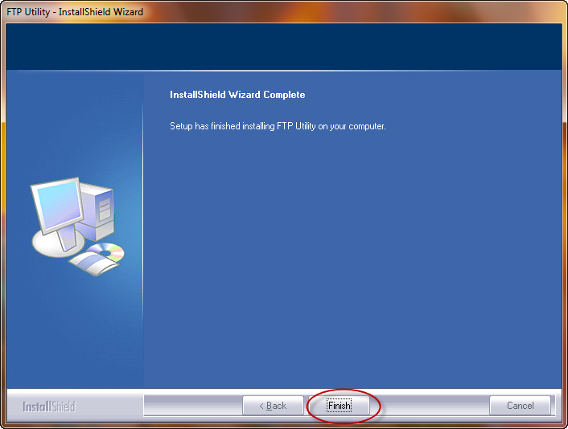
Redirecting the FTP utility to the C: Drive
- Hit the “Start” Button and type in “FTP”. That will bring up the follow options, click on “FTP Utility”.
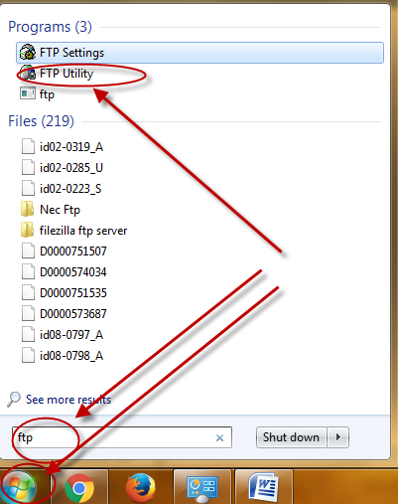
- Now the FTP software is visible in your system tray. 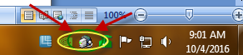
- Right click on the FTP Utility icon and click “FTP Utility Settings” 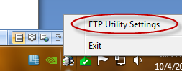
- You will get the following screen 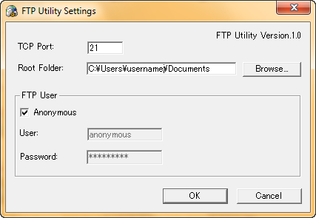
- Click “Browse” and go to the C: Drive and click “Ok” 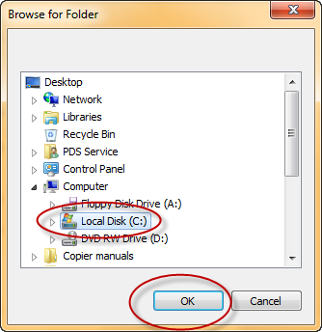
Acquiring IP address of Computer
- Click the Start button and type in “cmd”, double click on the “cmd program that is highlighted in the image below.
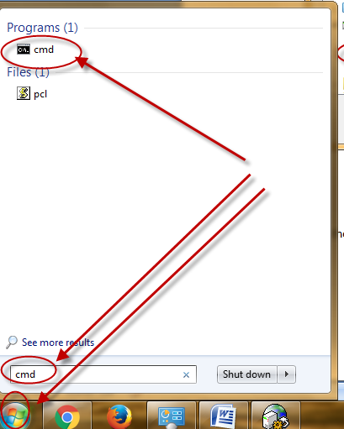
- You will get the following black box. 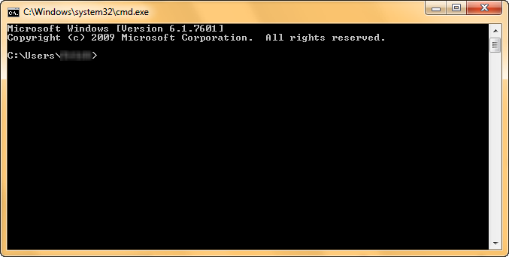
- Type in “ipconfig” and look for the IPv4 address 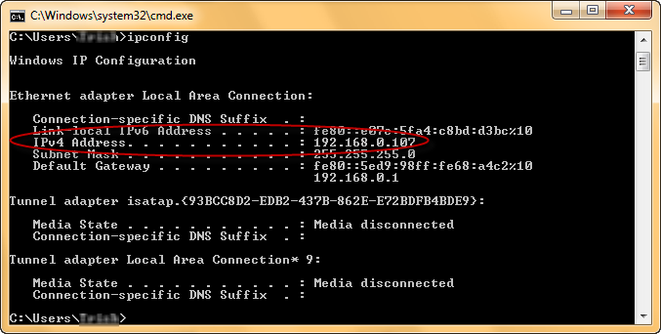

Add “scans” folder to C: drive and create Desktop shortcut
- Click the “Start” Button and click on “computer” 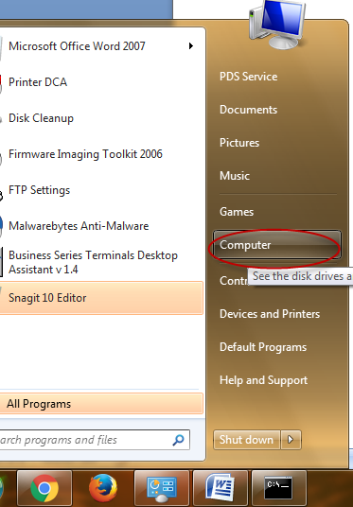
- Double click on “Local Disk C:” 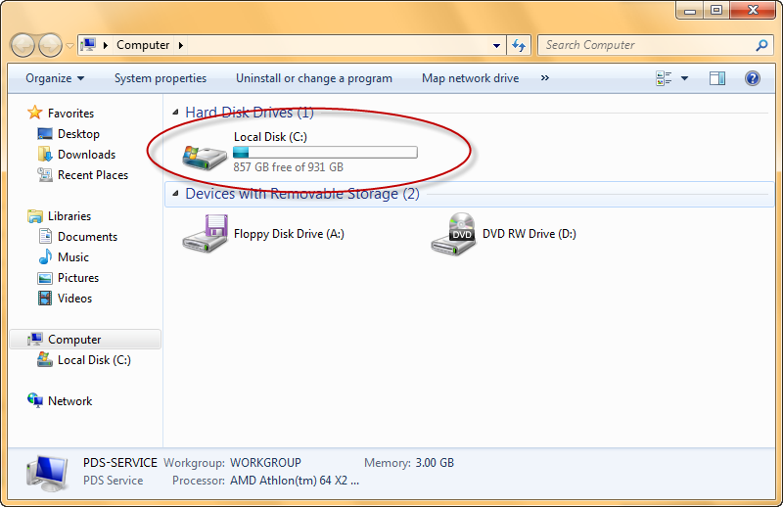
- Once in the C: Drive, right click in an open area and click “New” and choose folder. Rename it to “scans”.
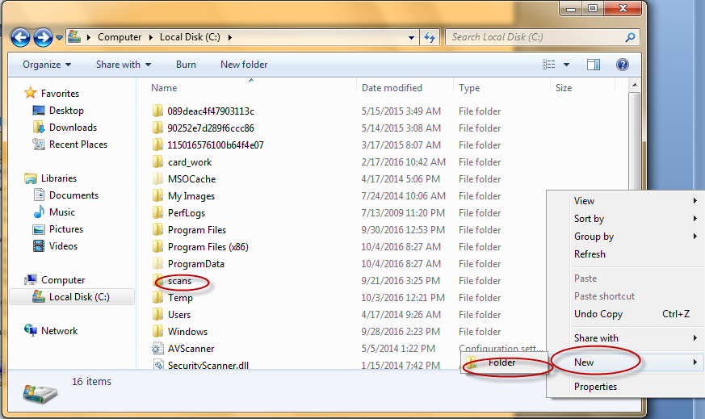
- Right Click on the “scans” folder and click “Send to” and choose “Desktop(create shortcut)” 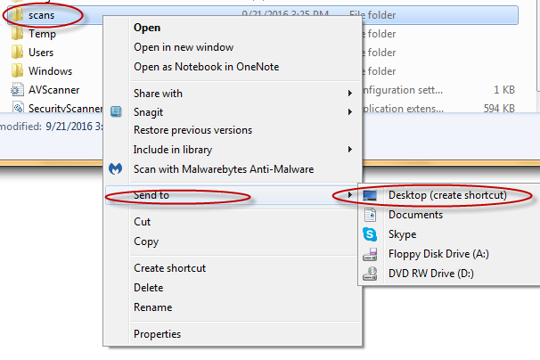
- You now have a “scans-shortcut” icon on your desktop.
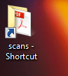
Adding 1 touch button to MFP
- To add the “1 touch button” you need to log into the web application of the MFP by typing in the IP address of the copier into a web browser(Internet explorer, Google Chrome, Firefox). To get the IP address of the copier click “start” and then “Devices and Printers”
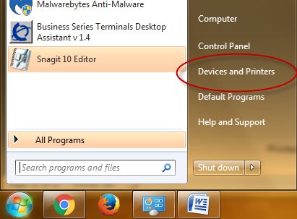
- Once in the device menu, right click on the copier and choose “Printer properties”. 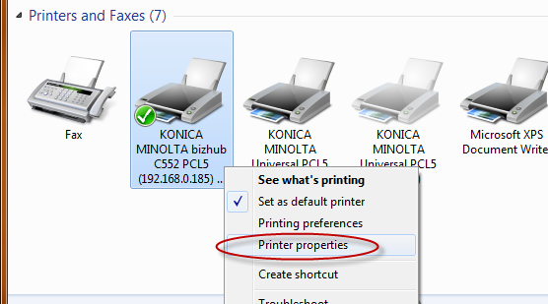
- Once the “Printer properties” comes up choose the “Ports” tab. Scroll down and look which item has the “Check” in the box. That should be your IP address of the copier.
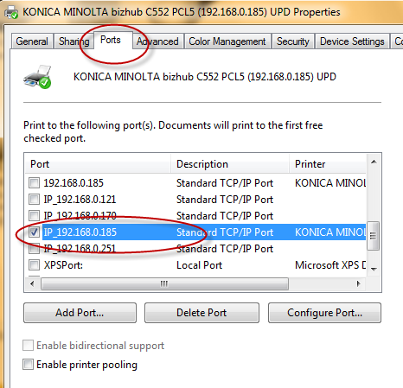
- Open a Web browser (Internet Explorer, Google Chrome, Firefox, or any browser of your choice) and type in the IP address that you found(IE. 192.168.0.185) in the URL. 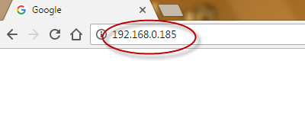
- That will bring up a webpage for the MFP that looks similar to the image below. Click on the highlighted “Address book list” icon. 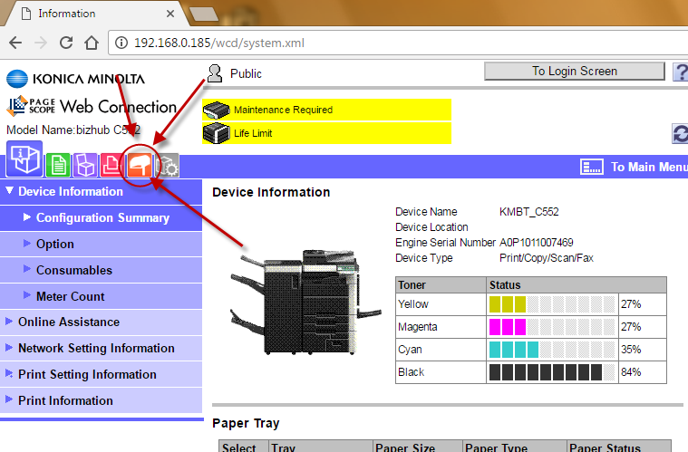
- Here you may or may not see a list of users, click “New Registration” 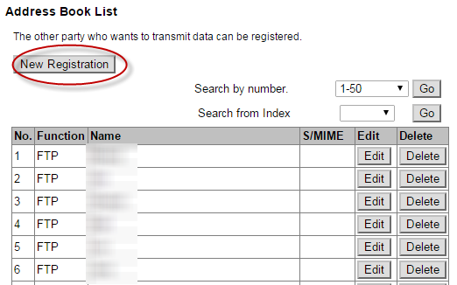
- Click the circle next to “FTP” and click “Ok”.
- Fill in the “Name”(user whom the scan should be sent to)
For “Index”, choose the letters that match the first letter on the “Name” and put a check in the “Main” checkbox. Add in the IP address of the computer that we acquired in earlier steps. For “File Path” put “scans”. Lastly, change the “anonymous” option to “on” and click “OK”
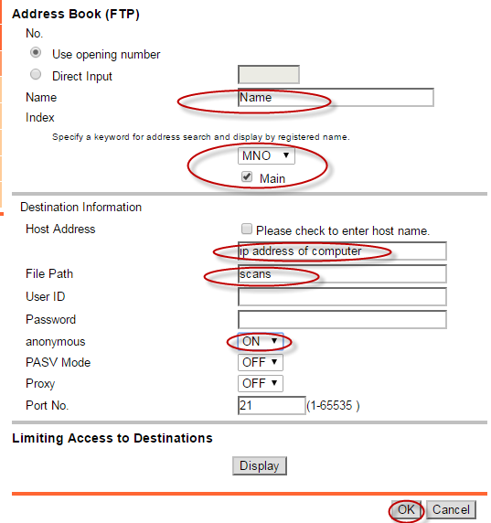
- Now go to the Copier/MFP and test out the scanning under the “Scan/Fax” button on the copier.
Troubleshooting:
If scanning is not working check to see if the FTP software is active down in the bottom right of your screen.
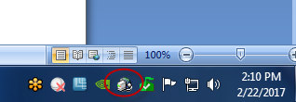
If it is active, make sure that your IP address of your computer matches the one touch button that you setup within the copiers web interface.
If that doesn’t help, hit start and type in “allow a program through the firewall” .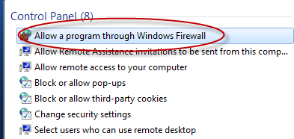
Once in that menu click “Change settings” .
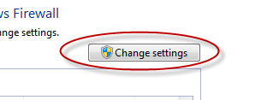
Scroll down through that list and look for the FTP utility.
If it is not in that list, click “allow another program”
From there you will need to click on each of the FTP items and click add one at a time. 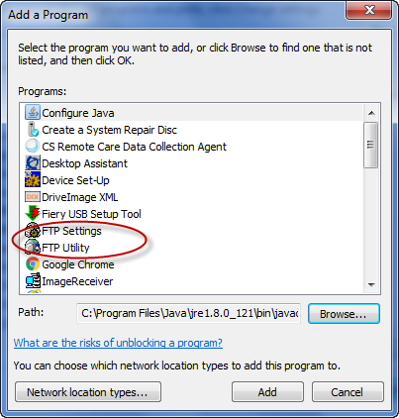
If it is not in that menu click browse and go to “C:\Program Files (x86)\KONICA MINOLTA\FTP Utility” and you can add the tool from there.

If you continue to have issues with the Scan to FTP please contact our support by calling. 1-888-461-4194

