How to Setup Scan to FTP on a Mac
Setup FTP in the Mac
- Go to “Finder” > “Applications”>”Utilities”>”Terminal” 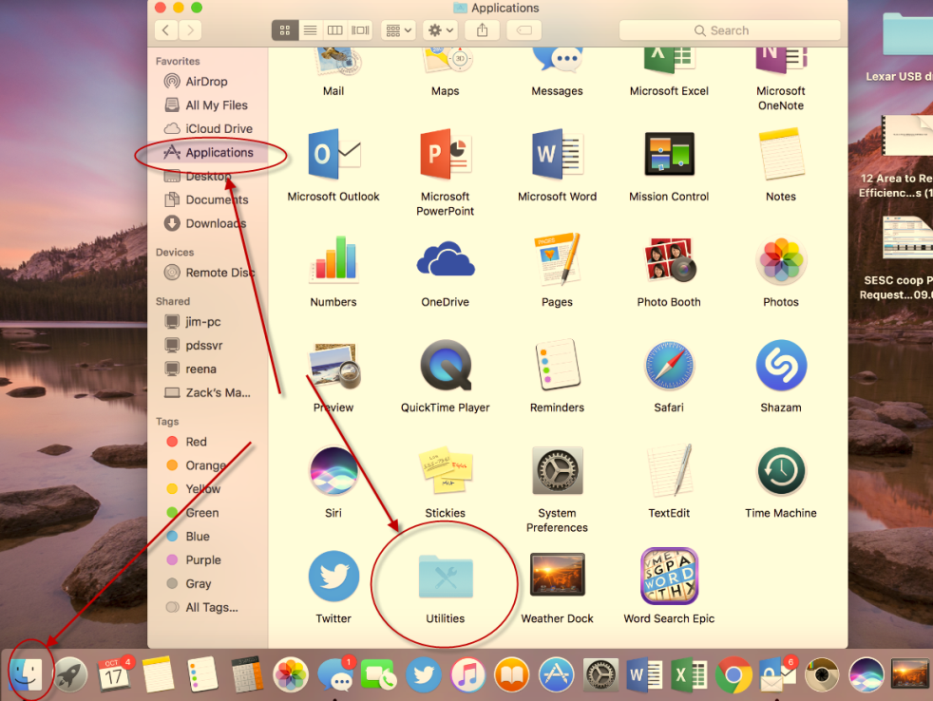
- Once in the Terminal type the Following Commands(complete with spaces)
sudo –s launchctl load –w /System/Library/LauchDaemons/ftp.plist
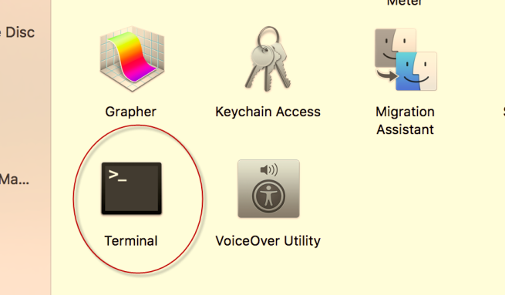
- If entered correctly you will be prompted for the users password(for the user that is logged on the laptop).
- If the password is entered incorrectly the option to re enter the password comes back up.
- If entered correctly, you can now close the terminal.

Create a Folder in the home drive
- Go to the Desktop> click on an open area on the desktop> press Command+shift+H to bring up the home drive
Press (CMD+shift+H )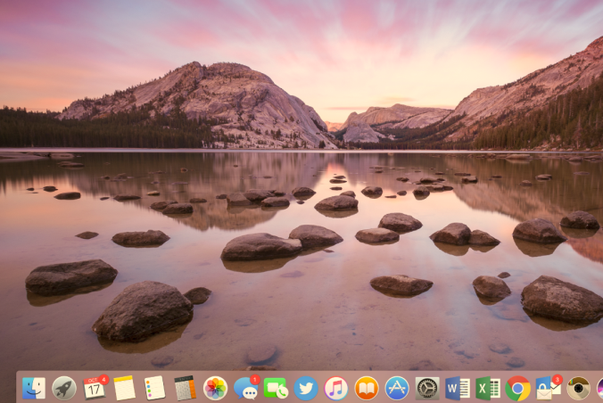 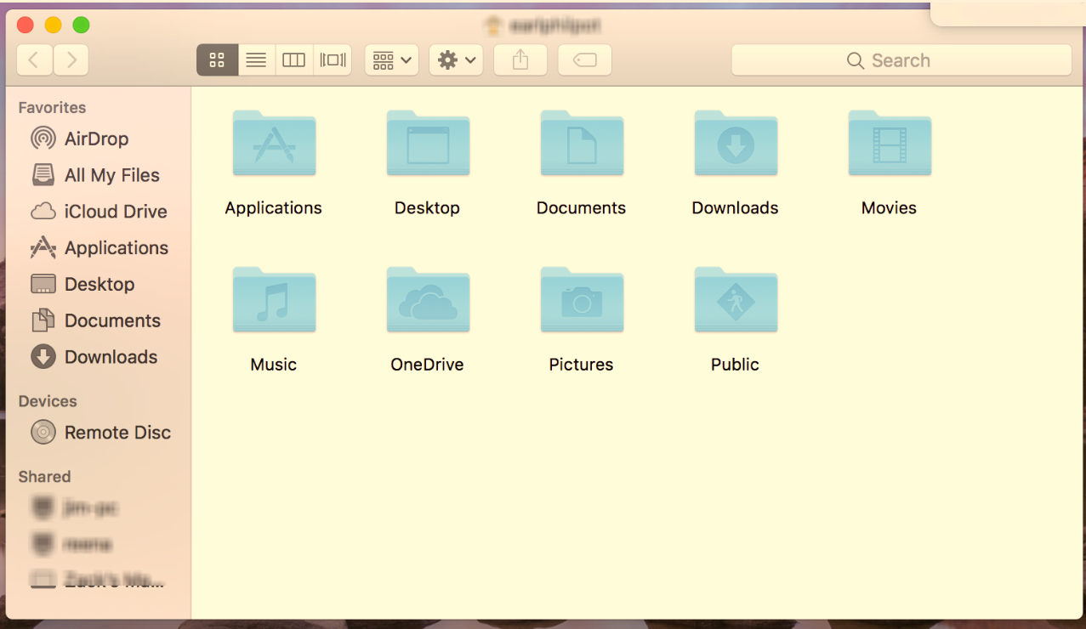
- Control click in the home drive and click “New Folder” rename the folder to “scans” 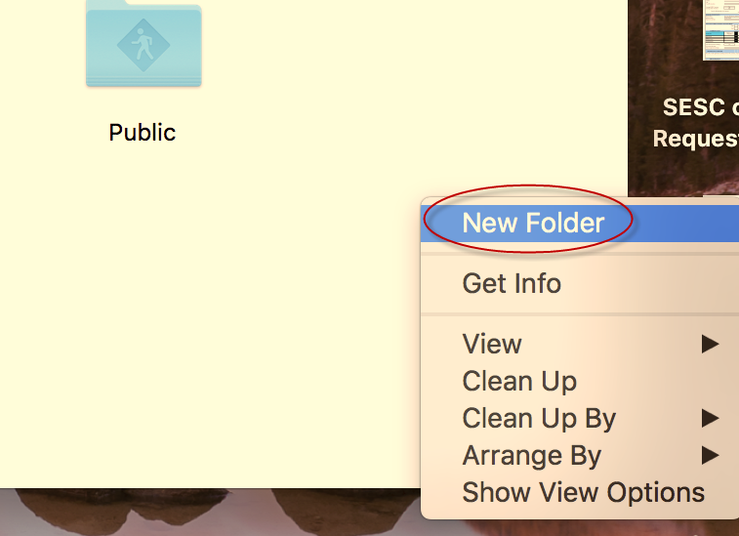
- Control click the “scans” folder and click “Make Alias” 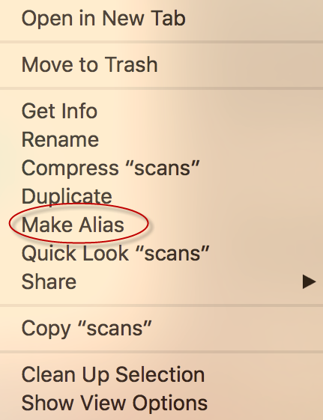
- Drag that “scans alias” folder to the desktop

Find IP address of the laptop
- Go to the “apple menu” and select “System Preferences” 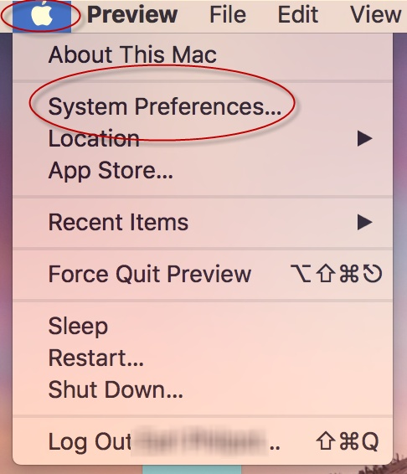
- Go to “Network”
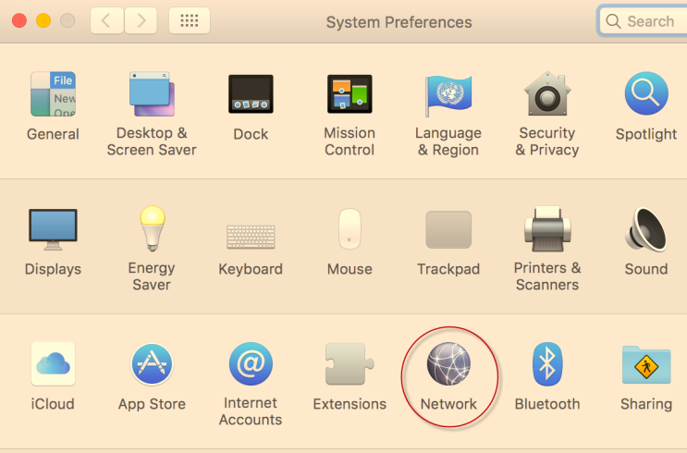
- Towards the top right of that screen you should see your “IP address”(I.E. 192.168.1.15)
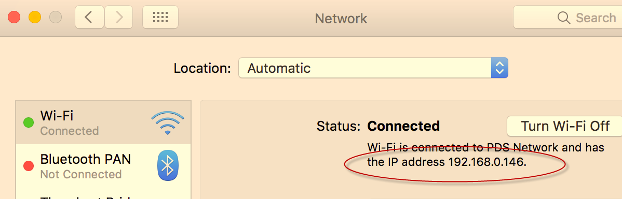
Setup 1 touch button on the MFP
- Pull up Safari or another web browser(Google Chrome, Firefox) and go to the IP address of the copier (192.168.?.??) 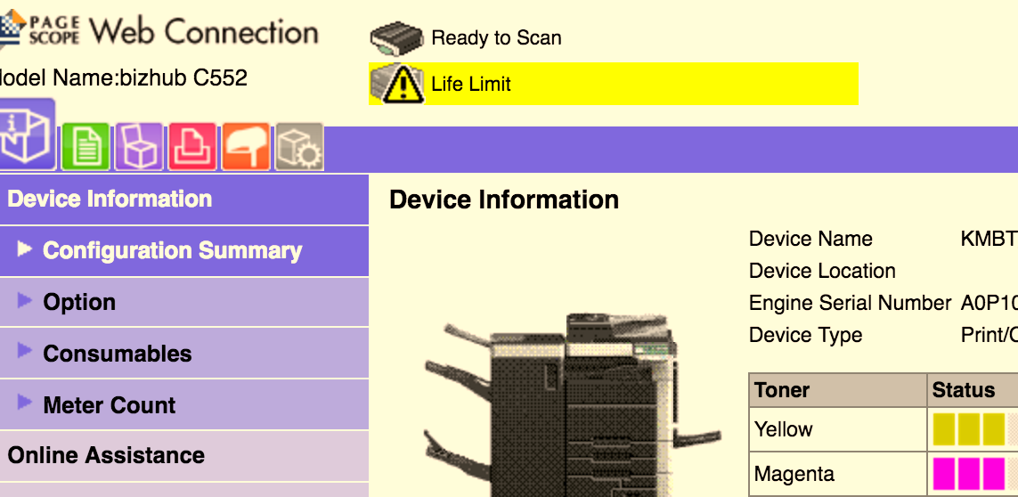
- Select the Orange Icon(Address book)
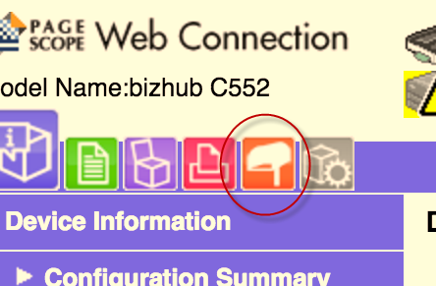
- Select “New Registration”
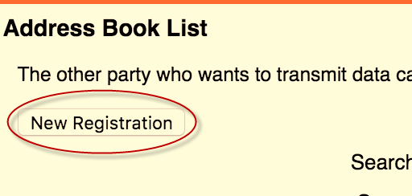
- Select “FTP” and hit “Ok”
- Fill in the following Information
Name: Name of user(what will appear on the one touch button)
Index (Match this to the first letter of the name)
Put the check mark in the “Main” box
Host Address(IP address of the Mac)
File Path: scans (Match the name of the folder you created in the home drive)
User ID/Password (the username and password of the login account on the Mac)
(Anonymous remains off on macs as we use the username and password) 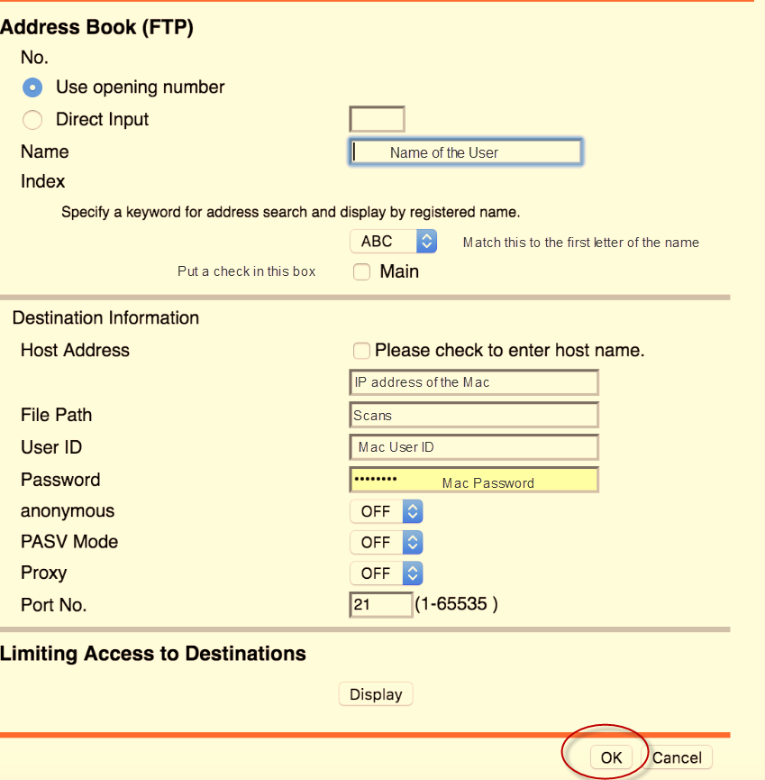
- Click “Ok”
- Test scanning to your computer.
If you continue to have issues with the Scan to FTP please contact our support by calling. 1-888-461-4194

