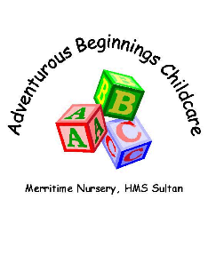

COVID19 Gradual Widening of Provision at Merritime Nursery
Parent Protocol
By sending your child back to nursery, you are agreeing to adhere to the following protocols.
Parents are expected to drop their child to nursery and confirm adherence to the protocols and that their child is healthy.
Each morning please check your child’s temperature and for any signs of symptoms of a cough, sore throat, a rash, loss of smell or taste, stomach pains or swollen glands. If your child has ANY of those symptoms DO NOT bring them to nursery and please inform the nursery.
Wash hands before leaving the house every morning and encourage your child to refrain from touching anything on the journey to nursery. (on arrival in nursery they will wash their hands again).
Where possible accompany your child to nursery on your own; one child one adult .
Please no queuing within the gated area of nursery drop off to enable social distancing to be observed.
Socially distance when awaiting entry to the nursery and please be patient with staff who will be welcoming children, taking messages and offering positivity and reassurance.
Please do not gather to socialise with other parents, we aim to provide a good example to our children where possible regarding social distancing.
Please do not allow your child to bring additional belongings to nursery, no toys or books please.
Please be patient, be kind and do not expect too much too quickly.
Please be aware of HMS Sultan guidance on entry/exiting the establishment and adhere to updated policy which is
- Single file walking
- Only people from the same household in your vehicle.
- If you must enter the other side of the base for any given reason and you are on foot you will be asked to use the footbridge to enter.
- All persons entering the base on a bike must wear a helmet, if not you will be asked to walk your bike on base.
- Windows of your vehicle must be fully closed.
I am sure you will all be happy to support us in our efforts to keep your child safe by following these protocols.
If any parent or carer chooses to deliberately ignore the protocols, you will be contacted, and we may be unable to continue offering your child a place whilst the reduced provision is still in place.

