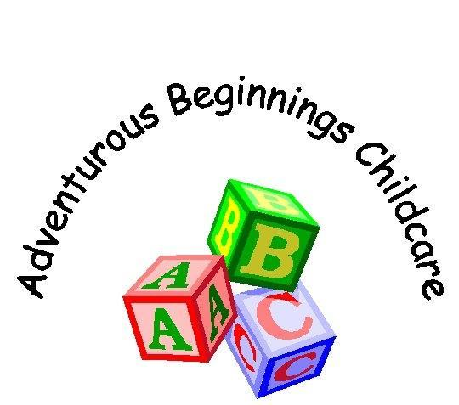
Child Protection Policy
Adventurous Beginnings Childcare is dedicated to ensuring that the welfare, safety and protection of all children are paramount at all times.

Aims
Our aims are to: -
- To create a happy and friendly environment, to encourage children to develop a positive self-image regardless of Race, Language, Religion, Culture, or home background.
- We ensure that all children are treated as equals and encourage children to develop a sense of independence.
- Enable children to have the self-confidence and the vocabulary to resist inappropriate approaches.
- Promote and encourage satisfying relationships with their families, other adults, and peers.

Some examples of the legal framework for this work are: -
- The Crime and Disorder Act 1998
- Sexual offences Act 2003
- The Rehabilitation of Offenders Act
- The Children Act 1989/2004
- Human Rights Act 1998
- Data Protection Act 1998
- The Protection of Children Act 1999
- The Children (NI) Order
- The Children (Scotland) Order
- Safeguarding vulnerable groups Act 2006.
- Working together to safeguard children 2018.

Liase with other bodies
We work within the Area Child Protection guidelines.
We have a copy of the Area Child Protection guidelines available for Staff and Parents to see. Or this can be viewed via the link below:

https://www.hants.gov.uk/educationandlearning/safeguardingchildren/guidance

We notify the registration authority (OFSTED) of any incident or accident, and any changes in our arrangements, which affect the wellbeing of children.

We have procedures for contacting the local authority on Child Protection issues.

Records of the local NSPCC contacts are also kept.

If a report is to be made to the authorities, we act within the Area Child Protection guidance in deciding whether we must inform the child’s parents at the same time. These records are signed and dated and kept in a separate confidential file.

Procedures for Recording and Reporting an Incident

If possible, the Nursery Manager/Deputy will speak to and listen to the child, reassuring them they are not at fault and will be respected at all times. All conversations will be recorded and signed by the Nursery Manager/Deputy.

Parents/Carers will be approached if the Nursery Manager/Deputy feel it is safe for the child, and the concerns will be discussed.

If the Nursery Manager/Deputy are not satisfied with the response from the child’s parents, or feel it is detrimental to their safety, Social Services/Area Child Protection Office will be contacted immediately.

At all stages of the investigation, accurate records will be made by way of Incident Reports, Witness Statements, and Interview records. All information will be passed onto Social Services/OFSTED/Area Child Protection Office.

All information will be always kept confidential.

All members of staff know the procedures for recording and reporting.

Informing Parents
Parents are normally the first point of contact. If a suspicion of abuse is recorded, parents are informed at the same time as the report is made, except where the guidance of the local Area Child Protection committee does not allow this. This will usually be the case where the parent is the likely abuser. In these cases, the investigating officers will inform parents.

Confidentiality
All suspicions and investigations are kept confidential and shared only with those who need to know. Any information shared under the guidance of the Area Child Protection committee.

Support to Families
The Nursery takes every step in its power to build up trusting and supportive relations among families, staff, and volunteers in the group.

The Nursery continues to welcome the child and the family whilst investigations are being made in relation to abuse in the home situation.

Confidential records kept on a child are shared with the child’s parents or those who have parental responsibility for the child only if appropriate under the guidance of the Area Child Protection Committee.

With the proviso that the care and safety of the child is paramount, we do all in our power to support and work with the child’s family.

Both the nursery and parent’s have a responsibility to protect children. The Nursery will discuss with parents their concerns where appropriate and will keep records of concerns. In situations where an urgent action needs to be taken to protect the child the concerns will be referred to Social Services/Area Child Protection Office immediately.

All Staff/Volunteers/Students will not be left alone or expected to tend to a child’s personal needs until they are Police checked by the Criminal records Bureau. Nursery partners must be satisfied with the outcome of this check and feel the person is confident with the duties required to fulfil their role in offering High Quality Childcare within the Nursery.

We have a copy of the ‘What to do if your worried a child is being abused’ guidelines based on the ‘Area Child Protection Guidelines, a Safeguarding Policy and a Whistle blowing policy. These are available for parents and staff to see and are situated on a notice board in the main corridor along with our named Lead Practitioner in Safeguarding
Vanessa Nimmo-Cameron Nursery Manager and Deputy Lead Practitioner in Safeguarding Emma Jerrard (Deputy Manager).

Contact Details: -
OFSTED: 0300 123 1231
HCC Children’s Services Department 08:30-17:00: 0300 555 1384 or email: childrens.services@hants.go.uk
Out of hours line: 0300 555 1373
Hampshire Police: 0845 045 4545/in an emergency call: 999
NSPCC Child Protection Helpline: 0808 800 5000 or email : help@nspcc.org.uk
Child line: 0800 1111

Criminal Record Bureau: -
GBG
1 Wilford Business Park
Ruddington Lane
Nottingham
NG11 7EP

Updated 05/02/2021

