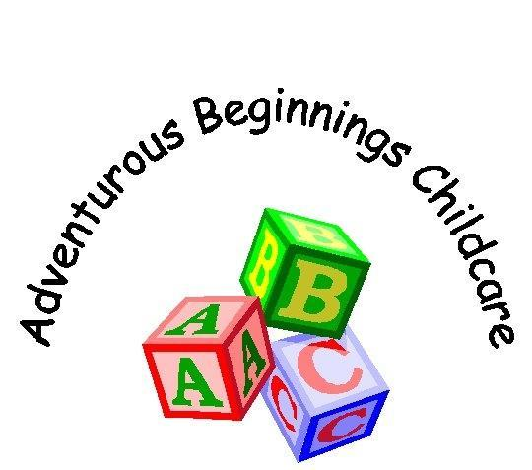
Dealing with Sick children & Infectious Diseases

As a nursery we are here to ensure that the welfare of all the children and staff is maintained to a high standard. If a child becomes unwell at home, they will not be permitted to attend their usual sessions until they have been treated or symptoms have cleared. It is the parents/carers responsibility to inform the nursery of any absence and the reason for it. If the child becomes unwell whilst at nursery, parents will be contacted immediately and must collect their child as soon as possible. Staff will do their best to comfort the child and administer aid if necessary, but it must be realised that there are no provisions for children who are ill at the nursery.

If medical assistance is required, then First aid will be administered by a trained appointed person until the arrival of the emergency services, as long as parents have given their permission on the Child’s Application form. Nursery Managers will contact Parents/carers immediately. If a parent has refused permission for the emergency services to be called then the parents will be called immediately.

Should a child need to be taken to hospital they will be accompanied by a member of staff who will have the child’s Application form containing personal details and medical contacts. Meanwhile management at Nursery will contact parents/carers to inform them of the situation. Staff will remain with the child until parents/carers arrive at the hospital.

In the case of an emergency staff will call the emergency services on SULTAN 2222.
Staff must give clear details as to the nature of the emergency, and the location i.e. Merritime Nursery,
Building 107,
Fort Rowner,
H.M.S. Sultan,

Parents/carers will be informed of any outbreaks of infectious diseases within the nursery. It is parent/carers responsibility to notify the nursery if their child is infectious, and may only return to nursery when advised by a doctor.
Extreme cases or outbreaks (e.g. Gastro-enteritis) should be reported to the local Environmental Health Department for advice.

When to send your child back to Nursery following an Illness

Vomiting/Sickness When a child has not been sick for 48 hours

Diarrhoea 48 hours from child’s first normal stool

Head Lice Following recommended treatment

Conjunctivitis 24 hours from on-set of treatment

Raised temperature When the child’s temperature has returned to normal and has remained stable for at least 24 hours without medication.

Chicken Pox When all the Childs spots have scabbed over and there are no more signs of any blistering. Your child will be checked by a member of management on their return.

Hand, Foot and Mouth Children who are unwell should be kept off until their symptoms have subsided and they are feeling better, Symptoms generally go away between 5/10 Days.

Impetigo Children should be kept away from nursery until lesions are crusted or healed. Antibiotic treatment may reduce the infected period.

Ringworm Children should be kept away from nursery until treatment has commenced.

Updated 07/01/2019

