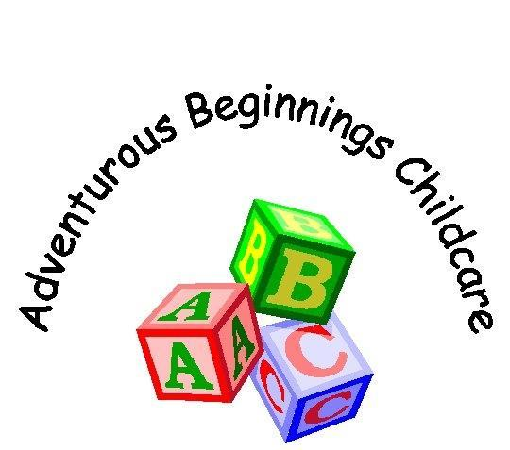
Diet Policy and Practice

The sharing of refreshments can play an important part in the social life of the Nursery as well as reinforcing children’s understanding of the importance of healthy eating.
Here at Merritime Nursery will ensure that:
- All snacks/meals provided are nutritious, avoiding large quantities of fat, sugar, salt, additives, preservatives and colourings.
- Children’s medical and personal dietary requirements are respected and we will endeavour to help as much as we can, however you may be asked to supply certain foods to ensure that their dietary requirements are being met.
- Parents and Children have an input into the menus.
- Menus are planned in advance and rotated on a 4 week Menu, ensuring that all children receive a varied diet.
- All food offered is fresh, wholesome and nutritious.
- A multi-cultural diet is offered to ensure that children from all backgrounds, encounter familiar tastes, also ensuring that our children have the opportunity to try unfamiliar foods.
- The dietary rules of religious groups, cultures and also of vegetarians/vegans are known from the start and met in appropriate ways.
- Milk provided for children is whole and pasteurised.
- Drinks are readily available to all children throughout the day.
- If parents wish for their baby to have formula milk, this should be supplied in powder form for staff to make up fresh as required.
We offer fresh fruit and vegetables everyday to encourage healthy eating and to support our children in meeting their 5 a day. We have information displayed in the kitchen advising staff of children’s allergies and dislikes to ensure that we cater for everyone individually.
A separate Baby weaning menu is available to ensure that parents feel supported during this time. All baby needs will be discussed before starting at our setting.
The Nursery encourages all children to be aware of Oral Health; tooth brushing is encouraged. If parents wish for this to happen they are asked to bring a named toothbrush and toothpaste into the setting.
All Staff have Level 2 Food Hygiene.
Reviewed 30/07/2019

