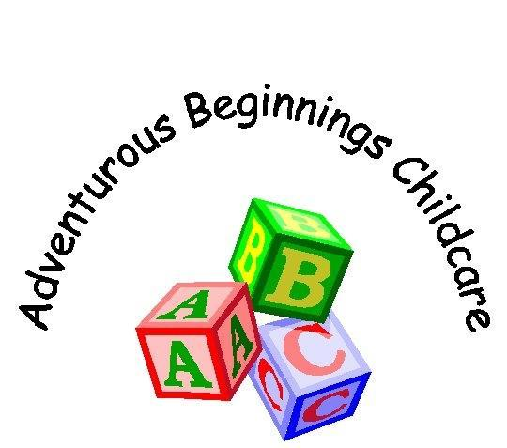
Health & Safety Policy

The Health & Safety of young children, all employees and all other persons who enter the Nursery premises is of paramount importance. In order to achieve and Maintain the safety of all persons stated above the nursery will ensure its safety in the following areas: -

- To provide adequate control of the Health & Safety risks arising from our work activities.
- To consult with our employees on matters affecting their Health & Safety.
- To ensure safe handling, use and storage of substances.
- To provide information, instruction and supervision for employees.
- To ensure all employees are competent to do their tasks, and to give them adequate training.
- To maintain safe and healthy working conditions, ensure all equipment and Toys are maintained.
- To review and revise this policy as necessary at regular intervals.
- To ensure all Staff are DBS Cleared.
- To ensure all staff are fully qualified or Training to become fully qualified in Childcare.
- To maintain cleanliness and good state of repair to the building.
- To ensure all Students/Volunteers are studying with a recognised training provider and have been DBS cleared through this provider.
- No Staff or Parents to use their Mobile Phones in areas used by the Children.
- To ensure we follow are policy regarding collection of children.
- To ensure our Nursery ratios are met on a daily basis.
- To ensure parents comply with our infectious diseases exclusion periods to avoid unnecessary spread of infection.

Responsibilities

- Overall Responsibility for Health & Safety in the nursery is that of the Nursery Owner Mrs Vanessa Nimmo-Cameron of Adventurous Beginnings Childcare, However Emma Jerrard (Deputy Manager) is our named Health & Safety officer and in her absence Charlotte Vials will oversea any Health & Safety requirements.

- The day-to-day responsibility for ensuring that Health & Safety is adhered to is that of all staff and nursery management.

- All employees must co-operate with management on all Health & Safety matters.

- All employees must always use the safety equipment provided by Adventurous Beginnings Childcare.

- Employees must not interfere with anything provided to safeguard their Health & Safety.

- Employees must take reasonable care of their own Health & Safety and report all Health & Safety concerns to their management team.

- All staff including the Management Team and the Cleaner to ensure that the daily risk assessments are completed.

The Management team is as follows:
- Vanessa Nimmo-Cameron – Nursery Owner/Manager
- Emma Jerrard – Nursery Deputy Manager
- Becky Hughes – Nursery Supervisor
Accident

- The First Aid box is kept in the Nursery Office; the management Team ensure it is well stocked and checked regularly.

- All staff members must hold a current First Aid Qualification.

- All staff will be responsible for reporting accidents to nursery management and in completing the relevant paperwork immediately and parents informed on arrival.

- All Accidents forms are studied to ensure that if an accident occurs, could it in anyway have been prevented. If so ensure that measures are taken immediately. Monthly accident reviews take place and are recorded.

- All accidents and cases of work-related ill health is to be recorded in the accident book, which is situated in the office.

- Managers/Deputy Manager are responsible for reporting accidents, diseases, and Dangerous occurrences to the enforcing authority/OFSTED.

Emergency Procedures & Fire & Evacuation

- HMS Sultan checks Fire Extinguishers regularly and Merritime Nursery check in their monthly reviews.

- Fire alarms checked by Emma Jerrard (Deputy Manager , H&S Officer) weekly and in her absence Vanessa Nimmo-Cameron (Manager) or Charlotte Vials (Deputy H&S Officer)

- All exits are checked by management before the opening of the nursery and throughout the day. An Opening and Closing checklist are completed by the cleaner/Management at the beginning and end of the day ensuring all exits are clear for the next day.

- Emergency evacuation practised termly or when a new member of staff or Student/volunteer joins the team.

- Supervision Ratios must always be adhered daily. To ensure this happens we have a nursery deployment form which indicates how many children we have in what age range and where staff have been allocated to maintain the current ratios listed below.
* Under 2’s = 1:3
* Under 3’s = 1:4
* Preschool = 1:8

- Managers/Deputy are responsible for ensuring that the Fire Risk Assessments is implemented, and any concerns are raised.

- Registers must be readily available, and children should be marked in on arrival immediately.

Evacuation Procedure

If the alarm should sound and you are not aware of any practice drills or testing, then please follow the procedure below:

- Remain calm and evacuate the building to your nearest fire exit. DO NOT go back to your allocated room. You can meet your group once you have evacuated the building safely.

- Gather at the current fire muster point:
CARAVAN PARK AT THE FRONT OF THE BUILDING

- Once everyone is safely gathered you will be asked per age group to allocate for all children against your register.

- The staff will then be allocated against the staff register by the manager on duty. PLEASE ENSURE YOU SIGN IN AND OUT DAILY.

- HQ1 will be alerted and will send security to check the building is safe before we can enter again, if needed the fire service will be on route to manage any fire reported.

- Your building fire officers are: Vanessa Nimmo-Cameron (Manager) & Emma Jerrard (Deputy Manager)

Unexpected dangers

- If a unknown package is found either within the nursery or close proximity to, staff will evacuate the children to a safe area and nursery management will contact security staff by dialling 2222, once the area is deemed safe by security staff then we will re-enter the building.

- If an unwanted visitor/intruder gets access into the nursery, staff’s main priority is to ensure the safety of the children and attempt to evacuate them from the danger area if possible, staff are to try and inform Management, and security by dialling 2222 from the nearest telephone.

Hazards

- General Household Waste is to be placed in refuse sacks, sealed, and stored in the refuse bin outside for collection from Local Authority.

- Nappies are first placed in nappy sacks then into the yellow bag supplied, sealed, and placed in the Yellow bin, for weekly collection from PHS All clear.

- Dangerous substances e.g., antibacterial, bleach, disinfectant, will be kept in the locked Nursery Utility room. This is only accessible to staff. COSHH date sheets are stored in the Health and Safety file in then office.

- Nursery chairs may be stacked, but only in small stacks to prevent any accidents.

- Staff only open the main door to familiar faces, if the person is not recognised management will be called and identification will be verified.

Emergency Contacts

Sickbay Emergency Services HQ1
H.M.S. Sultan HMS Sultan HMS Sultan
Tel: - 2239 Tel: - 2222 Tel: - 2261

STAY ALERT, STAY ALIVE

Updated 05/02/2021

